Contractors Working
Near track and overhead brief sheet

BACKGROUND
The Tramway Safety System is governed by the Railways Act which clearly defines how to work around tram infrastructure e.g. what clearances need to be observed between rail, railed vehicles, traction overhead and other fixed objects (curbing, buildings etc.) and road vehicles.

The Tramway electrical power supply system consists of the equipment and infrastructure required to provide the supply and reticulation of 600v DC electrical energy for the operation of the Tramway. The supply is taken to a DC solid-state rectifier. The positive output of the rectifier feeds via protection equipment to the overhead contact system from a single wire overhead line suspended at an average height of 6.0 metres.

The negative feed is taken directly to the track. For the purposes of the Electricity Regulations 1993 the track is a current carrying conductor connected to earth and is considered to be alive.

SAFE WORKING DISTANCES

Statutory Requirements
The safe working distances from live electrical equipment shall be those in Electrical Code of Practice (ECP34/2001) - Electrical Safety Distances. (See pages 4 & 5)

Overhead Contact System
No person or mechanical plant shall operate closer than 4.0 metres from the overhead conductors of the overhead contact system without permission from Christchurch Tramway Limited.

Where permission has been given, plant may not work any closer than 1.0 metres from the overhead contact system. (This permit is valid for a maximum of 28 days)

Application to Work Near Conductors of Overhead Electric Lines - FORM 30.

Isolation and Earthing Procedures
If it is required, the overhead contact system shall be isolated, earthed, locked and tagged before any work commences. Procedures for isolation and earthing shall be carried out by means of an Operating Order.

Overhead Electric Line Isolation Request – FORM 31

Christchurch Tramway Limited will grant application to work near the Tram tracks (Excluding Overhead) and arrange for the form to pass to Christchurch City Council (FORM 32) - (This permit is valid for a maximum of 28 days)

Application to Work Near Tram Tracks Request – FORM 32

Track (Return Current)
The track rails carry the return DC negative current. While the system is in operation the track is a current-carrying conductor and is considered to be alive.

There can be no assurance as to the magnitude or direction of flow of current in the track circuit. As there is a possibility of dangerous current flow across any break or join in the track while trams are operating, all track repairs involving any break in the track are to be carried out with the contact system isolated and earthed.

Underground Cables
No person shall excavate in the vicinity of any underground electric cable without first obtaining copies of the latest drawings from Christchurch City Council.

No mechanical plant is to operate within 600 mm of the marked position of any underground electric cables. The position of any cable must first be exposed by careful hand-digging trial holes.

Overhead Poles
No person shall excavate in the vicinity of any Tramway overhead pole without first liaising with the Christchurch Tramway and the Christchurch City Council Should any excavation occur or be proposed which could affect the stability of the overhead poles, appropriate technical advice as to safety shall be sought and appropriate measures taken to rectify the situation.

Tramway Operation hours
Christchurch Tramway operating hours are from 7.00 am - 11.00 pm

Operations Manager  Mark Small  E: m.small@christchurchattractions.nz  M: 021 846-106 | Tramway Engineer  Alex Hunter  E: workshop@tram.co.nz  C: 021 022-05094 | Workshop Engineer  David Maciulaitis  E: davidm@tram.co.nz  C: 021 310-756

SAFE DISTANCES FOR THE OPERATION OF MOBILE PLANT NEAR CONDUCTORS

5.1 GENERAL

5.1.1 This section does not apply to live line work or to any conductor forming part of the mobile plant or any collector wire, insulated cable, or flexible cord used for the purpose of supplying electricity to the mobile plant.

5.1.2 Mobile plant working near an electric overhead electric lines can damage the line and be hazardous for the plant operator, the mobile plant and people in the vicinity.

5.1.3 Conductors can be displaced from their normal position by wind or temperature change. This requires special consideration by mobile plant operators.

5.1.4 This section does not apply while mobile plant is in transit on a road and the relevant requirements of the Traffic Regulations 1976 are observed.

5.2 MINIMUM APPROACH DISTANCE

5.2.1 The distance between any live overhead electric line and any part of any mobile plant or load carried shall be “AT LEAST 4.0 METRES”, unless the operator has received written consent from the overhead electric line owner allowing a reduced distance.

5.2.2 When an approval has been obtained pursuant to clause 5.2.1, and subject to clause 5.5.1, the minimum approach distance between a conductor and any mobile plant shall not be less than specified in Table 6.

5.2.3 Figure 5 provides a quick reference guide to the minimum safe distances for use of mobile plant near conductors of overhead electric lines.

5.3 WORKING ABOVE OVERHEAD ELECTRIC LINES

5.3.1 Mobile plant or any load carried shall not operate above the conductors of any overhead electric line unless the operator has received written consent from the overhead electric line owner to work above the overhead electric line.

5.3.2 The use of helicopters above overhead electric lines is governed by the Civil Aviation Rules.

5.4 CONSENT FOR REDUCED MINIMUM APPROACH DISTANCES

5.4.1 The application for written consent from the overhead electric line owner shall be made with reasonable notice.

5.4.2 The overhead electric line owner’s written consent shall advise:
(a) The voltage of the overhead electric line and the minimum approach distance to be observed, which shall not be less than the requirements of Table 6; and
(b) Any other reasonable conditions to be observed while working in proximity to, or above, the overhead electric line.
(c) The section of line to which the consent applies.

TABLE 6 REDUCED MINIMUM APPROACH DISTANCES
(where written consent has been obtained)

Circuit voltage | Minimum approach  Distance (m)
Not exceeding 1 kV – insulated conductor | 0.15
Not exceeding 1 kV – conductor not insulated | 1.0
Exceeding 1 kV but not exceeding 66 kV | 1.0
Exceeding 66 kV but not exceeding 110 kV a.c. or d.c. | 1.5
Exceeding 110 kV but not exceeding 220 kV a.c. or d.c. | 2.2
Exceeding 220 kV d.c. but not exceeding 270 kV d.c. | 2.3
Exceeding 270 kV d.c. but not exceeding 350 kV d.c. | 2.8
Exceeding 350 kV d.c. or 220 kV a.c. | 4

5.5 REDUCED MINIMUM APPROACH DISTANCES FOR COMPETENT EMPLOYEES

5.5.1 Where the operator of any mobile plant is a competent employee working on, or in the proximity of, an overhead electric line, the approach distances may be reduced in accordance with the safety practices determined by the overhead electric line owner.

5.5.2 Direct contact of insulated elevating work platform with live conductors shall be acceptable only under approved live working procedures. Whenever a special reduced minimum approach distance is applied, the maximum practicable clearance from conductors shall be maintained.

5.6 OTHER REQUIREMENTS

5.6.1 Where any mobile plant is likely to be used at any time in the proximity of overhead electric lines, the owner or operator of such device shall affix an approved warning notice in a conspicuous place as near as practicable to the operator's position. The notice shall be maintained in a legible condition and shall state: "WARNING, KEEP CLEAR OF POWER LINES".

Reference: NZECP 34/2001 - New Zealand Electrical Code of Practice for Electrical Safe Distances – Section 5, Pages 15 & 16.

Obstacles Clearance Standards

On Curved Sections  (Measured from outside rail edge)  Outside of Curve – 1750mm (min)  Inside of Curve – 1750mm (min)  Inside of Curve  Outside of Curve  Measured from here | 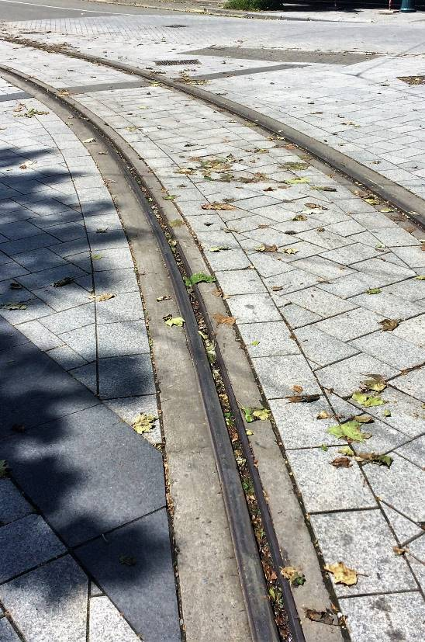

On Straights Sections  (Measured from outside rail edge)  Either side – 1300mm (min)  Measured from here  Consult Christchurch Tramway staff to confirm clearances prior to commencing any work. |  | 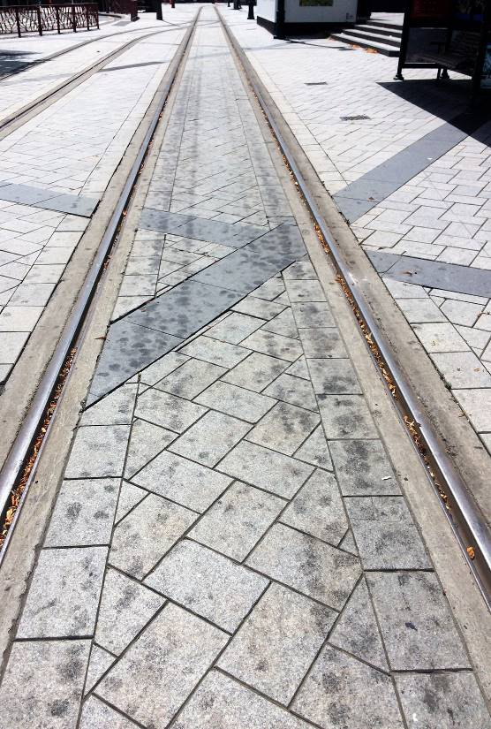
 | CHRISTCHURCH TRAMWAY LIMITED |  | Form 30

Phone: 03 366 7830 Email: workshop@tram.co.nz
Mark Small (Operations Manager): 021 846-106 Alex Hunter (Maintenance Engineer): 021 0220 5094

FORM 30 : APPLICATION TO WORK NEAR CONDUCTORS OF OVERHEAD ELECTRIC LINES

Permit Number:

Instructions to the machine operator
You must maintain a minimum distance of 4.0 metres under Section A or 1.0 metre under Section B, between any part of your machine or its load and any overhead electric line.

Note: 1 This approval is not transferable to any other operator.
2 This permit must be available for inspection on site at all times.
3 This permit applies only to the lines in the street or locality specified below.
4 This permit only to your machine while it is operated by you.

SECTION A – [4 metres minimum distance of overhead]

In compliance with Electricity Regulations 2010 - Regulation 17, you are hereby notified that the Voltage of the lines in the street or location specified below is 600 VOLTS DC and the minimum clearance to be observed is 4.0 Metres.

Name of Contractor:
Address of Contractor:
Mobile Number:
Email Address:
Full Name of Operator:
Details of work to be carried out:

Street or Location where work is to be carried out:
Date/s work to be carried out:

SECTION B – [Work between 4 metres to 1 metre minimum distance of overhead]

In compliance with Electricity Regulations 2010 - Regulation 17, you are hereby notified that the Voltage of the lines in the street or location specified below is 600 VOLTS DC and the minimum clearance to be observed is 1.0 Metre.

Special safeguards to be USED/observed (e.g. spotter):
Signature of CONTRACTOR/OPERATOR:

Signature of ISSUING OFFICER (CTL):
Designation:
Date of Issue: | Date of Expiry:

CHRISTCHURCH TRAMWAY LIMITED | Form 31

Phone: 03 366 7830 Email: workshop@tram.co.nz
Mark Small (Operations Manager): 021 846-106 Alex Hunter (Maintenance Engineer): 021 0220 5094

FORM 31 : OVERHEAD ELECTRIC LINE ISOLATION REQUEST

SECTION 1
Request Number:
Name of Contractor:
Address of Contractor:

Phone Number:
Email address:
Name & contact details of Site Foreman:

Street or Location where work is to be carried out:
Date & time isolation required
Date: | Time From:
Date: | Time To:

You may proceed with work when the overhead electric line has been isolated and earthed and then signed off by Christchurch Tramway Limited.

SECTION 2 – (CTL to COMPLETE)
THE OVERHEAD ELECTRIC LINE IS ISOLATED & EARTHED

Signature of Issuing Officer:
Date: | Time:
Christchurch Tramway Limited may reconnect supply to the overhead electric line when work has been completed and all staff on site are clear and have been advised the overhead electric lines are to be enlivened.

SECTION 3
WORK HAS BEEN COMPLETED & ALL STAFF ARE CLEAR & HAVE BEEN ADVISED ELECTRIC OVERHEAD LINE ARE TO BE ENLIVENED

Signature of Site Foreman:
Date: | Time:
(CTL TO COMPLETE)
Power EnliveneD (Issuing Officer):
Date: | Time:

CHRISTCHURCH TRAMWAY LIMITED | Form 32

Phone: 03 366 7830 Email: workshop@tram.co.nz
Mark Small (Operations Manager): 021 846-106 Alex Hunter (Maintenance Engineer): 021 0220 5094

FORM 32 : APPLICATION TO WORK NEAR TRAM TRACKS REQUEST

Permit Number: |  | VALID FOR A MAXIMUM OF 28 DAYS
Name of Contractor:
Address of Contractor or Contractor’s Agent:

Mobile Number:
Email Address:
Street /Location where work is to be carried out:

Detail of work to be carried out:

Date & time Works PLANNED TO Take Place
Date: | Time From:
Date: | Time To:

A copy of the Application Form, signed by both parties, must be submitted to the Christchurch City Council along with the Traffic Management Plan for Approval prior to any work commencing.

IF WORK TO BE CARRIED OUT IS CLOSER THAN 2.2 Metres FROM THE CENTRE OF THE TRACK THE FOLLOWING CONDITIONS WILL APPLY:

SIGNATURE FOR CONTRACTOR CARRYING OUT WORK:

PRINT NAME OF RESPONSIBLE PERSON ON SITE:

WORK TO BE CARRIED OUT IS APPROVED WITH THE ABOVE CONDITIONS

SIGNATURE -  CHRISTCHURCH TRAMWAYS LTD: | SIGNATURE -  CCC TRAMWAY ASSET MANAGER:
PRINT NAME: | PRINT NAME:
DATE: | DATE:

