**How to use the PC14 – Decision on Policy 3 map**

[Plan Change 14 – Decision on Policy 3 of the NPS-UD](https://experience.arcgis.com/experience/73d532447d90482c9691dc8ba8eda630/)

The map shows all of the decisions and alternative recommendations made on 18 September and 12 December 2024, including the few outside the Policy 3 areas.

Search for an address, then click on ‘Zoom to’:

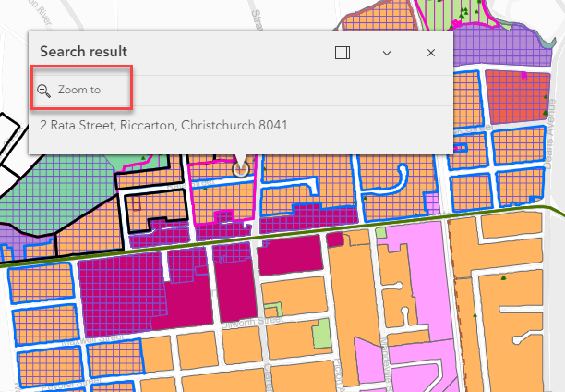

Click on the circle to open the property information, then click on the Legend:

Click on the 14 IHP Recommendation link to open the 14 IHP Recommendation page and see the zone:

**Alternative recommendations**

Alternative recommendations are visible on the wider map, and identified in the Legend:

In the property pop up window, scroll through to see any Alternative Recommendations relevant to the site, and click on a recommendation to view the details:

