Christchurch Wastewater Treatment Plant

Quarterly Monitoring Report

February 2019 - April 2019

Summary

This report summarises the results of parameters monitored by the Christchurch Wastewater Treatment Plant (CWTP) over the period February - April 2019 in accordance with consent CRC051724. Consent CRC051724 allows the discharge of treated wastewater from the CWTP Oxidation Ponds into the Pegasus Bay Coastal Marine Area via an ocean outfall.

Of the comprehensive sampling programme required by the consent, all samples were collected during the monitoring period and all monitored parameters achieved the required standards.

Christchurch Wastewater Treatment Plant Contents

Quarterly Monitoring Report

February - April 2019
1 Outfall Discharge 4
1.1 Resource Consent Conditions 4
1.2 Comments on Compliance 4
1.3 Resource Consent Standard Conditions 6
1.4 Comments on Compliance 6
1.5 Dissolved BOD₅ Compliance 7
1.6 Total Suspended Solids Compliance 8
1.7 Ammonia Nitrogen Compliance 9
1.8 Enterococci Monitoring 10
1.9 Faecal Coliform Compliance 11
2 Receiving Environment Monitoring in Pegasus Bay 12
2.1 Water Quality Resource Consent Conditions 12
2.2 Comments on Compliance 12
2.3 Beach Water Quality Analysis Results 13
2.4 Other Receiving Environment Analysis 15
2.5 Comments on Compliance 15

Outfall Discharge

Resource Consent Conditions
Consent CRC051724 allows CWTP to discharge up to 518,000 cubic metres per day of treated wastewater from the CWTP Oxidation Ponds at a maximum rate of six cubic metres per second into the Pegasus Bay coastal marine area. Compliance conditions regarding the physical discharge to the estuary are summarised in Table 1.1.1. Daily records of maximum outfall discharge flow rates and volumes are attached as an appendix to this report, and shown in summary in Figures 1.2.1 and 1.2.2.

Table 1.1.1 Pond Discharge Consent Compliance for Monitoring Period CRC051724
Consent Condition | Parameter | Compliance Condition | Compliance
 |  |  | Feb 19 | Mar 19 | Apr 19 | Overall
2 | Discharge Content | Discharge is only wastewater from the CWTP ponds | ☺ | ☺ | ☺ | ☺
3 | Discharge Volume | Recorded | ☺ | ☺ | ☺ | ☺
4 | Discharge Rate | Recorded | ☺ | ☺ | ☺ | ☺
9 | Outfall Maintenance | Routine maintenance completed and recorded | ☺ | ☺ | ☺ | ☺
10 | Outfall Condition | Visual inspection of outfall | n/a | n/a | n/a | n/a
12 | Pumping Pressure for a given flow | Monitored | ☺ | ☺ | ☺ | ☺
Key: ☺ Full Compliance 😐 Minor, Isolated or Risk of Non-Compliance ☹ Major or Consistent Non-Compliance

Comments on Compliance
Flowrate and pressure data were recorded as per consent requirements. All results are within the consent limits.

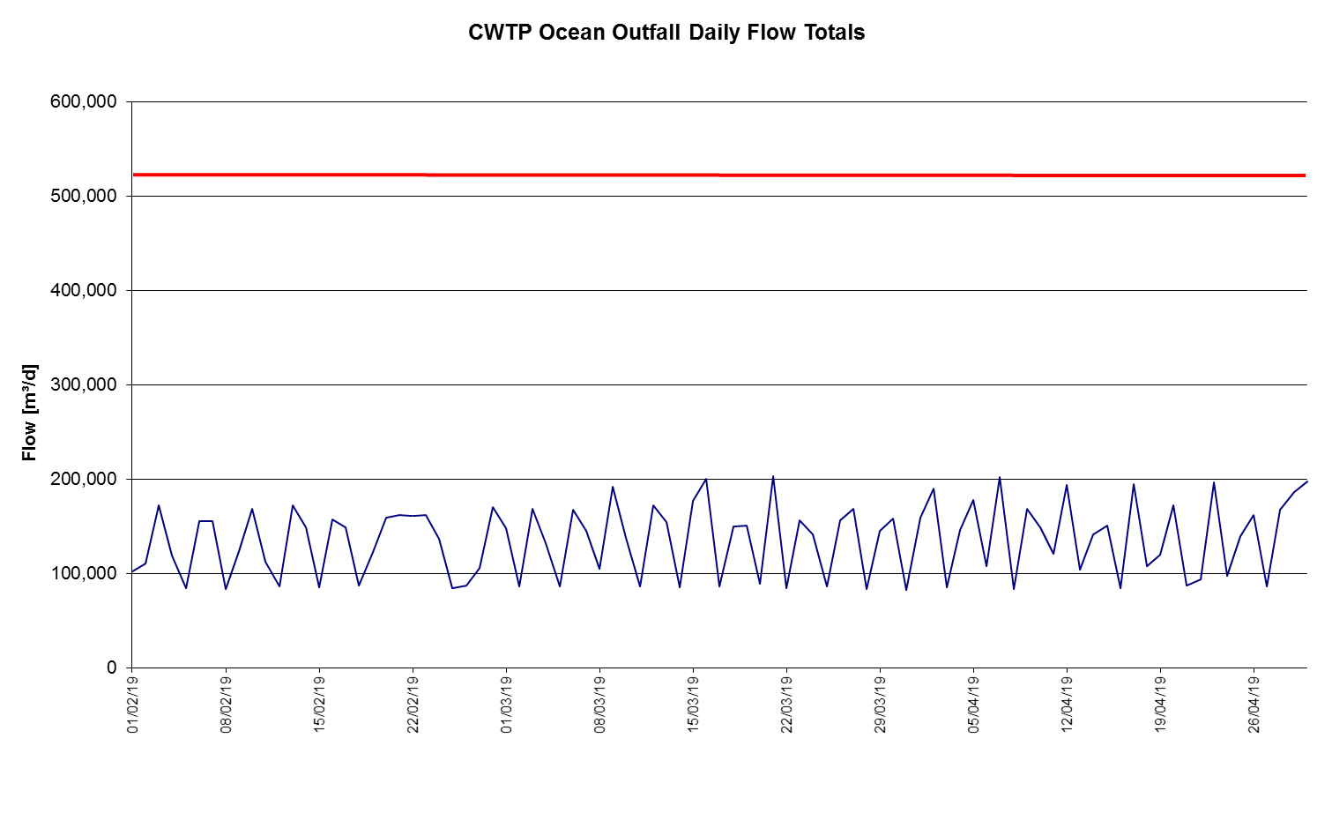
Figure 1.2.1 - Daily Outfall Flow Totals

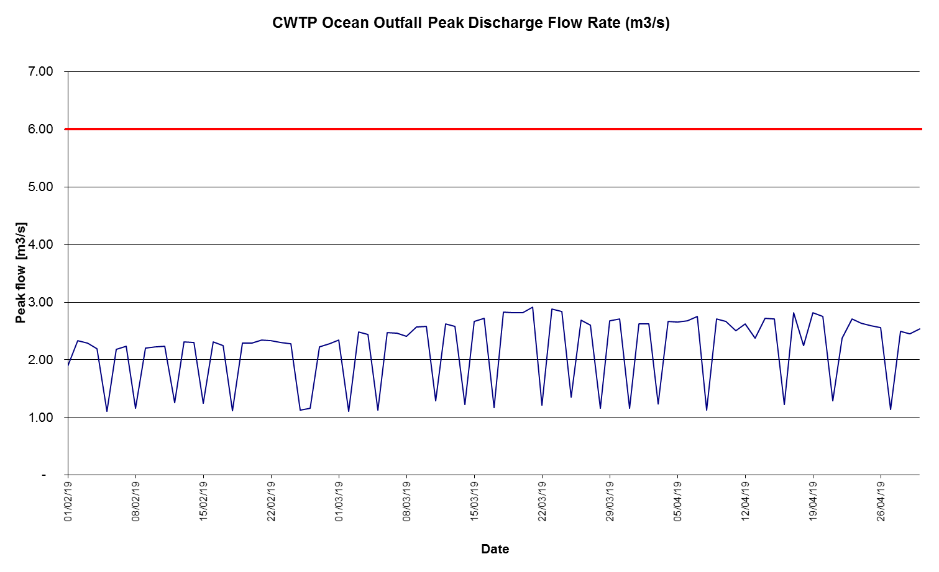
Figure 1.2.2 - Daily Peak Outfall Flows

Resource Consent Standard Conditions
Conditions 15 and 16 of consent CRC051724 set out concentration standards for a selection of parameters monitored in compliance with condition 13. No more than 16 samples in each rolling 26 week period should exceed the standard value for contaminants listed under condition 15a, and if more than seven from eight consecutive samples should exceed the standard value ECan must be notified within 48 hours. No more than six from eight consecutive samples should exceed the standard value for contaminants listed under condition 16a, and no more than two from eight consecutive samples should exceed the higher value. If more than seven from eight exceed the standard value, or three from eight exceed the higher value, ECan must be notified within 48 hours. Compliance conditions regarding adherence to these standard values are summarised in Table 1.3.1. Analysis results are supplied to Environment Canterbury at quarterly intervals. Contaminant monitoring results for consent CRC051724 are discussed further in Sections 1.4 – 1.9.

Table 1.3.1 Contaminant Limits Consent Compliance February 2019 - April 2019 CRC051724
Consent Condition | Parameter | Compliance Condition | Compliance
 |  |  | Feb 18 | Mar 18 | Apr 18 | Overall
15a | Dissolved BOD₅ | Concentration does not exceed 20 g/m³ | ☺ | ☺ | ☺ | ☺
 | Total Suspended Solids | Concentration does not exceed 50 g/m³ | 😐 | 😐 | 😐 | 😐
 | Ammoniacal Nitrogen | Concentration does not exceed 40 g/m³ | ☺ | ☺ | ☺ | ☺
16a | Faecal Coliforms | Concentration does not exceed 1,000(standard)/5,000(higher) MPN/100mL | 😐 | ☺ | ☺ | 😐
 | Enterococci | Concentration does not exceed 1,500 MPN/100mL | ☺ | ☺ | ☺ | ☺
ey: ☺ Compliance Achieved with no Exceedance of Standard 😐 Compliance Achieved with Occasional Exceedance of Standard ☹ Exceedance of Standard resulting in Non-Compliance

Comments on Compliance
All samples were collected and analysed. There were exceedances of standards for total suspended solids and faecal coliforms during this monitoring quarter, however compliance with the resource consent was still achieved.

Dissolved BOD₅ Compliance
The median dissolved BOD₅ concentration for the reporting period was 3.8g/m³. This is higher than the median concentrations in the previous quarter and higher than the same quarter last year. There were no exceedances of the standard value (20.0 g/m³) in the current monitoring quarter.
Table 1.5.1 Pond Discharge Dissolved BOD₅

Median Value [g/m³]  Current Monitoring Quarter  (February 2019 - April 2019) | 3.8 | Number of Exceedances  Current Monitoring Quarter  (February 2019 - April 2019) | 0
Median Value [g/m³]  Previous Monitoring Quarter  (November 2018 - January 2019) | 2.65 | Number of Exceedances  Previous Monitoring Quarter  (November 2018 - January 2019) | 0
Median Value [g/m³]  Same Monitoring Quarter of Previous Year  (February 2018 - April 2018) | 1.65 | Number of Exceedances  Same Monitoring Quarter of Previous Year  (February 2018 - April 2018) | 0

1.5.2 Pond Discharge Dissolved BOD₅

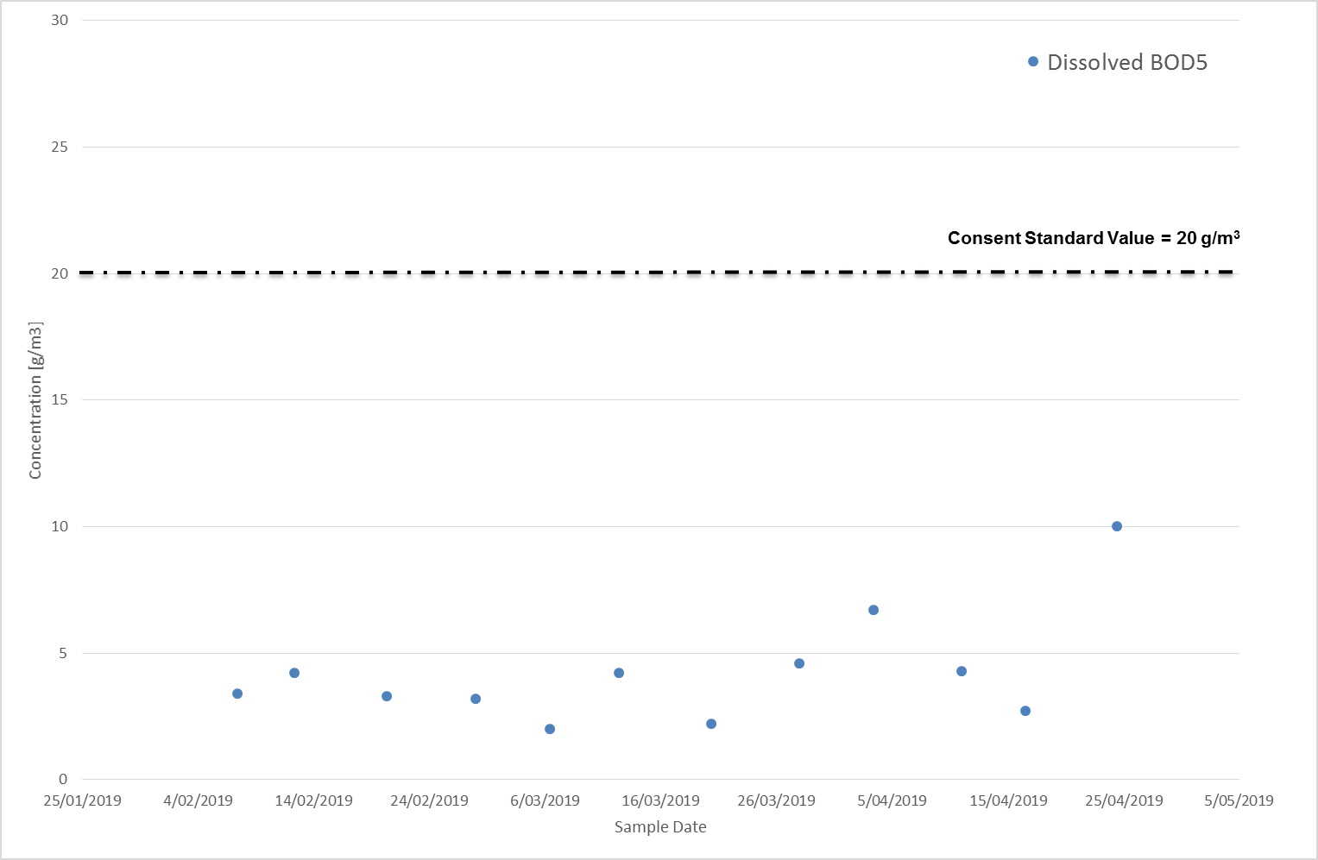

Total Suspended Solids Compliance
The median total suspended solids concentration for the monitoring period was 47 g/m³. This is higher than the previous quarter and higher than the same quarter last year. There were six exceedances of the standard value (50 g/m³) this quarter.

Table 1.6.1 Pond Discharge Total Suspended Solids

Median Value [g/m³]  Current Monitoring Quarter  (February 2019 - April 2019) | 47 | Number of Exceedances  Current Monitoring Quarter  (February 2019 - April 2019) | 6
Median Value [g/m³]  Previous Monitoring Quarter  (November 2018 - January 2019) | 26 | Number of Exceedances  Previous Monitoring Quarter  (November 2018 - January 2019) | 1
Median Value [g/m³]  Same Monitoring Quarter of Previous Year  (February 2018 - April 2018) | 17 | Number of Exceedances  Same Monitoring Quarter of Previous Year  (February 2018 - April 2018) | 0

1.6.2 Pond Discharge Total Suspended Solids

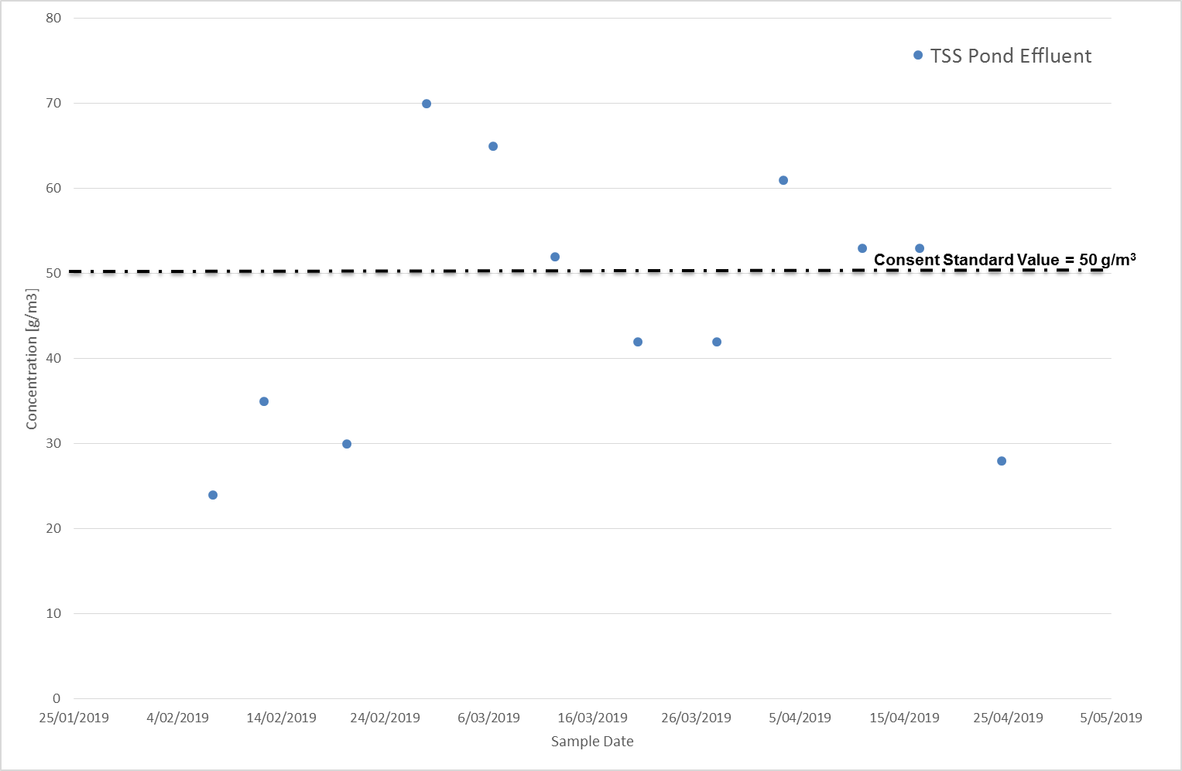

Ammonia Nitrogen Compliance
The median total ammonia nitrogen concentration for the monitoring period was 0.83 g/m³. This was less than the previous quarter and less than the same quarter last year. There were no exceedances of the 40 g/m³ limit.

Table 1.7.1 Pond Discharge Ammoniacal Nitrogen
Median Value [g/m³]  Current Monitoring Quarter  (February 2019 - April 2019) | 0.83 | Number of Exceedances  Current Monitoring Quarter  (February 2019 - April 2019) | 0
Median Value [g/m³]  Previous Monitoring Quarter  (November 2018 - January 2019) | 10.25 | Number of Exceedances  Previous Monitoring Quarter  (November 2018 - January 2019) | 0
Median Value [g/m³]  Same Monitoring Quarter of Previous Year  (February 2018 - April 2018) | 24 | Number of Exceedances  Same Monitoring Quarter of Previous Year  (February 2018 - April 2018) | 0

1.7.1 Pond Discharge Ammoniacal Nitrogen

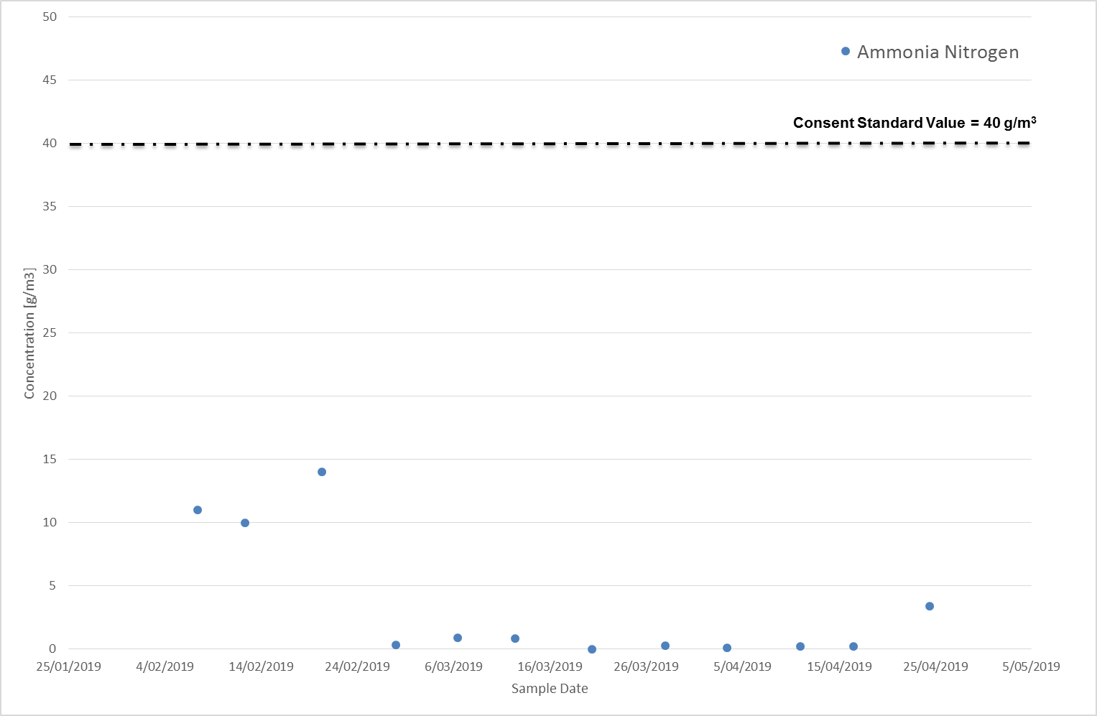

Enterococci Monitoring
The median enterococci concentration during the reporting period was 50.5 MPN/100mL. This was higher than previous quarter and lower than the same quarter last year. There were no exceedances of the 1,500 MPN/100ml limit during the reporting quarter.

Table 1.8.1 Pond Discharge Enterococci
Median Value [MPN/100mL]  Current Monitoring Quarter  (February 2019 - April 2019) | 50.5 | Number of Exceedances  Current Monitoring Quarter  (February 2019 - April 2019) | 0
Median Value [MPN/100mL]  Previous Monitoring Quarter  (November 2018 - January 2019) | 30 | Number of Exceedances  Previous Monitoring Quarter  (November 2018 - January 2019) | 0
Median Value [MPN/100mL]  Same Monitoring Quarter of Previous Year  (February 2018 - April 2018) | 73.5 | Number of Exceedances  Same Monitoring Quarter of Previous Year  (February 2018 - April 2018) | 0

1.8.1 Pond Discharge Enterococci

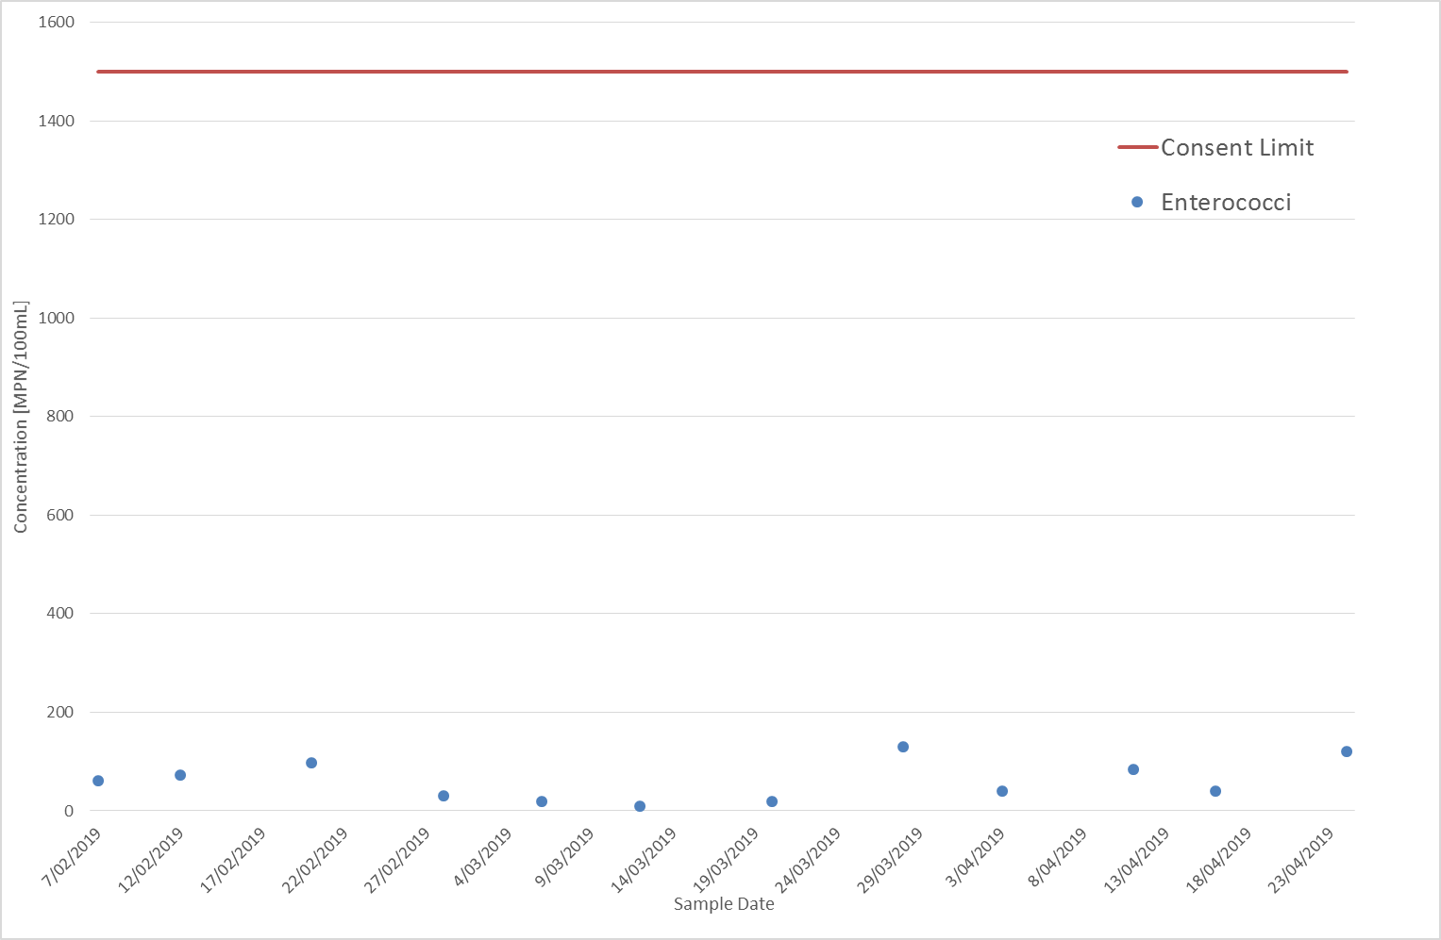

Faecal Coliform Compliance
The median concentration for the reporting period was 250 CFU/100 mL, which is higher than the median for the previous quarter, and lower than the same quarter last year. There was two exceedances of the standard faecal coliform limit.

Table 1.9.1 Pond Discharge Faecal Coliforms
Median Value [CFU/100 mL]  Current Monitoring Quarter  (February 2019 - April 2019) | 250 | Number of Exceedances  Current Monitoring Quarter  (February 2019 - April 2019) | 2
Median Value [CFU/100 mL]  Previous Monitoring Quarter  (November 2018 - January 2019) | 115 | Number of Exceedances  Previous Monitoring Quarter  (November 2018 - January 2019) | 0
Median Value [CFU/100 mL]  Same Monitoring Quarter of Previous Year  (February 2018 - April 2018) | 415 | Number of Exceedances  Same Monitoring Quarter of Previous Year  (February 2018 - April 2018) | 1

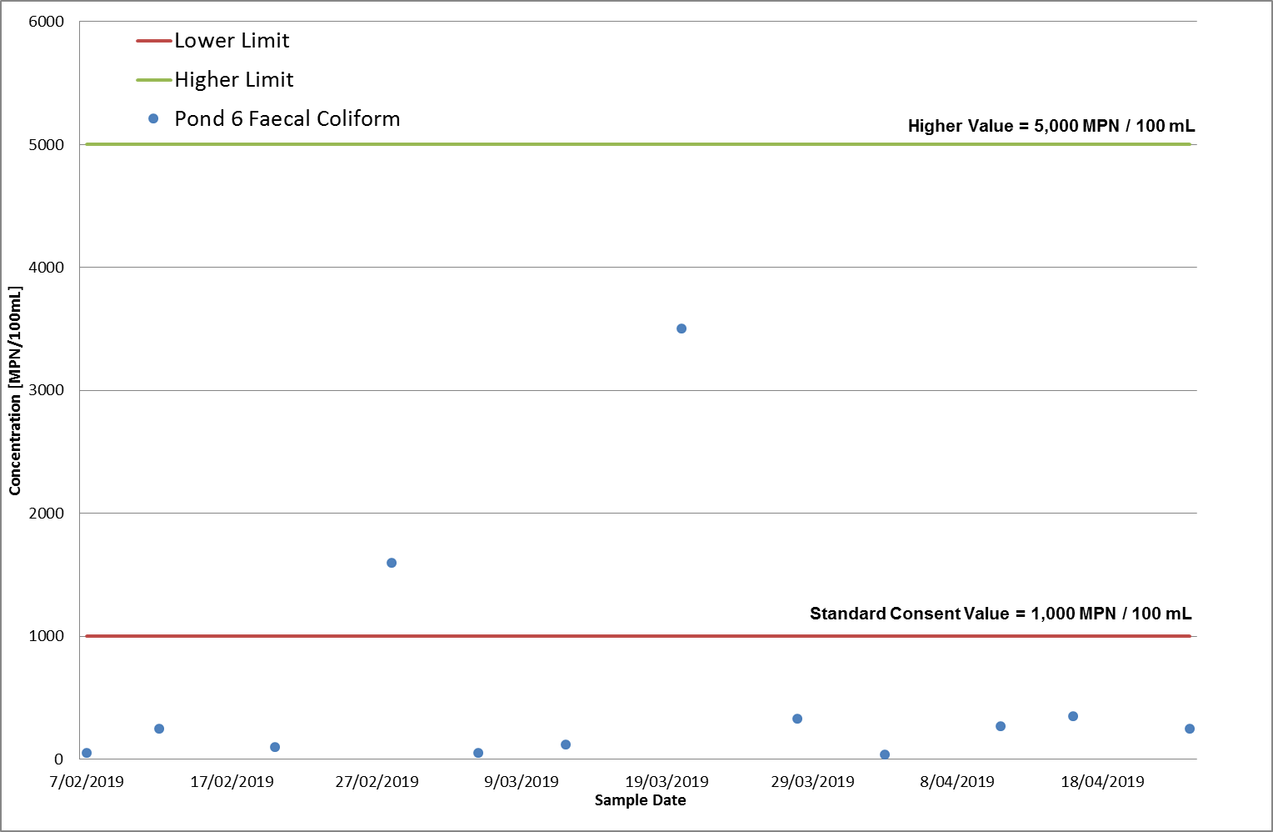1.9.1 Pond Discharge Faecal Coliforms

Receiving Environment Monitoring in Pegasus Bay

Water Quality Resource Consent Conditions
All samples were collected and analysed as required by consent condition 18. Samples for condition 18 are collected from South New Brighton Beach at Jellicoe Street, Sumner Beach at the surf club, and New Brighton at the Surf Club. Sampling for condition 21a was undertaken 19 February 2019.
Table 2.1.1 Receiving Environment Water Quality Consent Compliance
Consent Condition | Parameter | Compliance Condition | Compliance
 |  |  | Feb 19 – Apr 19
18 | Faecal Coliforms | Sampled and Analysed
 | Enterococci | Sampled and Analysed
21a | Temperature | 2 yearly
 | DO | 2 yearly
 | Salinity | 2 yearly
 | Total Suspended Solids | 2 yearly
 | Nitrogen Oxides | 2 yearly
 | Ammoniacal Nitrogen | 2 yearly
 | Dissolved Reactive Phosphorus | 2 yearly
 | Chlorophyll-a | 2 yearly
 | Trace Metals | 2 yearly
 | Faecal Coliforms | 2 yearly
 | Enterococci | 2 yearly
 | Phytoplankton Species | 2 yearly
Key: ☺ Full Compliance 😐 Minor, Isolated or Risk of Non-Compliance ☹ Major or Consistent Non-Compliance

Comments on Compliance
All results for the Pegasus Bay area were within consent for the recording period.
Beach Water Quality Analysis Results
Samples for condition 18 were taken at weekly intervals from the prescribed onshore locations. Results are presented in Figures 2.2.1 and 2.2.2.
2.2.1 Enterococci Levels at beaches adjacent to the Outfall
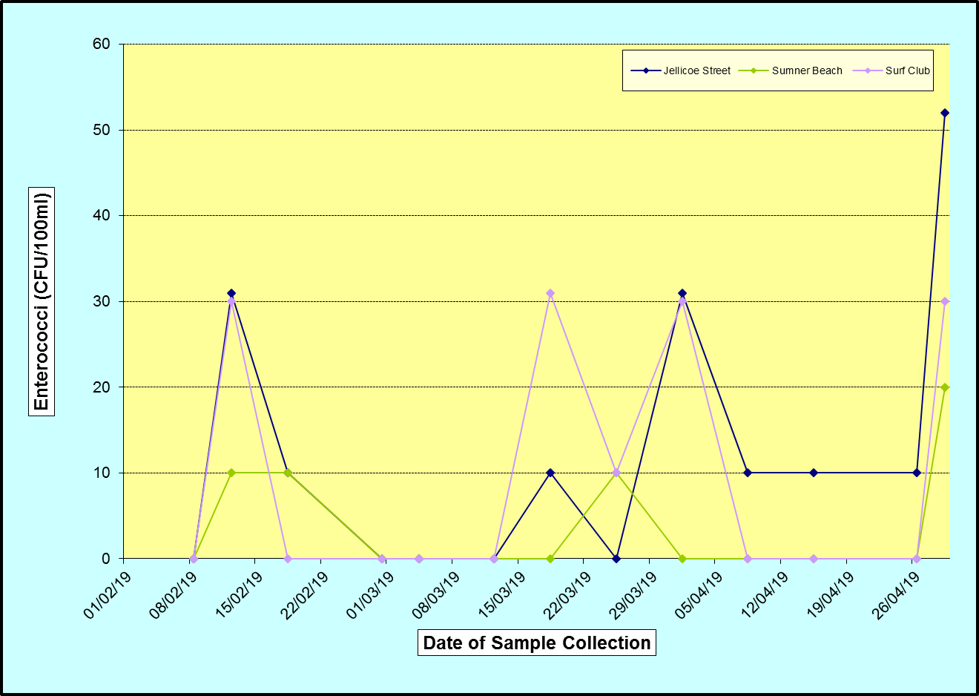
2.2.2 Faecal Coliform Levels at beaches adjacent to the Outfall
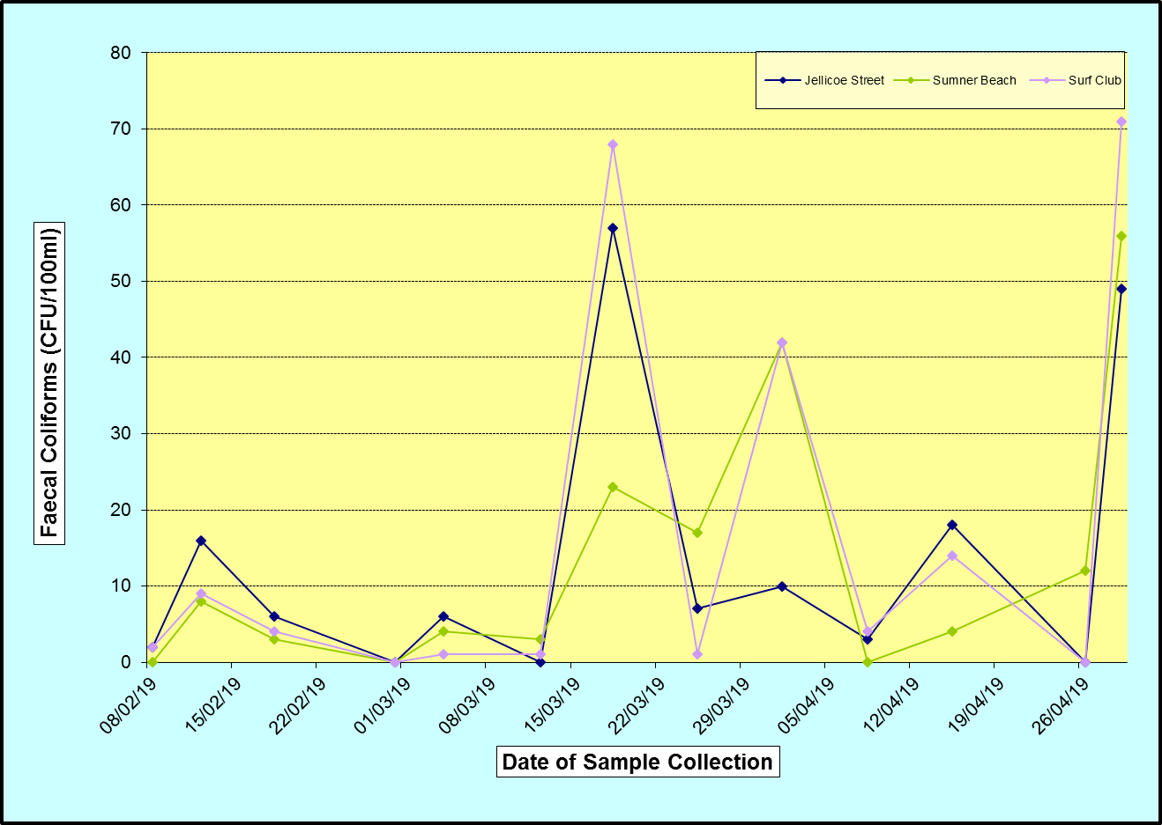

Other Receiving Environment Analysis
Consent conditions 23, 25, 26 and 27 call for monitoring of the marine environment around the outfall at various frequencies, some of which fall in the monitoring period. These requirements are summarised in Table 2.4.1, and the results are attached as an appendix to this report. Sampling for Conditions 23 – 26 are due 2017 but was delayed and completed in early 2018, while condition 36 is now only undertaken if requested by members of the community.
Table 2.3.1 Receiving Environment Monitoring Consent Compliance
Consent Condition | Parameter | Frequency | Compliance Condition | Compliance
 |  |  |  | Feb 19 – Apr 19
23 | Marine Sediments | 5-yearly | Not monitored this quarter | —
25 | Benthic Invertebrates | 5-yearly | Not monitored this quarter | —
26 | Epibenthic Fauna | 5-yearly | Not monitored this quarter | —
27 | Shellfish | Quarterly | Sampled and analysed | ☺
29 | Complaints | As required | Recorded and reported | ☺
31 | Report | Quarterly and Annually | Report and information lodged with ecan | ☺
36 | Community Liaison Group | Annually | Not done this quarter | —
Key: ☺ Full Compliance 😐 Minor, Isolated or Risk of Non-Compliance ☹ Major or Consistent Non-Compliance

Comments on Compliance
No complaints regarding the ocean outfall have been received this quarter. This report and supporting documentation will be submitted to Environment Canterbury.

