(Please note: These terms of reference are in draft form until they are adopted by Te Pātaka o Rākaihautū Banks Peninsula Community Board in August. They are unlikely to change.)
Akaroa Reclaimed Water and Reuse Scheme Community Reference Group – Terms of Reference

Objectives
The objectives of the Community Reference Group are:

To assist the project team to develop the preliminary design of the Akaroa Reclaimed Water and Reuse Scheme in a way that addresses community concerns where possible.

To suggest ways that the Akaroa Reclaimed Water and Reuse Scheme could be improved so that it can deliver multiple benefits for the community in the geographic areas considered.

Scope
The scope of the Community Reference Group is to meet the Objectives (1.1) for the following irrigation and water treatment sites:

The irrigation area at Robinsons Bay,

The irrigation area at Hammond Point

The irrigation area at Takamātua

The wetland area and land bounded by Old Coach Road and the Christchurch-Akaroa Highway

The discharge path and location for the wetland area

As the Council has already made a decision about where and how the reclaimed water will be reused, it is not in the scope of the group to consider alternative disposal locations.

Status
The group is an advisory body established by the group Sponsor who shall be the Head of Community Support, Governance and Partnerships at Christchurch City Council.
The group shall have the ability to make recommendations to Three Waters Capital Delivery Staff about matters relating to the above objectives and being matters within its scope.
Any amendments to the Terms of Reference for the Group are set by the Sponsor in Consultation with Council staff.
The Group is not a committee or subcommittee of the Community Board.

Background
The existing Akaroa Wastewater Treatment Plant discharging to Akaroa Harbour is to be replaced with a new treatment plant to be built on Old Coach Road near the intersection with Long Bay Road. Consents were granted for the treatment plant, a new terminal pump station in the Childrens Bay boat park and upgrades to the wastewater network.
In 2020, Council consulted on four options for the disposal/ reuse of treated wastewater that will be produced by the new treatment plant, after five years of options analysis. The Council decided on 10 December 2020 to use the highly treated wastewater to irrigate plantings of native trees in Robinsons Bay, Takamātua and Hammond Point (also known as the Inner Bays scheme). The scheme also includes a covered raw wastewater storage pond, a wetland and a reclaimed water storage pond on land opposite the proposed treatment plant on Old Coach Road. Reclaimed water storage is also proposed in Robinsons Bay, for times when it is too wet to irrigate. An overview of the project can be found in the consultation document and all the information relating to the hearings process including submissions can be found on the Have your Say page on the Council website.
The Council resolution is attached to these terms of reference and extensive background information about the project can be found on the project webpage.
Item 6 of the Council resolution about the Akaroa Reclaimed Water and Reuse Scheme was that the Council:
Requests Council Officers to work with the Community Board to establish a Community Reference Group including members from the local Rūnanga to ensure that community concerns about the approved Akaroa Reclaimed Water Treatment and Reuse Scheme are listened to and, where possible, addressed.
The community concerns are summarised in the Hearings Panel Report to the Council on the Akaroa Treated Wastewater Options. Please refer to Item 33 of the agenda of the Council meeting held on 10 December 2020, Attachment A, Council Officer’s Report to the Hearings Panel.

Code of Conduct
Members of the community reference group will be expected to adhere to the following code of conduct:
Treat all members of the community reference group and persons advising the group with respect
Work constructively with the project team to make suggestions that achieve the objectives
Read the background material provided to the group prior to attending the meetings
Arrive promptly at the meetings so that they can start and finish on time.

Meetings
Meetings are expected to be held approximately every four to six weeks. Meetings should be held in Akaroa.
Staff should be fully engaged with the group, providing advice to and taking feedback from the Group to Council.
The agenda and any reading material will be emailed to the group before each meeting with every endeavor made to provide information at least one week prior to the meeting.

Members of the Community Reference Group
The Community Reference Group shall be made up of members as listed below.
The Community Reference Group will be chaired by an independent facilitator. The Facilitator will attend all meetings and will be responsible for guiding the group in achieving the objectives, adhering to the code of conduct, ensuring that meetings are organised and run efficiently, and that all members have the opportunity to contribute equally.
The Facilitator and the Community Reference Group shall be accountable to the group Sponsor.
The Sponsor will dissolve the group at the time of consent lodgment for the irrigation schemes.
The Sponsor may dissolve the group prior to this if the group has achieved its objectives or if the Facilitator advises it will be unable to reach its objectives.
Name | Role
TBC | Two Banks Peninsula Community Board Members
TBC
TBC | Two Ōnuku Rūnanga nominees
TBC
TBC | Five Community Members
TBC
TBC
TBC
TBC

Community Reference Group Make Up
The Facilitator will be selected by Community Board members and Council staff.
Community Members will be selected by the nominated Community Board members and Council staff.
Ōnuku Rūnanga members will be nominated by the Rūnanga.
Group members will be formally appointed by the Community Board, following Council staff and the two nominated Community Board members assessing and reviewing all applications. The Community Board will be presented with all applications when considering the formal appointment of the group.
Should any members be unable to carry out their duties the Facilitator shall advise the Community Board and at the discretion of the Facilitator, a replacement member will be nominated for endorsement.
Community Members may not invite or appoint delegates if they are unable to attend meetings, and instead should communicate any relevant inputs to the Facilitator prior to the meeting.
If at any stage there are insufficient suitable candidates the group may continue to run with reduced membership.

Attachment A - Council Resolution – Meeting on 10 December 2020
The full Council resolution is as follows:
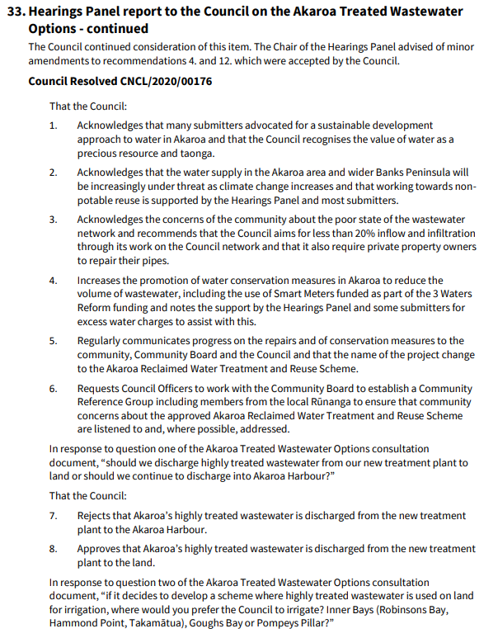
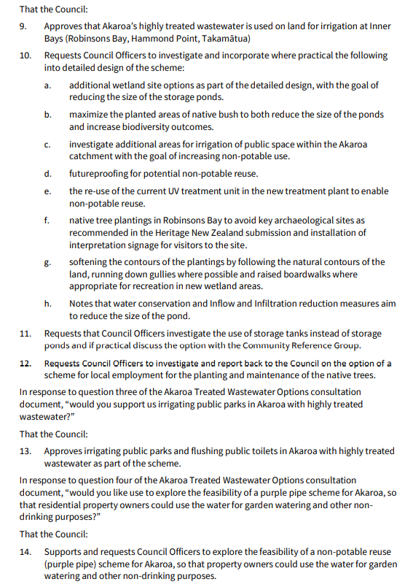
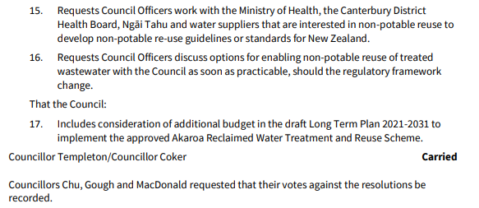

Akaroa treated wastewater options consultation document: https://ccc.govt.nz/assets/Documents/Consultation/2020/07-July/Akaroa-Wastewater/WEB-Akaroa-treated-wastewater-options.pdf
Consultation information on Akaroa treated wastewater options, including consultation document, submissions and hearing agenda: https://ccc.govt.nz/the-council/consultations-and-submissions/haveyoursay/show/316
Akaroa reclaimed water treatment and reuse scheme project webpage: https://ccc.govt.nz/services/water-and-drainage/wastewater/wastewater-projects/akaroa-wastewater-scheme
Council meeting agenda 10 December 2020: https://christchurch.infocouncil.biz/Open/2020/12/CNCL_20201210_AGN_4052_AT_WEB.htm
https://christchurch.infocouncil.biz/Open/2020/12/CNCL_20201210_MIN_4052_AT.PDF

