Draft Ōtautahi-Christchurch Community Strategy
Enabling active and connected communities to own their futures
Draft Strategy 2021

Consultation runs from 10 September – 25 October
ccc.govt.nz/haveyoursay

Acknowledgements
Council wishes to thank all contributors and stakeholders involved in the refresh of the Strengthening Communities Strategy. In particular, we’d like to thank the Strategy Working Group represented by the Christchurch City Mission, Age Concern, Community and Public Health, University of Canterbury, Canterbury Youth workers Collective, Social Equity and Wellbeing Network (SEWN) and relevant Council units including the Community Support, Governance and Partnerships Unit, Libraries, Parks Unit, Transport, Sport and Recreation Unit, Research and Monitoring and Urban Design teams.
Council would also like to thank and acknowledge residents, sector groups, staff and networks for their valuable contributions and insight that underpin this document.
Engagement feedback can be found in the Strengthening Communities Strategy Community Engagement Report https://ccc.govt.nz/assets/Documents/Consultation/2021/06-June/Strengthening-Communities-Strategy-Refresh-Community-Engagement-Report-.pdf

The evaluation of the Strengthening Communities Strategy 2007-2017 can also be found here:
https://ccc.govt.nz/the-council/consultations-and-submissions/haveyoursay/show/353

Accessible formats
This draft strategy and its accompanying consultation document are available in a reader-friendly Word version, which is an easier format for individuals who use software to help accessibility. This will assist our visually impaired and English as a second language communities.
The final version of the strategy will also be available in a Word version.
A summary of the final strategy will be available in Easy Read and translated into Te Reo, Farsi, Simplified Chinese, Korean, Nepali, Hindi, Samoan, Russian, Amharic, Tigrinya, Japanese, Dari and Tagalog here: ccc.org.nz/strategies
A New Zealand Sign Language video will be available here:
ccc.org.nz/strategies
A PDF downloadable version will be available here:
ccc.org.nz/strategies

Te Hononga: The primary relationship

Council and Mana whenua
Whiria ngā whenu o ngā papa, honoa ki te maurua tāukiuki
Bind together the strands of each mat and join together with the seams of respect and reciprocity
This whakataukī sums up our mutual commitment, with Ngāi Tahu Papatipu Rūnanga, to a governing partnership relationship based on understanding and respect. This partnership commits us to working together to improve social, economic, environmental and cultural wellbeing for all and aligns to our commitment to Te Tiriti o Waitangi as a framework for all.
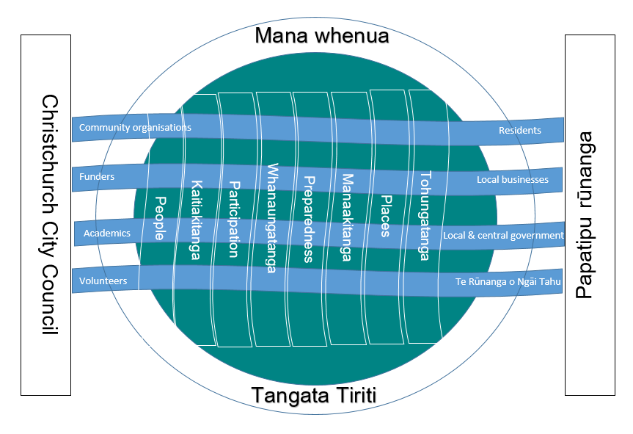
This design depicts the main components essential to strengthening communities.
The circle represents all communities with the outer circle representing the bi-cultural partnership that is Te Tiriti o Waitangi (Tangata Whenua or Tangata Tiriti). The heart of the circle is the community. Whether that community is physical, emotional, mental, spiritual or social, we are connected to others with similar interests, beliefs and understandings.
Each of the vertical strands represent the values many of us hold and are interwoven to strengthen our communities, our complexities and our similarities. Communities utilise these strands to connect to each other and to strengthen community.
The two pou (Christchurch City Council and Papatipu Rūnanga) represent the localised partnership underpinned by Te Hononga and Te Tiriti o Waitangi weaving the following core values that are fundamental to creating a strong, effective and nurturing environment.
Whanaungatanga – Fostering and maintaining important relationships within the organisation, within the iwi and within the community.
Manaakitanga – Showing respect, generosity and care for others.
Kaitiakitanga – Stewardship and guardianship of our environment as well as leadership, mentoring, guidance, nurturing, sharing, responsibilities, and external consultation.
Tohungatanga- The preservation and transmission of knowledge and expertise vital to sustain future generations.
Whakarapopoto Matua

Summary
Since the Strengthening Communities Strategy was first launched in 2007, Ōtautahi-Christchurch has faced significant challenges. These have tested even the strongest of us but have also have been the catalyst for creativity, innovation and collective action. This refreshed strategy builds on our long-term investment in strengthening communities and harnessing new opportunities – together.
Now entitled the Ōtautahi-Christchurch Community Strategy, it reflects our continued commitment to building, in partnership with others, inclusive, safe and resilient communities. It contributes to a range of other strategies, plans and partnerships, in particular the Greater Christchurch 2050 Partnership, a broader regional plan created to ensure the wellbeing of our people and the environment over the next 30 years.
In talking with a broad representation of the community throughout the review of the 2007 Strategy, this engagement highlights the importance people place on diversity, collaboration, being connected and building capability. People also value the physical infrastructure we provide – parks, libraries, recreation, transport innovations, aquatic centres, and community facilities – and they want to live in safe and accessible communities. We also have a key role in providing community grant funding to support voluntary and community initiated organisations respond to community needs and aspirations and to increase opportunities for people to volunteer their time and expertise.
We alone cannot address the many complex social issues that face our city, but we can bring resources and people together so that collectively we can achieve more. Particularly, we support communities to thrive through bonding, bridging and linking, alongside staff and elected members who have a deep understanding of the communities they serve.
The Strategy:
- Places our role with communities in the context of our responsibilities under the Local Government Act 2002 and our governing partnership with Ngāi Tahu Papatipu Rūnanga;
- Sets out a vision, principles and goals;
- Captures community feedback and identifies priority actions;
- Sets out a framework for implementation, monitoring and reporting over the next three to five years.

We have organised the strategy around four goals that set out our commitment to working alongside the community over the next 10 years.
Te Whenu Tua Tahi: Te Tāngata - Goal 1: People
The city actively promotes a culture of equity by valuing diversity and fostering inclusion across communities and generations.
Te Whenu Tua Rua: Te Whenua- Goal 2: Place
We support and help build connections between communities and their places and spaces to foster a sense of local identity, shared experience and stewardship.
Te Whenu Tua Toru: Te Mahi – Goal 3: Participation
Residents and groups in the wider community are socially and actively engaged and able to initiate and influence decisions affecting their lives.
Te Whenu Tua Whā: Te Takatū- Goal 4: Preparedness
People feel safe in their communities and neighbourhoods and work together to understand, adapt and thrive in the context of change and disruption.
Whakataki: Introduction and background
The people of Ōtautahi-Christchurch have experienced significant disruption over the past 10 years. As the city recovers from the effects of a devastating series of earthquakes, other events such as floods, fires and terror attacks and most recently a pandemic, have added to these stressors. Our communities have navigated house repairs, rebuilds, relocations, school closures, protracted insurance negotiations, employment and business insecurity, trauma, personal loss and uncertainty. Some of us continue to struggle with the effects of the last decade’s events.
These collective stressors have also been the catalyst for creativity, community leadership, innovation and collective action across the city and within local communities. We want to build on this and enhance the way we work together through a range of partnerships.
By working together with our communities, we can bring resources and people together so that collectively we can address the many complex social issues that face our city and achieve more. By empowering people, we enable them to take action and more responsibility for their communities. Empowerment also motivates and restores faith in the political process; believing we have a real stake in our futures.
In every community, everyone has something to contribute. It’s important that we develop and nurture networks that connect our assets and strengths and use them for the greater good. Council helps to make visible values, skills, knowledge within our communities to increase connectedness and build social capital.
When this social capital is activated, residents of all ages and abilities support each other, especially those in greatest need. This may be, keeping in touch with neighbours and increasing opportunities for people to volunteer time to any of the multitude of environmental, cultural, and recreational options available. This can also be anything from buying locally through to monetary donations, discretionary effort and community leadership. When communities connect, diverse strengths are shared, enhancing understanding and growing mutually beneficial exchanges.
As our city grows and changes, so do the needs of our diverse communities, including the most vulnerable amongst us. Our refreshed 2021 Ōtautahi-Christchurch Community Strategy reflects our ongoing commitment to working alongside the many organisations that help make our communities stronger, more resilient and better connected over the next 10 years and beyond. Its name change better reflects the role Council plays supporting communities to grow and thrive.

How are we doing?
While Ōtautahi-Christchurch is a relatively prosperous city, not everyone is thriving. We acknowledge that some people face barriers to participation and do not feel like valued community members. We know that this contributes to loneliness and isolation. When peoples voices are underrepresented in engagement and their contributions at a community level over-looked this can have high costs for both individuals and families as well as the wider community.
A new way of working is required
As our population continues to grow and diversify, so too does our infrastructure. Strong, dynamic community engagement is required to ensure we create a safe and welcoming city for everybody. The strength and success of our communities depend on the extent to which people are able to participate and contribute and the extent in which they feel they have agency over the things that are important to them.
A range of latest resident surveys highlight some worrying trends. We have identified some key themes that we will to give priority to over the next 5 years to achieve real and sustainable change.
ACCESS AND EQUITY | PUBLIC SAFETY | ACTIVE CITIZENSHIP | RESILIENCE
Individuals and families living in poverty struggle financially but also forego basic necessities in order to make ends meet. This can exclude people from accessing civic life and local amenities.  Poverty is not evenly distributed across Christchurch with those areas most affected having negative effects on people’s health and wellbeing at the neighbourhood and community level. | For Christchurch people to thrive, it is essential that our neighbourhoods are safe and accessible, and that residents have the opportunity to access public and community services.  A thriving, vibrant central city is critical to Christchurch’s growth but perceptions about anti-social behaviour and safety impact this. | There is a perception that community engagement does affect the final decision made by Council and residents do not feel they have the ability to influence decision-making.  Our under-represented communities do not have a strong relationship with Council, if any.  Volunteering trends indicate an overall drop as well as a reversal from older age groups to youth participants. | Communities are best placed to identify and respond in the most appropriate way to their needs. Our partnerships with NGOs support grass roots developments working in communities.  This includes developing skills, exploration of community aspirations, supporting collective action on common goals and increasing cooperation and collaboration with Council.
17% of NZ households with children are below this poverty line. (Otago University child poverty monitor 2019)  1 in 4 Pasifika children and 1 in 5 Māori children meet the criteria for material hardship. (Stats NZ 2021)  Disabled people reported having less access to emotional and instrumental support from others, and lower levels of trust in other people and in public institutions. (Census 2018) | People are feeling less safe walking alone in their neighbourhoods after dark than in recent years. In 2020, 61% of Christchurch respondents felt safe, compared with 71% in 2010. This is also lower than the national average (65% in 2020). (Quality of Life Survey) People most likely to feel unsafe are people with a disability, non-heterosexual, Māori, people on incomes lower than $30,000 or those over 65.  The central city is unsurprisingly deemed safer during the day than after dark. In 2020, 5% of Christchurch respondents felt unsafe in the city centre during the day, compared with 46% after dark. (Quality of Life Survey)  Volunteering, at least once a month or more, in the local neighbourhood is 25%, compared to 36% in the wider community. (Life in Christchurch) | Confidence in Council decision-making has fallen over time. In 2020, around 30% of Christchurch respondents had confidence that Council makes decisions in the best interest of the city, down from 53% in 2010. This decrease has also occurred nationally and the 2020 proportion equalled the national average. (Quality of Life Survey, 2020).  24% feel they have no influence on public decision-making and 36% understand how Council decisions are made. (Residents Survey 2020-2021) | Since 2018, residents have become less prepared in case of a natural disaster. Younger people are less prepared than the rest of the population. Between 2018 and 2021, the proportion of residents who had enough water stored for 3 days declined from 70% to 62% (combination of discontinued residents survey question, and Life in Christchurch, 2020)  The proportion of residents who had enough food stored for 3 days declined from 87% to 84% between 2018 and 2021. (combination of discontinued residents survey question, and Life in Christchurch, 2020)  46% of respondents are worried or very worried about the impact of climate change on the city’s future (Quality of Life Survey, 2020).
We will work to better understand what excludes people from fully participating in their communities and across Council services. We will improve the capture of consistent and relevant data, set clear targets and partner with communities and others to ensure more equitable and inclusive opportunities for all. | We will increase positive perceptions of the central city after dark, encourage community led activities that increase volunteering in local neighbourhoods, supporting the activation of public spaces and places to increase inclusion and a sense of belonging. | We will ensure that the community’s priorities, values, aspirations and concerns are incorporated at all levels of the organisation through policy development, planning, decision-making, service delivery and review. By reframing our engagement practices we will increase trust and satisfaction that people and communities can authentically shape and influence their futures. | Communities will be supported and enabled to respond to the impacts of climate change and emergencies with a particular emphasis on underrepresented or vulnerable communities

Our role
Under the Local Government Act 2002, all councils must have a strategic framework. Ours was updated in 2020 and is led by the vision that Ōtautahi-Christchurch is a city of opportunity for all… open to new ideas, new people and new ways of doing things – a city where anything is possible.
The Ōtautahi-Christchurch Community Strategy is central to achieving our overall strategic priorities, with an emphasis on enabling active and connected communities to own their future. The Strategy works to achieve the community outcome of Resilient Communities specifically:
- A strong sense of community
- Active participation in civic life
- Safe and healthy communities
- Celebration of our identity through arts, culture, heritage, sports and recreation
- Valuing the voices of all (including children)
Staff and elected members work with and have a deep understanding of the communities they serve. Their roles are:
- Bonding - Enabling a sense of community within groups and neighbourhoods with shared interests and goals
- Bridging- Building strong and productive relationships across organisations, Māori, iwi and other key stakeholders, supporting from behind or leading where appropriate
- Linking - Supporting others to access knowledge, resources, influence and opportunity
- Capacity building – Providing, advice, organisational support, and curating outcomes and learnings.
A partnership approach is required to fully achieve this and we commit to working alongside:
- Iwi Partners
Within the Christchurch City Council Territorial Authority area is the Tribal Authority of the six Papatipu Rūnanga that make up Ngāi Tahu in Ōtautahi – Christchurch and Te Pātaka o Rākaihautu – Banks Peninsular.
We commit to strengthening our relationships with other tangata whenua and iwi entities, including Ngā Mātā Waka, Taura Here groups and our urban marae, Ngā Hau e Whā Multicultural National Marae and Te Whatu Manawa Māoritanga o Rehua Marae.
- The Third Sector
Community groups and non-governmental organisations (NGOs) are at the heart of this Strategy. They are the primary means by which people come together to work for the good of communities. Of the than 114,000 such organisations across New Zealand, 27,000 are registered charities and 10 percent of these have no paid workers. These formal and informal organisations make a significant contribution to the wellbeing of our city and economy. Our collaborations with publicly funded health, recreation and social services encourages stronger communities.
- Voluntary sector
Spending time providing services and support to others without financial reward is an example of social connectivity and a way in which people build and maintain social networks. Including the value of unpaid work (calculated at $22.10 per hour), the sector makes a direct contribution, estimated to be $9.51 billion per annum, around 6 percent of the country’s Gross Domestic Product.
- The public sector (local and central government)
Central government agencies, including academic institutions, play an integral part in building strong communities, often as strategic partners, researchers, and funders, and by translating community needs into policy and services. Local government provides facilities, libraries, parks, transport links and options, recreation centres, events and opportunities for communities to connect and activate places and spaces. Local government also plays a lead role in driving social change through sustainable procurement policies.
- Funders, philanthropic organisations, foundations and personal giving
Grant funders provide resources to charitable groups and other third sector organisations who provide programmes and activities to effect change in their own communities. Philanthropic organisations, foundations and personal giving also contribute to the economy. This includes commercial entities that provide pro-bono work or sponsorship. Along with other funders, we are exploring how we can move from an old transactional funding model to a more high-trust, transformational approach, where groups are partners rather than passive recipients of the charitable dollar.
- Community Boards
Community governance refers to a collaborative approach to decision-making which recognises the needs to work in partnership and the value that each partner brings to the process and outcomes. This approach is based on the clear devolution of decision-making to be dealt with at the most local level (the principle of subsidiarity). A key way of shifting some governance responsibility closer to the community is through our community boards. Each board acts as an advocate for the interests of its community. Council staff support community boards to better understand the needs of community and to establish robust, trusted relationships and collaborations.

The Strategy

Te Whakakitenga: Vision
Te Haumako; Te Whitingia - to enrich: to shine
Ngā Mātāpono - principles and values
- Te Tiriti o Waitangi is New Zealand’s founding document
- Our work considers future generations
- We do not act alone – we always look for a partnership approach
- Our relationships are collaborative, trusted and enduring
- We commit to inclusive practices across the whole of Council
- We advocate for and support responses to social injustice and inequities
- People’s time, knowledge and skills are valued
Our work will be
- Effective and accurate
- Guided by the needs and aspirations of people in the wider community
- Future focused and ready us for change and disruption
- Strengths-based: identifying and valuing the assets within our community
- Agile and supportive of creativity, innovation and responses
- Supportive of co-design and co-governance principles

Ngā Whenu: Pillars
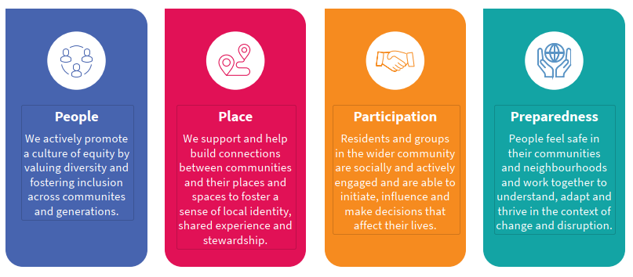

Te Rautaki: Strategy Alignment
This strategy is not a stand-alone document. It aligns with Greater Christchurch 2050 in its desire to improve intergenerational wellbeing through the decisions and actions we take today. The strategy anchors a wide range of other cross cutting themes. We remain committed to these related strategies, plans, and partnership agreements across Council, Government and the wider community.
Council Strategic Framework 2020
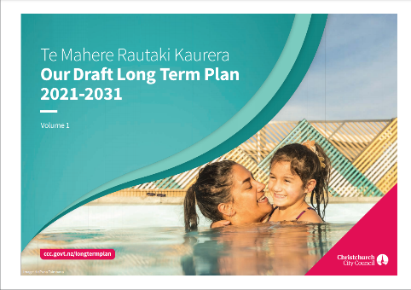
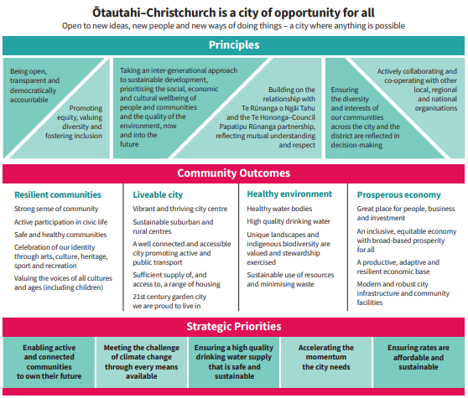
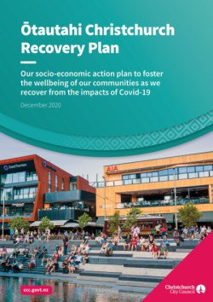

Council Long Term Plan Ōtautahi-Christchurch Recovery Plan

Greater Christchurch 2050 (incorporating Resilient Greater Christchurch)
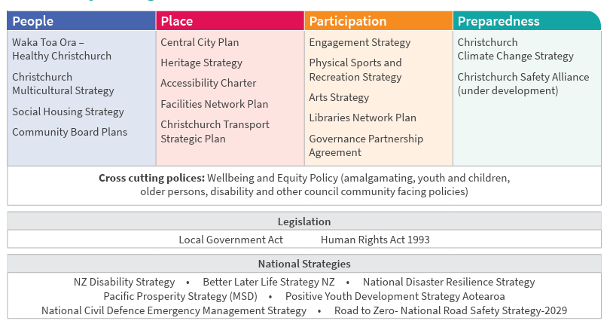
Related key strategies

Te Whenu Tuatahi: Te Tāngata

Pillar 1: PEOPLE
We actively promote a culture of equity by valuing diversity and fostering inclusion across communities and generations.
“Address structural exclusion - understand how and why it happens and respond.” Elected member
What you told us
- Prioritise accessibility in all aspects of the community
- Pacific communities want to build a better relationship with us
- Support inclusive and welcoming activities and opportunities for lifelong learning
- Communicate in a way community wish to be communicated with
- People need to see themselves reflected in the city
- Value the contributions of older people
- Community groups want us have deeper relationships with them
We are committed to delivering better services and improving outcomes for everyone. We want to understand and work alongside the community to ensure these services and support systems are accessible and appropriate irrespective of income, age, gender, ability, ethnicity, religion or location.
We recognise the wide range of capacity and capability among communities both geographical in nature and those of interest or identity. We anticipate and respond flexibly to diverse needs, support those who are in greatest need and acknowledge that one size does not fit all - people will guide us in what is most important to them.
Practices that exclude and discriminate contribute to isolation and reduced trust. Where communities are able to respond to injustice and contribute to policies, plans and delivery, the result is a more effective use of resources and improved equity.
We will
Develop and enhance relationships with tangata whenua via mana whenua and Te Hononga
Build, nurture and strengthen relationships with Pacific communities
Continue to build on the relationships and achievements developed through the Multicultural Strategy - Our Future Together
Harness the strengths of diverse communities and address issues of social exclusion including the digital divide
Support groups involved in providing access to arts, culture, heritage, recreation, and those who care for the environment
Facilitate and promote lifelong learning opportunities for all

Te Whenu Tuarua: Te Whenua

Pillar 2: PLACE
We support and help build connections between communities and their places and spaces to foster a sense of local identity, shared experience and stewardship.
“Place is about geography - but also about memory and imagination. People make places even as places change people. Places are secured by individual and collective struggle and spirit. Place is where culture is made, where traditions and histories are kept and lost, where identities are created, tested and reshaped over time” The Power of Place National Museum of African American History and Culture

t can be inferred that sense of place is what
people feel matters most regarding the place to which they belon
t can be inferred that sense of place is what
people feel matters most regarding the place to which they belon
t can be inferred that sense of place is what
people feel matters most regarding the place to which they belon
It can be inferred that sense of place is what
people feel matters most regarding the place to which they belong
What you told us
- You want welcoming, inclusive spaces that are affordable, safe and accessible
- Local and city-wide events are highly valued
- You want more opportunities for intergenerational activities
- Public amenities need to be of a design that encourage more connection
- Community input into the design process is critical
- We care for our environment
People intentionally create social interactions and bonds through common interest, aspiration and passion. It is these networks of relationships and goodwill among people that create sense of community and feeling of connection. It is through sharing public spaces and places, that these bonds are strengthened.
We provide a wide range of public spaces, including libraries, parks, reserves, playgrounds, aquatic centres, heritage, environmental trails, coastal areas, recreation and sports facilities. We support activities and initiatives that create meaningful, life-enhancing connections
people feel matters most regarding the place to which they belon

We will
Encourage communities to create and sustain a sense of local identity and ownership
Work with new and emerging communities in both rural and urban areas to build a sense of belonging
Support the community activation and kaitiakitanga of public places and spaces

Te Whenu Tuatoru: Te Mahi

Pillar 3: PARTICIPATION
Residents and groups in the wider community are socially and actively engaged and are able to initiate, influence and make decisions that affect their lives.
“It’s time to explore a new model of governance, one based on a re-energised civil society that draws on the strength and resourcefulness of people working together in diverse local and regional communities – a localist response.” Future of local government declaration (2017)
What you told us
- You feel at times that decisions are often predetermined making you question the authenticity of community engagement
- A lack of personal resources or confidence hinder the ability to engage at times
- Working with community takes time - relationships and trust are critical
- There is a lack of awareness about opportunities to engage – we need to tailor engagements better
- Bring new people into discussions, not just the same people
- Young people, including children, have valuable contributions to make
Democracy requires active citizenship to create governance “of the people, by the people, for the people.” Local governments have a responsibility to engage community members in a robust and equitable manner in order to effectively carryout their key functions. Working towards a co-design approach to actively involve communities in decision-making.
Where communities have well developed skills and influence, they are more able to achieve the changes they want to see that will help improve their quality of life. Such communities are organised, able to maintain membership and participation and empowered to take collective action on the things that matter to them and have the capacity to plan for, implement and sustain change.
Volunteering helps build a more cohesive, safer, stronger community, increasing the social network between communities and neighbourhoods.
We will
Empower and equip residents and groups to participate in decisions affecting their communities and neighbourhoods
Increase general understanding of the decision-making process and how people can have their say.
Provide well-informed support and advice to elected members for effective decision making
Increase volunteering opportunities across the Council and the wider community

Te Whenu Tuawhā: Te Takatū

Pillar 4: PREPAREDNESS
People feel safe in their communities and neighbourhoods and work together to understand, adapt and thrive in the context of change and disruption.
“The world doesn’t change one person at a time. It changes as networks of relationships form among people who discover they share a common cause and vision of what’s possible. Community is the answer. Community is the unit of change. The only way we get through difficult times is together.” Meg Wheatley
What you told us
- Use research and datasets intentionally to identify and prioritise work
- Use appropriate information channels (formal and informal)
- Continue to support the community and voluntary sector - grant funding is important
- Nurture community leadership
- Communicate change and risks in a timely fashion and reach deeper into local populations
As we prepare for and adapt to the effects of climate change, community capacity building has clear benefits. Communities have unique insight into the issues that affect them, so their contributions in planning and facilitating responses, recovery, or adaptation are critical.
The preservation of local and city networks, and the consistent contributions of core community group members over long periods, maintains readiness and agility to meet both predicted and unexpected change. Equally important is how we support and enable emerging leadership and new ideas. This is climate resilience.
We will
Work with communities to prepare for and respond to emergencies, and also increase climate resilience and adaptation action
Support the capacity of the community and voluntary sectors to plan, adapt and respond to risk, disruption and change
Support neighbourhood and city-wide initiatives aimed at increasing a sense of safety and wellbeing

Ngā Āpititanga

Glossary
Co-design - early input from stakeholders in a design process. People become partners in the process and the delivery.
Co-Governance/Localism - Doing everything at the lowest possible community level and involving government only if absolutely necessary. (This is also known as subsidiarity and decentralisation).
Community Led Planning (CLP) - a step-by-step process that enables every citizen to participate in and contribute to improving the social, economic, environmental and cultural well-being of their local area. It relies on people coming together locally, to research local needs and priorities and to agree on a range of actions that will help to improve their neighbourhood.
Community resilience - The sustained ability of a community to use available resources to respond to, withstand, and recover from adverse situations.
Equity - Ensuring people have what they need, making things fairer so they can reach their full potential.
Resilience - Adapting well in the face of diversity, trauma, tragedy, threats, or significant sources of stress.
Social capital - defined as “features of social organisation such as networks, norms, and social trust that facilitate coordination and cooperation for mutual benefit” Putman. There are three types of social capital - bridging capital, bonding capital and linking capital
Social cohesion is achieved by building social capital, increasing mobility and reducing exclusion.
Social exclusion where people are unable to participate fully in social, cultural economic and political life and where society can exclude people for a range of reasons.
Tangata Tiriti- ‘people of the treaty’ refers to all non-Maori citizens of New Zealand.
Te Whenu – Goal, objective.

Te Haumako Te Whitingia
Everybody’s Christchurch
Implementation Plan 2021-2026

WHAKATINANATANGA

Implementation
Here we outline our priorities for the next three to five years. While not a comprehensive list of what we do, it highlights activities that will significantly contribute towards achieving our goals and objectives.
Delivering this strategy is a Council-wide endeavour. The strategy aims to influence the community outcomes, and will often involve working through complex relationships and interdependencies. We don’t act alone, and rely on partnerships and collaboration with key stakeholders and communities across the organisation and city.

Monitoring and reporting
We will measure our performance annually against the objectives of the strategy, using a mix of quantitative metrics and narrative case studies to illustrate outcomes.
We will establish a cross-Council implementation team that will:
- Report to relevant committees and working groups to show how our goals and objectives are achieved at operational levels as and when required
- Present community board reports to Council bi-monthly, highlighting local progress
- Produce community newsletters to share activities and highlight success
- Track survey data directly relevant to the strategy objectives
- Monitor agreed actions in our joint Health in All Policies work plan with Community and Public Health and Environment Canterbury
- Encourage community reporting and feedback and sharing of best practice
- Produce an annual implementation plan and community grant funding report
- Update the implementation plan in 2026

Te Whenu Tuatahi: Te Tāngata

Pillar 1: PEOPLE
We actively promote a culture of equity by valuing diversity and fostering inclusion across communities and generations.
OBJECTIVE 1.1: Develop and enhance relationships with tangata whenua via mana whenua and Te Hononga
Mahinga | Actions | Examples
Promote learning and reference to Te Ao Māori in our work across Council and with communities. | Festivals and events align with Māori dates of significance.  Signage and reports use te reo Māori in a respectful and appropriate way.  Māori values are reflected in all aspects of our key strategies, policies and plans
Actively contribute to supporting strong and resilient Māoritanga within communities; fostering and maintaining relationships with Māori community providers and networks. | - Increased cultural understanding of staff across the organisation  - A range of events, resources and services to support knowledge and understanding of Te Ao Māori  - Recognise Māori cultural celebrations, such as Matariki, in Council’s programme of events  - Maori Non-Governmental Organisations (NGOs) supported through Strengthening Communities Funding
OBJECTIVE 1.2: Build, nurture and strengthen relationships with Pacific communities
Mahinga | Actions | Examples
Provide culturally appropriate channels for Pacific communities to have a voice and to share their culture. | - Increased cultural understanding of staff across the organisation  - The specific characteristics, needs and diversity of each island group are reflected in engagement and influence decision making and service design and delivery  - Support community leadership and organisational capacity
Actively contribute to building strong and resilient Pacific communities, fostering and maintaining relationships with Pacific groups and networks | - Groups are supported through Strengthening Communities Funding  - Increased contact between Council and Pacific community groups and networks.
OBJECTIVE 1.3: Continue to build on the relationships and achievements developed through the Multicultural Strategy - Our Future Together
Mahinga | Actions | Examples
Work with culturally and linguistically diverse (CALD) communities and sector networks to build capability and to promote and celebrate diversity. | - Multicultural Advisory Group advice provided to Council influences decision making and service delivery  - Community leadership and organisational capacity support are provided  - INFORM network is facilitated  - Events and activities are funded and or supported  - Annual Diversity and Inclusion report is published  - Staff support and advice is provided to Council’s Multicultural Committee
OBJECTIVE 1.4: Harness the strengths of diverse communities and address issues of social exclusion
Mahinga | Actions | Examples
Continue to enhance the capacity and aspirations of the youth, disability, older adults, rainbow, and other communities of interest or identity | - Youth related initiatives are funded and/or supported  - Activities and events for older adults are funded and /or supported.  - The principles of the Accessibility Charter are upheld  - DAG- Disability Advisory Group advice to Council impacts decision making.
OBJECTIVE 1.5: Support groups involved in providing access to arts, culture, heritage, recreation, and those who care for the environment
Mahinga | Actions | Examples
Grant funding enables the delivery of a broad range of opportunities at community board and metropolitan levels. | - Annual funding report  - Number of events, activities  - Number of volunteer hours  - Number of people who participated
Provide accessible information on the opportunities available locally and citywide, through appropriate channels. | - Community Newsletters  - Community networks and forums  - Translated information where appropriate  - Sector networks are supported
OBJECTIVE 1.6: Facilitate and promote lifelong learning opportunities for all.
Mahinga | Actions | Examples
Encourage active participation and connection to non-formal community-based learning opportunities | - Activities funded or supported that enhance personal growth, health and well-being, active citizenship,  - Support for people to upskill i.e. technological competencies and innovation for older adults  - Engagement with Council’s library programmes  - Intergenerational learning opportunities are supported

Te Whenu Tuarua: Te Whenua

Pillar 2: PLACE
We support and help build connections between communities and their places and spaces to foster a sense of local identity, shared experience and stewardship.
OBJECTIVE 2.1: Encourage communities to create and sustain a sense of local identity and ownership
Mahinga | Actions | Examples
Enable and support community-led placemaking initiatives. | - Effective activation of placemaking initiatives  - Funding provided  - Number of collaborative relationships we have
Work with volunteers to encourage care for their local neighbourhoods. | - Volunteer numbers, public planting days  - Schools in local parks, volunteer numbers from libraries, graffiti team etc.  - Physical area cared for
Support local events that connect people. | - Neighbourhood weeks, local awards, celebrations, our events and festivals.  - Local grassroots initiatives supported
OBJECTIVE 2.2: Work with new and emerging communities in both rural and urban areas to build a sense of belonging.
Mahinga | Actions | Examples
Initiate engagement with residents and stakeholders in new and emerging neighbourhoods (including the central city). | - Community development assistance provided  - Local community building events are supported
Help establish residents associations and community groups as requested. | - Number of groups supported including new residents associations (both formally recognised and informal).
Help welcome and settle new residents | - Community development advice and support provided
OBJECTIVE 2.3: Support the community activation and kaitiakitanga of public places and spaces
Mahinga | Actions | Examples
Support community-led activation and management of facilities through a partnership model. | - Network Facilities Plan implementation  - Number of community groups managing local Council facilities
Encourage and promote volunteering opportunities. Continuous development of volunteer programmes to upskill and recognise our volunteers. | - All volunteers recorded in Better Impact database,  - Volunteer events promoted on Facebook and website.

Te Whenu Tuatoru: Te Mahi

Pillar 3: PARTICIPATION
Residents and groups in the wider community are socially and actively engaged and are able to initiate, influence and make decisions that affect their lives.
OBJECTIVE 3.1: Empower and equip residents and groups to participate in decisions affecting their communities and neighbourhoods
Mahinga | Actions | Examples
Ensure mana whenua are represented, as a decision-maker in all areas of mutual interest. | - Papatipu Runanga Committee  - Engagement reporting
Ensure local government engagement processes are appropriate, with clear pathways to involvement. | - Relevant resident surveys  - Number of submissions  - Presentations/deputations to community boards and Council
Increase participation of children and youth to enable them to influence decision-making; nurture emerging leadership. | - Youth-related initiatives are funded and supported.  - Civics training provided
Stimulate more interest in local democracy, especially electoral participation. | - Presentations/deputations to community boards and Council
OBJECTIVE 3.2: Increase general understanding of the decision-making process and how people can have their say
Mahinga | Actions | Examples
Let people know how they can influence what happens in their communities and how they can have their say. | - Provide information via social media, written material and face to face on how people can provide targeted feedback  - Communities understand the difference between compliance and where they influence.
Let people know what happens to their feedback. | - Clearly explain what decisions are to be made and provide updates at every stage of the process so those providing feedback are aware of all the information influencing decision-makers
OBJECTIVE 3.3: Provide well-informed support and advice to staff and elected members for effective decision-making
Mahinga | Actions | Examples
Document and share community issues and trends | - A deep understanding of community issues is developed through robust relationships  - Community profiles are developed to inform decision-making  - Council reports and funding recommendations are evidence-based
Community boards’ plans are developed across the city | - Community board plans completed and are reflective of community needs and aspirations  - Resident survey - trust in decision making
Staff across council work together more seamlessly to respond to community needs and aspirations | - Cross unit/team working groups and project teams  - Using local knowledge in planning and delivery  - Examples provided in outcomes reporting
OBJECTIVE 3.4: Increase volunteering opportunities across the Council and the wider community
Mahinga | Actions | Examples
Support and acknowledge volunteers and those managing volunteers | - Maximise use of the Better Impact database.  - Policies for volunteer events and sufficient oversight  - Training and mentorship for those managing volunteers  - Acknowledge and take part in national days of celebration for volunteers
Promote and direct people to our volunteering opportunities | - Website, social media, word of mouth, attendance at community forums.
Explore Council skills-share with community groups | - Corporate Volunteering

Te Whenu Tuawhā: Te Takatū

Pillar 4: PREPAREDNESS
People feel safe in their communities and neighbourhoods and work together to understand, adapt and thrive in the context of change and disruption.
OBJECTIVE 4.1: Work with communities to prepare for and respond to emergencies, and also increase climate resilience and adaptation action.
Mahinga | Actions | Examples
Support and resource community approaches to sustainable environmental practices and climate action | - Community gardens, food resilience, environmental projects are funded and or supported
Support communities to develop Community Response Plans, working alongside residents associations, neighbourhood groups, and sector networks. | - Community Response Plans completed
Ensure community adaptation plans are developed in key areas across the district impacted by climate change. | - Community plans completed
OBJECTIVE 4.2: Support the capacity of the community and voluntary sector to plan, adapt and respond to risk, disruption and change
Mahinga | Actions | Examples
Nurture and support new and emerging community leadership through capacity building | - Community development advice provided  - Community board level or sector based networks and forums supported and/or facilitated
Work collaboratively with other funders to deliver high trust, community grant funding | - Collaboratively funded projects under way  - Council funding review completed to align with strategy
OBJECTIVES 4.3: Support neighbourhood and city-wide initiatives aimed at increasing a sense of safety and wellbeing
Mahinga | Actions | Examples
Develop neighbourhood and metropolitan safety partnerships, identifying priorities areas for working together and increase perceptions of safety in the Central City. | - Alliance and safety plan developed  - Dashboard monitoring and reporting system in place
Deliver our graffiti prevention and removal programme. | - Number of volunteer hours  - 95 percent of requests are responded to within two days  - Graffiti prevention initiatives undertaken

https://ccc.govt.nz/the-council/consultations-and-submissions/haveyoursay/show/353
https://ccc.govt.nz/assets/Documents/Consultation/2021/06-June/Strengthening-Communities-Strategy-Refresh-Community-Engagement-Report-.pdf
See our role
Statistics NZ (2019)Non-Profit Institutions Satellite Account 2018 https://www.stats.govt.nz/reports/non-profit insitutions-satellite-account-2018

