Application Summary

65-67 Victoria Street

- INTRODUCTION

The proposal is to establish a 46m² LED advertising billboard being attached to the north facing façade of an existing four storey building located at 65-67 Victoria Street.

The dimensions of the billboard will be 9.6m high by 4.8m wide (46m²), being located 6.275m above ground level and having a maximum height at the top of the billboard of 15.875m above ground level. The billboard will be framed within the northern façade of the existing building by wrapping the existing black cladding on the eastern façade to provide for a level of mitigation (refer photo below).

The LED billboard is proposed to display static images for a minimum period of 10 seconds and will be lit 24 hours a day, 7 days per week.

The site is zoned Commercial Central City in the Christchurch District Plan. This zone provides for the consolidation of business activities while providing for a diverse mix of activities, and a vibrant place for residents, workers and visitors.

The sites adjoining the application site are all zoned Commercial Central City Business zone in the Christchurch District Plan, which contains predominantly office and retail, and food and beverage activities, many of which are occupying new buildings constructed post-earthquake.

The properties immediately adjoining the façade where the billboard is proposed consist of a low lying single storey building and a 2-storey building (71 – 77 Victoria Street). There are two areas zoned for Residential Central City within the immediately surrounding environment which are relevant to the site as they potentially have view-sheds of the proposed billboard. Opposite the site and to the north are two triangular shaped areas of open space areas zoned Open Space Community Parks in the Christchurch District Plan.

A number of existing signs exist along the extent of Victoria Street between Bealey Avenue and Kilmore Street, being within land zoned Commercial Central City Business Zone and visible when travelling south along Victoria Street. This existing signage is listed as follows and depicted in Figure 1 below (orange stars):

- 50 Victoria Street – a 40m² LED billboard to display non site related advertisements is positioned on the north-western façade of a recently established 4-storey commercial building (granted 2016)
- 83 Victoria Street – a 55m² static billboard on a new 6 storey building was authorised pursuant to RMA92023724 (granted 2015)
- 104 Victoria Street – two static signs were approved under RMA200018659 being 36m² on the southern elevation of the building and 70m² on the northern elevation (granted 2006) – however in 2015 RMA92031239 approved the conversion of the sign on the northern elevation to a 50m² LED sign.
- 149 Victoria Street – 20m² of signage on a tower consented under RMA20017633
- 183 Victoria Street – a 32m² LED billboard (granted 2015)

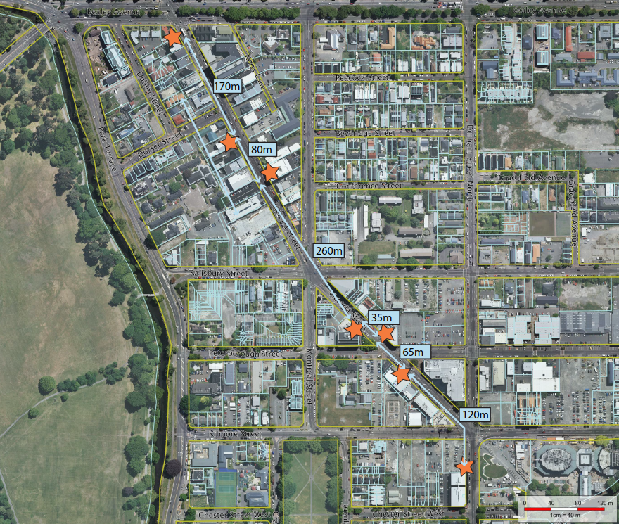
Proposed billboard
Figure 1 Existing signage along Victoria Street

- REQUIREMENT FOR RESOURCE CONSENT

The proposal is a discretionary activity under the Christchurch District Plan as it breaches the following rules:

- Rule 6.8.4.2.4 Signs attached to buildings – the maximum area of signage per building in the Commercial Central City Business zone is calculated as being the length along the primary road frontage (m) x 0.5. The primary frontage of the building identified for the proposed sign is approximately 16m. The total permitted area of signage attached to the building is therefore 8m². The maximum height above ground level at the top of the sign shall be 9 metres of the façade height, whichever is lower. The proposed sign is 46.08m² in area and has a total height of 15.875m above ground.

- Rule 6.8.4.2.5 Projecting signs and signs attached to or on verandas - in addition to meeting the built form standards in Rule 6.8.4.2.4, for signs projecting from the face of a building, the maximum projection from the face of the building shall be 0.2m. The proposed sign projects 0.4m from the face of the building.

Pursuant to Rule 6.8.4.1.4 (D1) resource consent is required for a discretionary activity as the proposal includes illuminated signs, including intermittently illuminated signs with changing images/digital signs that are not provided for in Rule 6.8.4.1.1 P11 or P15, Rule 6.8.4.1.3 RD2, RD3 or RD5, or Rule 6.8.4.1.5.

- PLANS SHOWING THE LOCATION OF THE APPLICATION SITE AND THE PROPOSED BILLBOARD

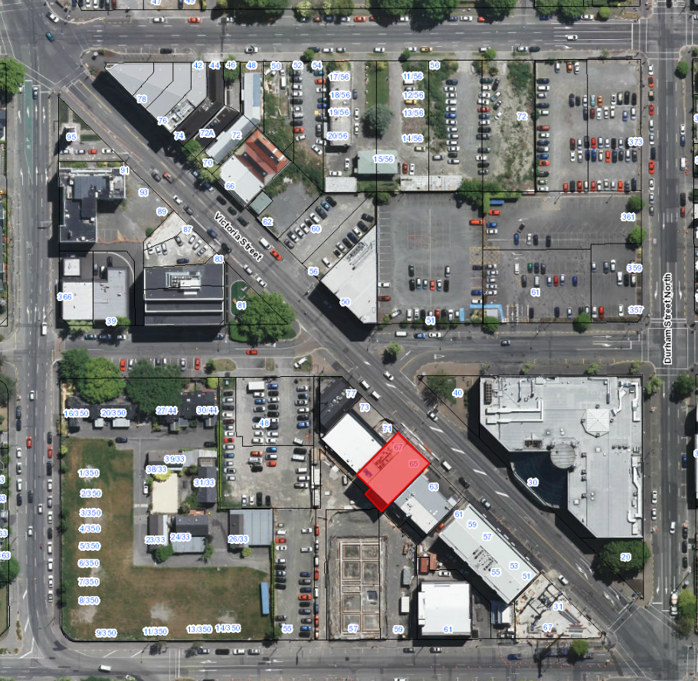
Application Site (65 Victoria Street)
Façade proposed for billboard location

