HIGH DENSITY RESIDENTIAL ZONE – Sub-chapter 14A

Job No: Planner:

Address: Date:

Operative District Plan zone:

High Density Residential zone provisions introduced by PC14

Development pathway
Yes | Has the applicant elected to use the Chapter 14B development pathway?  If so, use the operative District Plan zone Checksheet instead. | Operative DP overlay ‘zone ‘)

Y | SITE CHARACTERISTICS | Comments
 | Heritage Item/Setting on or adjacent to site; Papanui War Memorial Avenues
 | Protected tree on or adjacent to site (incl public realm tree)
 | Water body
 | Character Area Overlay
 | Residential Heritage Area overlay
 | Central City Residential Precinct
 | Reduced Building Height Precincts
 | Other Precincts or Interface Areas
 | Accommodation & Community Facilities overlay
 | Styx River Setback QM on Belfast/Northwood ODP
 | Airport noise contours

Flood Management Area:
Within Fixed Minimum Floor Level Overlay

Outside Fixed Minimum Floor Level Overlay

High Flood Hazard Management Area

Flood Ponding Area
 | Liquefaction Management Area
 | Sensitive activity near road/rail – refer rules in Ch 6.1.7
 | Overlay areas - other
 | Electricity Transmission Line Corridor
 | Designation
 | HAIL site
 | Coastal hazard – Refer City Plan
 | Other

ACTIVITY STATUS TABLES AND ACTIVITY SPECIFIC STANDARDS
Compliance |  |  | Rule | Comments
Y | N | N/A

Permitted activities

14A.6.1.1 Activity specific standards

Does the activity comply with all relevant activity specific standards? Refer rule for details.

Other activity classifications
14A.6.1.2 Controlled activities
C1 Communal waste and recycling area not complying with BFS.
14A.6.1.3 Restricted discretionary activities
RD2 New buildings & alterations/additions to existing buildings (excl retirement villages) resulting in:
- Four or more residential units
- breach of garage and carport BFS
- breach of GF habitable space BFS.
RD30 Four or more residential units within the 2023 Remodelled 50 dB LdN Outer Envelope
RD1, RD3 Cultural activity at 52 Rolleston Ave
RD6-8 VA not meeting standards, but meeting guest numbers
RD4, RD5 Retirement village buildings
Activities prescribed in this rule as a restricted discretionary activity due to non-compliance with the specified standards.
14A.6.1.4 Discretionary activities
Within Central City, an education/ spiritual/health/preschool activity between 40m² and 201m² meeting specified hours of operation, except on local road or frontage to Fitzgerald/ Bealey/Madras/Durham North.
VA exceeding permitted guest numbers
Activities prescribed in this rule as a discretionary activity due to non-compliance with the specified standards.
Any activity not otherwise provided for as a permitted, controlled, restricted discretionary, non-complying or prohibited activity.
14A.6.1.5 Non-complying activities
Non-res activities and home occupations as specified.
Other types of VA.

Built form standards
Complies |  |  | Rule | Comments
Y | N | N/A

14A.6.2.1 Building height

14m max, unless specified below.

39m within CC Residential Precinct

22m within walkable catchment of CCZ not within the Central City Residential Precinct.

7m minimum for residential units when developing 3 or more (highest point).

8m max for residential buildings within Industrial Interface Area.

Any building exceeding 14m:

Parts above 14m must be setback from road boundary by 4m.

Ground level communal ODLS of 50m² per 10 res units (rounded to nearest 10) on 4th floor and above. Max required areas is 20% of site area. Min dimension of 8m.

Any building from 19-22m:

Parts above 19m must be set back 2m from highest part of each façade at or below 19m (incl balustrades & similar arch features).

OR

Roof pitch less than 45° measured from external walls of building (excl eaves and getters to max combined width of 650mm per wall).

Doesn’t apply to CC Res Precinct or retirement villages.

Any building from 36-39m in CC Residential Precinct:

Parts above 36m must be set back 2-5m from highest part of each façade at or below 36m (incl balustrades & similar arch features).

OR

Roof pitch less than 45° measured from external walls of building (excl eaves and getters to max combined width of 650mm per wall).

Doesn’t apply to retirement villages.
 |  |  | 14A.6.2.2 Height in relation to boundary  Parts of buildings below 12m in height – recession planes apply  Exclusions:  Parts of building over 12m if set back 6m from northern boundary, 8m from southern boundary, 7m from east/west boundaries.  3+ residential units up to a max of 14m height – no recession plane for any part of building along the first 20m of a side boundary measured from the road; or within 60% of the site depth, measured from the road boundary, whichever is lesser. For corner sites, depth is measured from internal boundaries perpendicular to road boundary, EXCEPT where boundary is with a site other than HRZ or an OS zone.  Road boundaries, existing or proposed internal boundaries within a site, where there is a common wall.  Where boundary is on legal right of way, entrance strip, access site or pedestrian access way, HIRB is measured from the farthest boundary of that access.  Note – there are no permitted intrusions, and FMA exemption in 5.4.1.3 doesn’t apply.  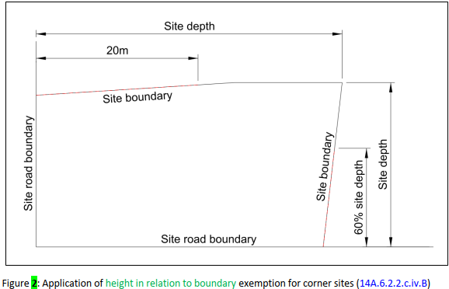 | Boundary rule if not adjoining public land
 |  |  | 14A.6.2.3 Setbacks  Front boundary – 1.5m  Side boundary – 1m  Rear boundary – 1m  Exemptions:  Buildings on adjacent sites with a common wall  Site/rear: Accessory buildings, or garages with internal access to res unit, with height less than 3m and total length up to 10.1m.  Front: Eaves, roof overhangs & gutters can intrude up to 650mm (combined); porch with max width 1.2m can intrude up to 800mm.  Retirement villages – setbacks only apply to perimeter boundary of site/devt. | Boundary rule for internal boundaries not adjoining public land
 |  |  | 14A.6.2.4 Outlook space  Minimum outlook space from habitable room windows (diagram below):  Principal living room – 4m x 4m  All other habitable rooms – 1m x 1m  Width is measured from centre point of largest window on that building face  May be over driveway or footpath within the site, or over a public street or public open space  May be over or under a balcony  May overlap with spaces from other rooms in same building  Can’t extend over OS or OLS required by another unit  Must be clear and unobstructed by buildings.  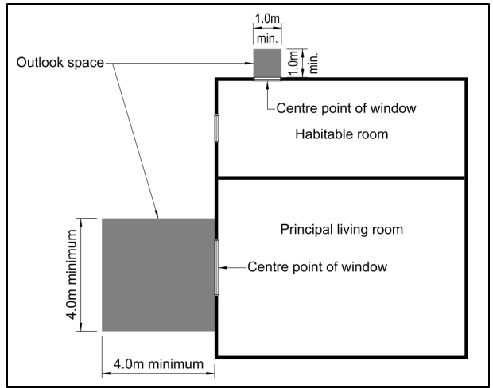 | Boundary rule if not adjoining public land

14A.6.2.5 Building separation

Res units above 12m height on same development site must be separated each other by at least 10m horizontal distance, except where there is a common wall.

14A.6.2.6 Fencing and screening

Road boundary – 50% of road boundary width (excl access) 1.8m max, remaining width 1.0m max.

Side, rear, internal – 2.0m max

Boundary with land zoned OSCP, OSWM, ARP – 1.0m max, or 2.0m if whole fence/screening structure is at least 50% visually transparent.

(Fencing under this rule is on site boundary or within road boundary setback.)

14.6.2.7 Landscaped area

Residential unit at ground floor level:

Minimum 20% of the developed site in grass or plants

Can include canopy of trees regardless of ground treatment below

Doesn’t need to be associated with individual units.

Can be provided as total across the site if min dimension of 0.6m.

Non-residential developments:

Minimum 20% of the site in landscaping

Must include one native tree/250m² gross site area (prior to subdivision), or part thereof

Trees must be 1.5m min height at time of planting.

May include private or communal open space in residential developments.

14.6.2.8 Windows to street

Res units facing the street must have min 20% of the street-facing façade in glazing (windows or doors).

Gables are not counted as part of the façade, as per diagram (internal ceiling height is from highest room).

Only applies to units with street-facing façade within 12m of road boundary or road designation, with no other res units located in between.

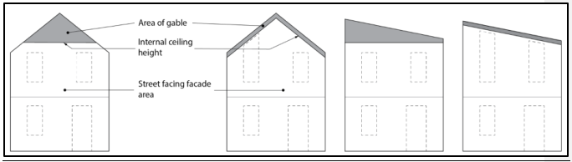

Units with a hinged front door facing the street with direct access to unit (not garage) can include the door, up to 2m² max regardless of whether it’s glazed.

Total glazing can be further reduced to 15% (incl door area) if the unit has a hinged front door and a ground floor habitable room with transparent glazed window on street-facing faced of min 1m² and max sill height of 1.2m (from internal floor level).

14A.6.2.9 Ground floor habitable room
Buildings containing res units must have habitable room at ground level with 3m min internal dimension. Doesn’t apply to upper-level units built over GF units.
50% of ground floor must be habitable rooms, or 30% where at least 25% GFA of the building is at 5th floor and above.

14A.6.2.10 Outdoor living space:

Residential units at ground floor level:

20m² total area – ground floor, balcony, patio or roof terrace.

3m min dimension for any ground level space

8m² and 1.8m min dimension for any balcony/patio/roof terrace

Accessible from unit

Can be grouped in 1 communally accessible location which can be at ground level.

Free of buildings, parking spaces, servicing and manoeuvring areas.

Residential units above ground floor level:

8m² balcony, patio or roof terrace with 1.8m min dimension, accessible from unit.

Can be grouped in 1 communally accessible location which can be at ground level.

Studio units with min 35m² internal FA, or single bed units with min 45m²:

15m² for units on ground floor, with 3m min dimension.

6m² for units above ground floor, with 1.5m min dimension for balconies, patios or roof terraces.

Rule 14A.6.2.11 Service, storage and waste management

4+ unit developments, per unit:

2.25m³ with 1.2m dimension at ground level for waste/recycling bins. Can be indoor or outdoor, and individual or communal. If located between unit and road boundary or ped/vehicle access, must be screened by 1.2m min solid fence.

3m³ with 1.5m dimension outdoor space for washing line, for ground floor units.

Each residential unit must covered and secure storage areas with min dimension of 600mm with total volume of:

6m³ for one-bedrooms

8m³ for two-bedrooms

10m³ for three or more bedrooms.

At least 50% to be internal to the unit

Additional to any storage in kitchen, bathroom, bedrooms.

Additional to any car parking area in a garage (deemed to be 5.5m x 3.1m x 2.4m).

14A.6.2.12 Building coverage

Max 50% of net site area covered by buildings.

Excludes eaves/roof overhangs/gutters up to 650mm combined width.
Total building coverage of up to 60% permitted if:
- No on-site parking provided
- Ground level communal ODLS provided of 10% of development site, 8m min dimension.
- Min development site dimension of 25m
- Min 50% of required landscaping is shrubs.

14A.6.2.13 Water supply for fire fighting
All residential units - via the reticulated system and in accordance with Code of Practice.

14A.6.2.14 Garaging and carpark location
Garage/carport/loading bay/carparking areas for units fronting road must be at least 1.2m further from road boundary than street-facing façade of the unit.

14A.6.2.15 Location of outdoor mechanical ventilation
Outdoor heat pumps or similar mech ventilation units at ground level between street façade and road boundary – must be screened by fencing. Max 50% transparent and min height of 1.2m or height of unit, whichever is higher.
Exemptions:
- Unit located within 1.5m of road boundary where fencing complies with 14A.5.2.9, or
- Screening provided by bushes/shrubs at min 80% height of unit, or
- Units installed to service units constructed prior to 2/12/2024 where street-facing façade at least 4.5m from road boundary.

14A.6.2.16 Minimum unit size

Net floor area:

35m² for studios

45m² for one-bedrooms

60m² for two-bedrooms

90m² for three or more bedrooms.

14A.6.2.17 Building length
New buildings – 30m max length of an elevation, measured from external face.
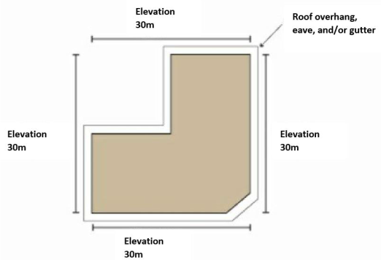

14A.6.2.18 Res units within the Industrial interface overlay

For new res units and extensions, with habitable room windows at or above 8m in height above GL, where the windows have line of sight to the IG, IH or IP zones - the habitable room containing the window must have mech ventilation systems and air con units meeting specified requirements (refer rule for details).

No balconies above 8m in height with line of sight to an industrial zone.

Line of sight = industrial zoned sites are visible (including partially obstructed) from “any position within the habitable space out the window or from any part of the balcony”.

14A.6.2.19 Minimum building setbacks from railway lines

4m setback from rail corridor boundary for buildings, balconies, decks on sites adjacent to a rail corridor.

14A.6.2.20 Development within 50 dB Airport Noise Contour

Within the 50 dB ANC and 2023 Remodelled 50 dB Outer Envelope:

Res units require heating and cooling devices as per rule.

If opening windows, mechanical ventilation must be provided in compliance with NZBC G4 as if windows were closed.

Air con & mechanical ventilation noise requirements specified in rule.

New buildings and additions to existing buildings within the 50 dB contours:

Acoustic insulation requirements to be met, and a report provided with BC applications.

Doesn’t apply within Airport Noise Rule Exclusion overlay.

AREA SPECIFIC RULES – 14A.6.3
Compliance |  |  | Rule | Comments
Y | N | N/A

Accommodation & Community Facilities overlay

Activity status & standards

Is the activity provided for as a Permitted activity?
Refer rule for list.
14A.6.3.2.1 Building height
11m, or 12m for part of building with a pitched roof of at least 22°.
14A.6.3.2.2 Maximum continuous building length – specified activities
15m max length of building elevation for new buildings.
10m max length for additions to existing buildings.
14A.6.3.2.3 Front entrances and facades – specified activities
Pedestrian access directly from the road frontage.
Min 30% glazing on ground floor along road frontage.
Min 20% glazing on elevations above ground level on road frontage.
14A.6.3.2.4 Landscaped areas (non-residential activities)
Areas adjoining the road frontage:
- Min of 1 tree/10m of road frontage or part thereof, distributed along the frontage.
- 2m planted strip.
Sites adjoining residential and OS zones - 1 tree/10m of the boundary or part thereof, evenly spaced along boundary.

Styx River Setback QM

Activity status & standards

Is the activity provided for as a Permitted activity?
Refer rule for list.
14A.6.3.2.1 Building height
Special Area A on the ODP – 12m
Special Area B on the ODP – 5m.

14A.6.3.2.5 Building setback & size

20m building setback from outer edge of esplanade reserve adjoining Styx River

150m building setback from southern boundary of HRZ.

500m² max GFA for buildings between 150 – 200m from southern boundary of HRZ.

14A.6.3.2.6 Roading, access and parking

Vehicle access points limited to locations on ODP.

CHAPTER 7 - TRANSPORT RULES
Compliance |  |  | Rule | Comments
Y | N | N/A
7.4.2 Activity status
C1 High traffic generation outside Central City, where:
- Land use otherwise permitted in zone
- Doesn’t exceed thresholds in table 7.4.4.18.1
- No direct vehicle access from SH, major arterial, or across railway
RD1 Activity not meeting standards
RD8 Permanent carparking buildings or lots in Central City where parking is the primary activity on site.
7.4.3 Rules
7.4.3.1 Min/max number and dimension of car parks
- Min dimension of car parks available to the general public - Appendix 7.5.14 Table 7.5.1.3
- Mobility parks – Within Central City: Buildings with GFA > 2,500m² and other activities where standard parks are provided (excl residential developments and VA ≤ 10 guests) - Appendix 7.5.1 Table 7.5.1.2.
7.4.3.2 Minimum number of cycle parking facilities
All activities, Appendix 7.5.2.
7.4.3.3 Minimum number of loading spaces
All activities where standard car parks are provided, Appendix 7.5.3.
7.4.3.4 Manoeuvring for parking and loading areas
On-site manoeuvring area for all activities with a vehicle access Appendix 7.5.6
On-site vehicle manoeuvring area to ensure forward movement off site – all activities with access to
- arterial road;
- collector road where 3 or more parking spaces provided;
- 6 or more parking spaces;
- heavy vehicle bay;
- local street or local distributor street within Central City core;
- main distributor street within the Central City where access serves 3 or more parking spaces;
- local street outside the Central City core where the vehicle access serves 6+ parking spaces.
7.4.3.5 Gradient of parking and loading areas
Non-residential activities with vehicle access.
7.4.3.6 Design of parking and loading areas
Lighting - non-residential activities with parking/loading areas used during darkness (excl VA)
Formed, sealed, drained and marked out - any urban activity except residential/VA with less than 3 car parks; sites with access off unsealed road; temporary activities.
7.4.3.7 Access design
Access standards - all activities with vehicle access, Appendix 7.5.7.
Pedestrian access – where shared pedestrian access is to 3 or more res units, App 7.5.7 c, d NEW
Queue space - 4 or more car parks or residential units, Appendix 7.5.8.
Outside Central City - Pedestrian warning system or visibility splay Appendix 7.5.9 - access to urban road serving more than 15 car parks or more than 10 HVM per day, and/or on key pedestrian frontage.
Central City where access serves more than 15 car parks or 10 HVM/day:
- Access to street within the core - Pedestrian warning system as per Appendix 7.5.9.
- Access to other streets: Visibility splay or pedestrian warning system as per Appendix 7.5.9. No audio 8pm – 8am for sites within 20m of HRZ except re emergency vehicle.
7.4.3.8(a) Provision of vehicle crossings
All activities with vehicle access to road or service lane.
7.2.3.8(e) Maximum number of vehicle crossings
All activities Appendix 7.5.11
7.2.3.8(f) Distance between vehicle crossings and intersections
All activities Appendix 7.5.11
7.4.3.9 Location of buildings and access in relation to road/rail level crossings
No new vehicle crossings within 30m of a rail level crossing limit line unless site boundaries don’t enable compliance.
Buildings close to level crossings without automated warning devices – location as per App 7.5.13.
 |  |  | 7.4.3.10 High trip generators - refer rule.
7.4.3.11 Vehicle access to sites fronting more than one street (Central City)
New vehicle access Appendix 7.5.15
7.4.3.12 Central City Lane formation
New Central City Lane – legal width between 6m-12m with 4.5m minimum height clearance

GENERAL RULES
Compliance |  |  |  |  | Rule |  | Comments
Y |  | N |  | N/A
Natural hazard rules - Chapter 5 DP
 |  |  |  |  | Flood hazard rules – Chapter 5.4
 |  |  |  |  | Liquefaction management rules – Chapter 5.5
 |  |  |  |  | Slope Instability rules – Chapter 5.6
Other provisions
 |  |  |  |  | Hazardous substances – Chapter 4
 |  |  |  |  | Noise – Chapter 6.1
 |  |  |  |  | Outdoor lighting – Chapter 6.3
 |  |  |  |  | Aircraft Protection – Chapter 6.7
 |  |  |  |  | Water Body setbacks Chapter 6.6
 |  |  |  |  | Sign rules – Chapter 6.8
 |  |  |  |  | Licensed premises/sale of alcohol - Chapter 6.9
 |  |  |  |  | Earthworks – Chapter 8.9
 |  |  |  |  | Indigenous biodiversity – Chapter 9.1
 |  |  |  |  | Landscapes and natural character – Chapter 9.2
 |  |  |  |  | Historic Heritage – Chapter 9.3
 |  |  |  |  | Trees – Chapter 9.4
 |  |  |  |  | Ngai Tahu values – Chapter 9.5
 |  |  |  |  | Coastal environment – Chapter 9.6
NES – Managing Contaminants in Soil to Protect Human Health
Applies if site has been used for a HAIL activity, and proposed activity involves disturbance of soil, change of land use, subdivision, removal of fuel storage tank, or soil sampling.
Preliminary Site Investigation may be required.
GENERAL COMMENTS:

