MEDIUM DENSITY RESIDENTIAL ZONE – Sub-chapter 14A

Job No: Planner:

Address: Date:

Medium Density Residential zone provisions introduced by PC14 – as per Council decisions dated 2.12.24, operative 12.12.24.

Rules shown in red are the subject of an Alternative Recommendation to the Minister, and have legal effect alongside the operative District Plan provisions.

Development pathway
Yes | Has the applicant elected to use the Chapter 14B development pathway?  If so, use the operative DP zone Checksheet instead. | Operative DP Overlay ‘zone’

Y | SITE CHARACTERISTICS | Comments
 | Heritage Item/Setting on or adjacent to site
 | Residential Heritage Area overlay (PC13)
 | Protected tree on or adjacent to site (incl public realm tree)
 | Water body
 | Character Area Overlay
 | Industrial Interface Area (Alt Rec)
 | Riccarton Bush Interface Area (Alt Rec)
 | Local Centre Intensification Precinct (Alt Rec)
 | City Spine Qualifying Matter (Alt Rec)
 | Other Precincts and/or Interface Areas
 | Accommodation & Community Facilities overlay

Flood Management Area:
Within Fixed Minimum Floor Level Overlay

Outside Fixed Minimum Floor Level Overlay

High Flood Hazard Management Area

Flood Ponding Area

Waimakariri FMA

Slope Instability Management Area
Cliff Collapse

Rockfall
Mass Movement

Remainder

Coastal hazards
Coastal Hazard Medium Risk Management Area

Coastal Hazard High Risk Management Area
Tsunami Risk Management Area

City Plan provisions
 | Liquefaction Management Area
 | Sensitive activity near road/rail – refer rules in Ch 6.1.7
 | Electricity Transmission Line Corridor
 | Overlay areas - other
 | Airport noise contours
 | Designation
 | HAIL site
 | Other

ACTIVITY STATUS TABLES AND ACTIVITY SPECIFIC STANDARDS
Compliance |  |  | Rule | Comments
Y | N | N/A

Permitted activities

14A.1.1.1 Activity specific standards

Does the activity comply with all relevant activity specific standards?
P1 No more than 3 residential units per site, or no more than 2 units within 50 dB Air Noise Contour and/or 2023 Remodelled 50 dB Outer Envelope (RD35), except within Airport Noise Exclusion Overlay (Alt Rec), & in Ricc Bush overlay (2 units max)
P3 Conversion of EPH/OPH units existing on 17 March 2023 – minimum 35m² GFA excl garages, and separate ODLS readily accessible from living area of 20m² with 3m dimension. No other built form standards apply where unit is converted without addition or alteration.
Refer rule for non-residential activities and retirement village standards.

Other activity classifications
14A.5.1.2 Controlled activities
Communal waste and recycling area not complying with BFS.
14A.5.1.3 Restricted discretionary activities
RD1 New buildings & alterations/additions to existing buildings (excl retirement villages) resulting in:
- Four or more residential units
- Over 40m² of a building used for non-res activities.
RD33 Three or more residential units within 50 dB Air Noise Contour and/or 2023 Remodelled 50 dB Outer Envelope (RD35), except within Airport Noise Exclusion Overlay (Alt Rec)
Specified sensitive activities within 50 dB Air Noise Contour and/or 2023 Remodelled 50 dB Outer Envelope
Boarding house; Student hostels 7-9 bedrooms; Convenience activities; Care facility
Other activities prescribed in this rule as a restricted discretionary activity due to non-compliance with the specified BF or activity specific standards.
14A.5.1.4 Discretionary activities
Student hostels 10+ bedrooms
Show homes
Brownfield mixed use redevelopment – Deans Ave/Saleyards (Alt Rec to delete)
Home occupation > 40% of the res unit GFA (excl detached accessory buildings)
Activities prescribed in this rule as a discretionary activity due to non-compliance with the specified standards.
Any activity not otherwise provided for as a permitted, controlled, restricted discretionary, non-complying or prohibited activity.
14A.5.1.5 Non-complying activities
Sensitive activities and buildings near National Grid/electricity distribution lines/structures
Res unit requirements - Industrial Interface Overlay
Visitor accommodation - other

Built form standards
Complies |  |  | Rule | Comments
Y | N | N/A

14A.5.2.1 Site density

No density rule other than 14A.5.3 Area Specific Standards

14A.5.2.2 Landscaped area

Residential unit at ground floor level:

Minimum 20% of the developed site in grass or plants

Can include canopy of trees regardless of ground treatment below

Doesn’t need to be associated with individual units.

Non-residential developments:

Minimum 20% of the site in landscaping, with min 50% in trees and shrubs

Must include one tree/250m² gross site area (prior to subdivision), or part thereof

At least one tree adjacent to road boundary

Trees must be 1.5m min height at time of planting.

May include private or communal open space in residential developments.

Salvation Army Addington Overlay – landscape plan required.

14A.5.2.3 Building height

11m, except that 50% of a building’s roof in elevation can exceed this by 1m where entire roof slopes 15° or more:

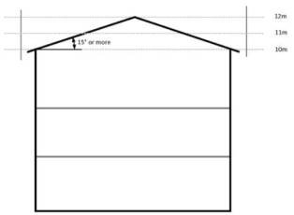

MRZ in St Albans ODP Area A – 14m

RMD Higher Height Limit Overlay - Carlton Mill 30m, all others 5 storeys above ground level.

RMD Higher Height Limit Overlay - Deans Ave 20m (Alt Rec to delete)

Local Centre Intensification Precinct – 12m (Alt Rec)

FENZ emergency services facilities – 14m

929 Ferry Rd – 20m

14A.5.2.4 Building coverage

Max 50% of net site area.

Retirement villages – calc over entire complex.

Excludes eaves, roof overhangs & gutters up to 650mm total width from wall.

14A.5.2.5 Outdoor living space:

Residential units at ground floor level:

20m² total area – ground floor, balcony, patio or roof terrace.

3m min dimension for any ground level space

8m² and 1.8m min dimension for any balcony/patio/roof terrace

Accessible from unit

Can be grouped in 1 communally accessible location.

Residential units above ground floor level:

8m² balcony, patio or roof terrace with 1.8m min dimension

Accessible from unit.

Can be grouped in 1 communally accessible location which can be at ground level.

Studio units with min 35m² internal FA, or single bed units with min 45m² entirely at upper level:

6m² private balcony with 1.5m min dimension.

Doesn’t apply to units in a retirement village.

Salvation Army Addington Overlay – communal ODLS required, 10m² per unit.
 |  |  | 14A.5.2.6 Height in relation to boundary  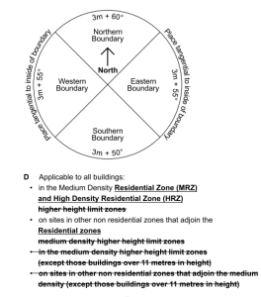  Recession planes taken from 3m vertical distance along all boundaries except road boundaries, existing or proposed internal boundaries within a site, and where there is a common wall - App 14A.16.2 Diagram D. (Alt Rec re vertical distance and angles)  Where boundary is on legal right of way, entrance strip, access site or pedestrian access way, HIRB is measured from the farthest boundary of that access.  Local Centre Intensification Precinct (Alt Rec) – for 3 or more res units up to 12m high, no recession plane:  along first 20m of side boundary measured from road (doesn’t apply if boundary is with site in residential zone outside LCIP other than HRZ; or OS zone ), or  within 60% of site depth measured from road, whichever is lesser.  Retirement village – applies to perimeter boundary only.  Note – there are no permitted intrusions, and FMA exemption in 5.4.1.3 doesn’t apply. | Boundary rule if not adjoining public land
 |  |  | 14A.5.2.7 Minimum building setbacks  Front boundary – 1.5m  Side boundary – 1m  Rear boundary – 1m  Rail corridor – 4m  Exemptions from front/side/rear setbacks:  Buildings on adjacent sites with a common wall  Side/rear boundary: Accessory buildings, and garages with internal access to res unit, with height less than 3m and total length up to 10.1m.  Front boundary: Eaves, roof overhangs & gutters can intrude up to 650mm (combined); porch with max width 1.2m can intrude up to 800mm.  Retirement villages – apply to perimeter boundary only. | Boundary rule for internal boundaries not adjoining public land
 |  |  | 14A.5.2.8 Outlook space per unit  Minimum outlook space from habitable room windows (diagram below):  Principal living room – 4m x 4m  All other habitable rooms – 1m x 1m  Width measured from centre point of largest window on that building face  May be over driveway or footpath within the site, or over a public street or public open space  May be over or under a balcony  May overlap with spaces from other rooms in same building  May overlap on same wall plane in multi-storey building  Can’t extend over OS or OLS required by another unit  Must be clear and unobstructed by buildings.  Retirement villages – applies only to principal living areas of self-contained units or communal living areas, within 15m of perimeter.  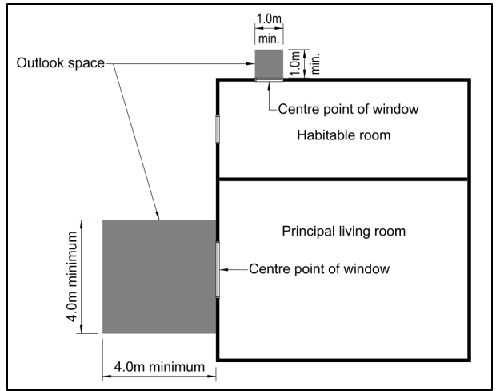 | Boundary rule if not adjoining public land

14A.5.2.9 Fencing and screening

Road boundary – 50% of road boundary width (excl access) 1.8m max, remaining width 1.0m max.

Side, rear, internal – 2.0m max

Boundary with land zoned OSCP, OSWM, ARP – 1.0m max, or 2.0m if whole fence/screening structure is at least 50% visually transparent.

Must be on site boundary or within road boundary setback.

Retirement villages – Fencing along public road boundary – max 1.8m height, at least 50% visually transparent.

14A.5.2.10 Windows to street

Res units facing the street must have min 20% of the street-facing façade in glazing (windows or doors).

Gables are not counted as part of the façade, as per diagram - internal ceiling height is from highest room.

Only applies to units with street-facing façade within 12m of road boundary or road designation, with no other res units located in between.

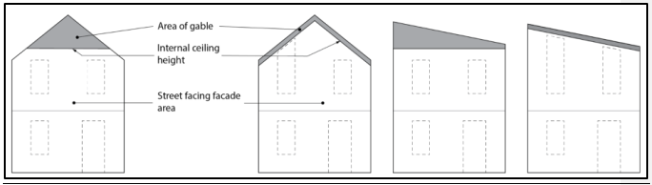

Units with a hinged front door facing the street with direct access to unit (not garage) can include the door, up to 2m² max regardless of whether it’s glazed.

Total glazing can be further reduced to 15% (incl door area) if the unit has a hinged front door directly to unit (not garage), and a ground floor habitable room with transparent glazed window on street-facing faced of min 1m² and min sill height of 1.2m (from internal floor level).

Retirement villages – Percentage measured across total length of all street-facing facades.

14A.5.2.11 Minimum unit size

Net floor area (incl toilets, bathrooms, excl parking areas, garages, balconies):

35m² for studios

45m² for one-bedrooms

60m² for two-bedrooms

90m² for three or more bedrooms.

Excludes units in a retirement village.

14A.5.2.12 Ground floor habitable room
Res units fronting road or public open space must have a habitable room at ground level with 3m min internal dimension. Doesn’t apply to upper-level units built over GF units.
Minimum 50% of any ground floor area of any res unit must be habitable rooms.
50% of ground floor must be habitable and/or indoor communal living space, where permitted building height is over 11m.
Does not apply to units in a retirement village.

Rule 14A.5.2.13 Service, storage and waste management spaces

4+ unit developments, per unit:

2.25m² with 1.2m dimension at ground level for waste/recycling bins, indoor or outdoor. If located between unit and road boundary or ped/vehicle access must be screened by 1.2m min solid or slatted fence.

3m² with 1.5m dimension outdoor space for washing line, for ground floor units.

Spaces can be individual or communal.

All units - covered and secure storage areas with min dimension of 660mm with total volume of:

6m² for one-bedrooms; 8m² for two-bedrooms; 10m² for 3+ bedrooms.

At least 50% to be internal to the unit

Additional to any storage in kitchen, bathroom, bedrooms.

Additional to any car parking area in a garage (deemed to be 5.5m x 3.1m x 2.4m).

14A.5.2.14 Water supply for fire fighting
All residential units - via the reticulated system and in accordance with Code of Practice, or alternative water sources provisions.

14A.5.2.15 Garaging and carport building location
Garage/carport/loading bay/carparking areas for units fronting road must be at least 1.2m further from road boundary than street-facing façade of the unit.

14A.5.2.16 Location of outdoor mechanical ventilation
Outdoor heat pumps or similar mech ventilation units at ground level between street façade and road boundary must be screened by fencing. Max 50% transparent, and min height of 1.2m or height of unit whichever is higher.
Exemptions:
- Unit located within 1.5m of road boundary where fencing complies with 14A.5.2.9, or
- Screening provided by bushes/shrubs at min 80% height of unit, or
- Units installed to service res units constructed prior to 2/12/2024 where street-facing façade at least 4.5m from road boundary.

14A.5.2.17 Building length
New buildings – 30m max length of an elevation, measured from external face.
Retirement villages – only applies within 15m of external boundary or perimeter.
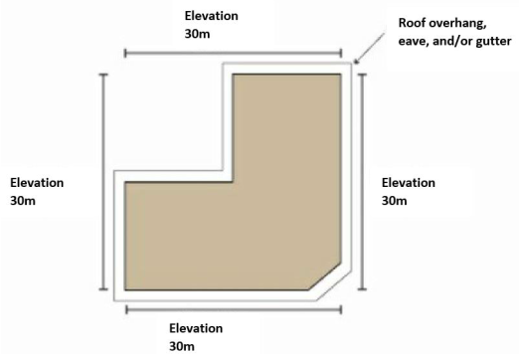

14A.5.2.18 Res units within the Industrial interface overlay

For new res units and extensions, with habitable room windows at or above 8m in height above GL, where the windows have line of sight to the IG, IH or IP zones - the habitable room containing the window must have mech ventilation systems and air con units meeting specified requirements (refer rule for details).

No balconies above 8m in height with line of sight to an industrial zone.

Line of sight = industrial zoned sites are visible (including partially obstructed) from “any position within the habitable space out the window or from any part of the balcony”.

14A.5.2.19 Development within 50 dB Airport Noise Contour

Within the 50 dB ANC and 2023 Remodelled 50 dB Outer Envelope:

Res units require heating and cooling devices as per rule.

If opening windows, mechanical ventilation must be provided in compliance with NZBC G4 as if windows were closed.

Air con & mechanical ventilation noise requirements specified in rule.

New buildings and additions to existing buildings within the 50 dB contours:

Acoustic insulation requirements to be met, and a report provided with BC applications.

Doesn’t apply within Airport Noise Rule Exclusion overlay.

AREA SPECIFIC RULES – 14A.5.3
Compliance |  |  | Rule | Comments
Y | N | N/A

Activity Status

14A.5.3.1.1 Area-specific activity standards

Does the activity comply with all relevant activity specific standards? Refer rule for details.
P1 Activities within Accomm & Community Facilities Overlay

P2 Visitor accomm within Accomm & Community Facilities Overlay

P3 Retirement villages within Accomm & Community Facilities Overlay
14A.5.1.3 Area-specific restricted discretionary activities
RD1 Buildings not meeting 14A.5.3.2.2 City Spine road boundary setback (Alt Rec)
RD2 Commercial Local zone (St Albans) ODP – development in Areas A, B & C
RD3 Deans Ave development plan (Alt Rec to delete)
RD11 Lyttelton Character Area Overlay:
- external alterations/additions/ demolition of existing buildings (excl demolition of accessory buildings)
- new buildings and accessory buildings (excl within LP Influences O/lay)
- relocation of building onto site.
- Res units not meeting site density 14A.5.3.2.7 or building coverage 14A.5.2.3.9
RD4 Service stations in ACF Overlay
Other activities prescribed in this rule as a restricted discretionary activity due to non-compliance with the specified BF or activity specific standards.

14A.5.3.1.4 Area-specific discretionary activity
Riccarton Bush Interface rule non-compliance (Alt Rec)

Built Form Standards
14A.5.3.2.1 Area specific development plans (Alt Rec to delete)
RMD Higher Height Limit & Site Density Overlay at Deans Ave:
Sites must not access Deans Ave other than via proposed road shown on Development Plan Addington – App 14A.16.3.

14A.5.3.2.2 Road boundary building setback (Alt Rec)

Sites within the City Spine Transport Corridor with road frontage:

– 4.5m road boundary setback in RS/RSDT overlay in Ch 14B
– 2m road boundary setback in RMD overlay in Ch 14B
14A.5.3.2.3 Building height
Accomm & Comm Facilities Overlay: 11m, or 12m for part of building with a pitched roof of at least 22°.
St Albans ODP - 14m in Area A on ODP. Rule 14A.5.2.3 doesn’t apply.
Riccarton Bush Interface Area outside ACF Overlay – 8m (Alt Rec)
14A.5.3.2.4 Maximum continuous building length
Specified activities in ACF Overlay:
- 15m max length of building elevation for new buildings.
- 10m max length for additions to existing buildings.
14A.5.3.2.5 Front entrances and facades
Specified activities in ACF Overlay:
- Pedestrian access directly from the road frontage.
- Min 30% glazing on ground floor along road frontage.
- Min 20% glazing on elevations above ground level on road frontage.
14A.5.3.2.6 Landscaped areas for select areas
Accomm & Community Facilities Overlay:
For non-res activities, areas adjoining the road frontage
- Min of 1 tree/10m of road frontage or part thereof, distributed along the frontage.
- 2m planted strip.
- Sites adjoining residential and OS zones - 1 tree/10m of the boundary or part thereof, evenly spaced along boundary.
14A.5.3.2.7 Site density
Lyttelton Character Area – Separate site with minimum net site area for residential unit of 250m².
Riccarton Bush Interface Area: (Alt Rec)
- 400m² min net site area per residential unit.
- No more than 2 residential units per development site
- Some sites excluded – see rule for details.
14A.5.3.2.8 Setbacks
Lyttelton CA overlay:
- Nil setback from one side internal boundary permitted with written approval of adjoining owner/occupier
- No road boundary setback.
Riccarton Bush Interface Area (Alt Rec):
- Road boundary – 4.5m or 2m for specified sites
- Internal boundaries – 1m.
14A.5.3.2.9 Building coverage
Lyttelton CA overlay - max 60% of net site area.
Exclusions:
- Fences/walls
- Eaves/roof overhangs up to 600mm width and guttering up to 200mm width from wall of building
- Uncovered pools up to 800mm height above GL
- Decks/terraces/porches/balconies/verandahs/bay or box windows max 800mm above GL and/or covered or unroofed, or if greater than 800mm and/or covered or roofed have max total of 6m².
Riccarton Bush Interface Area:
- Max 35% building coverage, or 50% on specific sites (Alt Rec)

CHAPTER 7 - TRANSPORT RULES
Compliance |  |  | Rule | Comments
Y | N | N/A
7.4.2 Activity status
C1 High traffic generation outside Central City, where:
- Land use otherwise permitted in zone
- Doesn’t exceed thresholds in table 7.4.4.18.1
- No direct vehicle access from SH, major arterial, or across railway
RD1 Activity not meeting standards
7.4.3 Rules
7.4.3.1 Min/max number and dimension of car parks
- Min dimension of car parks available to the general public - Appendix 7.5.14 Table 7.5.1.3
- Mobility parks - Buildings with GFA > 2,500m² and other activities where standard parks are provided (except residential developments < 3 units and VA ≤ 10 guests), Appendix 7.5.1 Table 7.5.1.2
- Parking and manoeuvring area must be no more than 50% GLFA of buildings on site (excl HRZ).
7.4.3.2 Minimum number of cycle parking facilities
All activities, Appendix 7.5.2.
7.4.3.3 Minimum number of loading spaces
All activities where standard car parks are provided, Appendix 7.5.3.
7.4.3.4 Manoeuvring for parking and loading areas
On-site manoeuvring area for all activities with a vehicle access Appendix 7.5.6
On-site vehicle manoeuvring area to ensure forward movement off site – all activities with access to
- arterial road;
- collector road where 3 or more parking spaces provided;
- 6 or more parking spaces;
- heavy vehicle bay;
- local street or local distributor street within Central City core;
- main distributor street within the Central City where access serves 3 or more parking spaces;
- local street outside the Central City core where the vehicle access serves 6+ parking spaces.
7.4.3.5 Gradient of parking and loading areas
Non-residential activities with vehicle access.
7.4.3.6 Design of parking and loading areas
Lighting - non-residential activities with parking/loading areas used during darkness (excl VA)
Formed, sealed, drained and marked out - any urban activity except residential/VA with less than 3 car parks; sites with access off unsealed road; temporary activities.
7.4.3.7 Access design
Access standards - all activities with vehicle access, Appendix 7.5.7.
Pedestrian access – where shared pedestrian access is to 3 or more res units, App 7.5.7 c, d NEW
Queue space - 4 or more car parks or residential units, Appendix 7.5.8.
Pedestrian warning system or visibility splay Appendix 7.5.9 - access to urban road serving more than 15 car parks or more than 10 HVM per day, and/or on key pedestrian frontage.
7.4.3.8(a) Provision of vehicle crossings
All activities with vehicle access to road or service lane.
7.2.3.8 (b) & (c) Design of vehicle crossings
Arterial road or collector road with speed limit 70km/hr or more, buildings in rural zone, and rural selling places, Appendix 7.5.10
7.2.3.8(d) Spacing of vehicle crossings
On roads with speed limit 70 km/hr or more, Appendix 7.5.11 Table 7.5.11.1
7.2.3.8(e) Maximum number of vehicle crossings
All activities Appendix 7.5.11
7.2.3.8(f) Distance between vehicle crossings and intersections
All activities Appendix 7.5.11
7.4.3.9 Location of buildings and access in relation to road/rail level crossings
No new vehicle crossings within 30m of a rail level crossing limit line unless site boundaries don’t enable compliance.
Buildings close to level crossings without automated warning devices – location as per App 7.5.13.
 |  |  | 7.4.3.10 High trip generators - refer rule.

GENERAL RULES
Compliance |  |  |  |  | Rule | Comments
Y |  | N |  | N/A
Natural hazard rules - Chapter 5 DP
 |  |  |  |  | Flood hazard rules – Chapter 5.4
 |  |  |  |  | Liquefaction management rules – Chapter 5.5
 |  |  |  |  | Slope Instability rules – Chapter 5.6
 |  |  |  |  | Coastal Hazard rules – Chapter 5.4A
Other provisions
 |  |  |  |  | Hazardous substances – Chapter 4
 |  |  |  |  | Noise – Chapter 6.1
 |  |  |  |  | Outdoor lighting – Chapter 6.3
 |  |  |  |  | Aircraft Protection – Chapter 6.7
 |  |  |  |  | Water Body setbacks Chapter 6.6
 |  |  |  |  | Sign rules – Chapter 6.8
 |  |  |  |  | Licensed premises/sale of alcohol - Chapter 6.9
 |  |  |  |  | Earthworks – Chapter 8.9
 |  |  |  |  | Indigenous biodiversity – Chapter 9.1
 |  |  |  |  | Landscapes and natural character – Chapter 9.2
 |  |  |  |  | Historic Heritage – Chapter 9.3
 |  |  |  |  | Trees – Chapter 9.4
 |  |  |  |  | Ngai Tahu values – Chapter 9.5
 |  |  |  |  | Coastal environment – Chapter 9.6
NES – Managing Contaminants in Soil to Protect Human Health
Applies if site has been used for a HAIL activity, and proposed activity involves disturbance of soil, change of land use, subdivision, removal of fuel storage tank, or soil sampling.
Preliminary Site Investigation may be required.

GENERAL COMMENTS:

