SITE ENTRY REQUIREMENTS

It is a Christchurch Waste Water Treatment Plant (CWTP) requirement that;
- All Visitors must have an appointment and be accompanied by a CWTP employee whilst on site
- All Visitors and Contractors must sign in on arrival and out when leaving

CONTRACTORS
- All persons performing work at the CWTP are required to undergo a site induction
- You must adhere to the requirements of the Permit to Work system
- You follow all site rules / instructions
- Be aware of CWTP hazards and advise CWTP of any hazards you may introduce

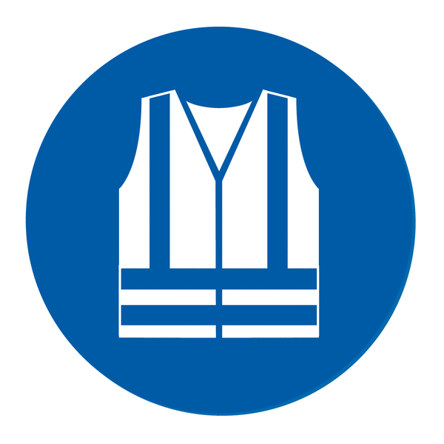
Minimum Personal Protective Equipment (PPE) requirements in process areas: Hi-viz (day/night), safety footwear, eye protection, hard hat, and gloves.

SITE HAZARDS
- Hazardous Areas and Atmospheres (areas containing concentrations of flammable gases, vapours or dust) and oxygen deficient zones are present throughout the site.
- Chemicals - There are a mixture of acids, gases and other hazardous substances on site. Refer to Material Safety Data Sheets (MSDS)
- Biological Hazards –Hepatitis, Typhoid, Tetanus
- Biogases – Methane and Hydrogen Sulphide
- Confined Spaces
- Mobile Plant / Equipment– Loaders, Trucks, Cranes, etc.
- Open Tanks and Ponds -Aerated tanks with low buoyancy
- Dynamic Hazards – Refer to Dynamic Hazard Board and site map for temporary hazards, locations, and control methods.
- Site Hazard Register -Contact your site host to review the site hazard register

All incidents / accidents must be reported immediately to your CWTP host and an incident / accident form completed.

