This form is to be filled out in accordance with Operating Procedure: CWTP Permit to Work Procedure
TRIM: 22/1725380
The Permit Issuer shall review this Permit to Work (PTW) from and ensure all sections are completed as applicable. JSA must be attached
Permit number ____________________________ Start Date ________
Work Order Number ________________________ End Date _________
ACR required (circle) Yes No ACR number __________________
JOB DETAILS
Description and reason for work: ________________________________________________________________________________________________________________________________________________________________________________________________________________________

Emergency response
Ambulance | 111
Fire Brigade | 111
Nearest Site First Aid

Work Site Details
Site Name | CCC Wastewater Treatment Plant
Site Phone | (03) 941 5705
Site Address | Shuttle Drive, Bromley, Chch

List additional emergency response requirements if necessary

Controls: ☐ Isolations ☐ Working at Height ☐ Confined Spaces ☐ Hot Work ☐ Excavations ☐ Cranes ☐Transfer of Control

Person in Charge of work
Name
Position
Company
Mobile Ph/RT
Safety Observer
Name
Mobile Ph/RT

WORK PARTY
I confirm I have reviewed the JSA and Isolations
 | Name | Signature
1
2
3
4
5
6
7

ISSUE The Hazard ID (JSA) has been completed by the Receiver. All Isolations (if required) are in place and the work is safe to commence.
Operations sign off | ______________________ |  | Date/time issued | ______________________
Maintenance sign off | ______________________ |  | Signed by Permit Receiver |  | ______________________
Signed by I&EC team when required |  | ______________________

List any impacts to the worksite, operations, other personnel, or environment

List potential events that could stop work

☐ Technical documentation provided e.g. P&ID, Asbuilt
CLOSE OUT
This Permit is closed. All relevant Certificates have been closed by the Safety Observer. The worksite has been left in a safe and tidy condition
Close Out Date | ____________________ | Signed by I&EC team when required | ______________________
Signed by permit issuer | ____________________ | Signed by Permit Receiver | ______________________

JOB SAFETY ANALYSIS

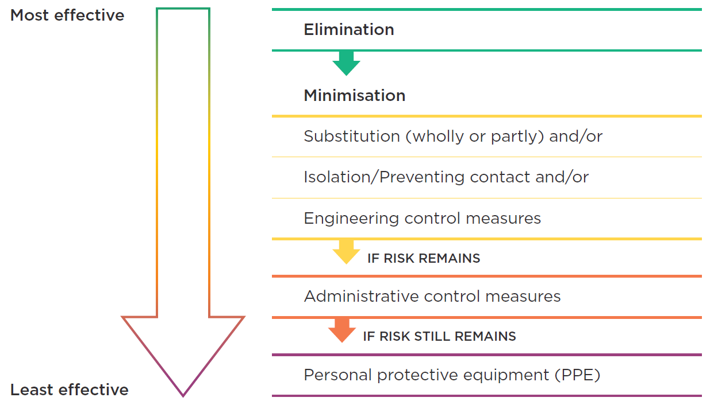
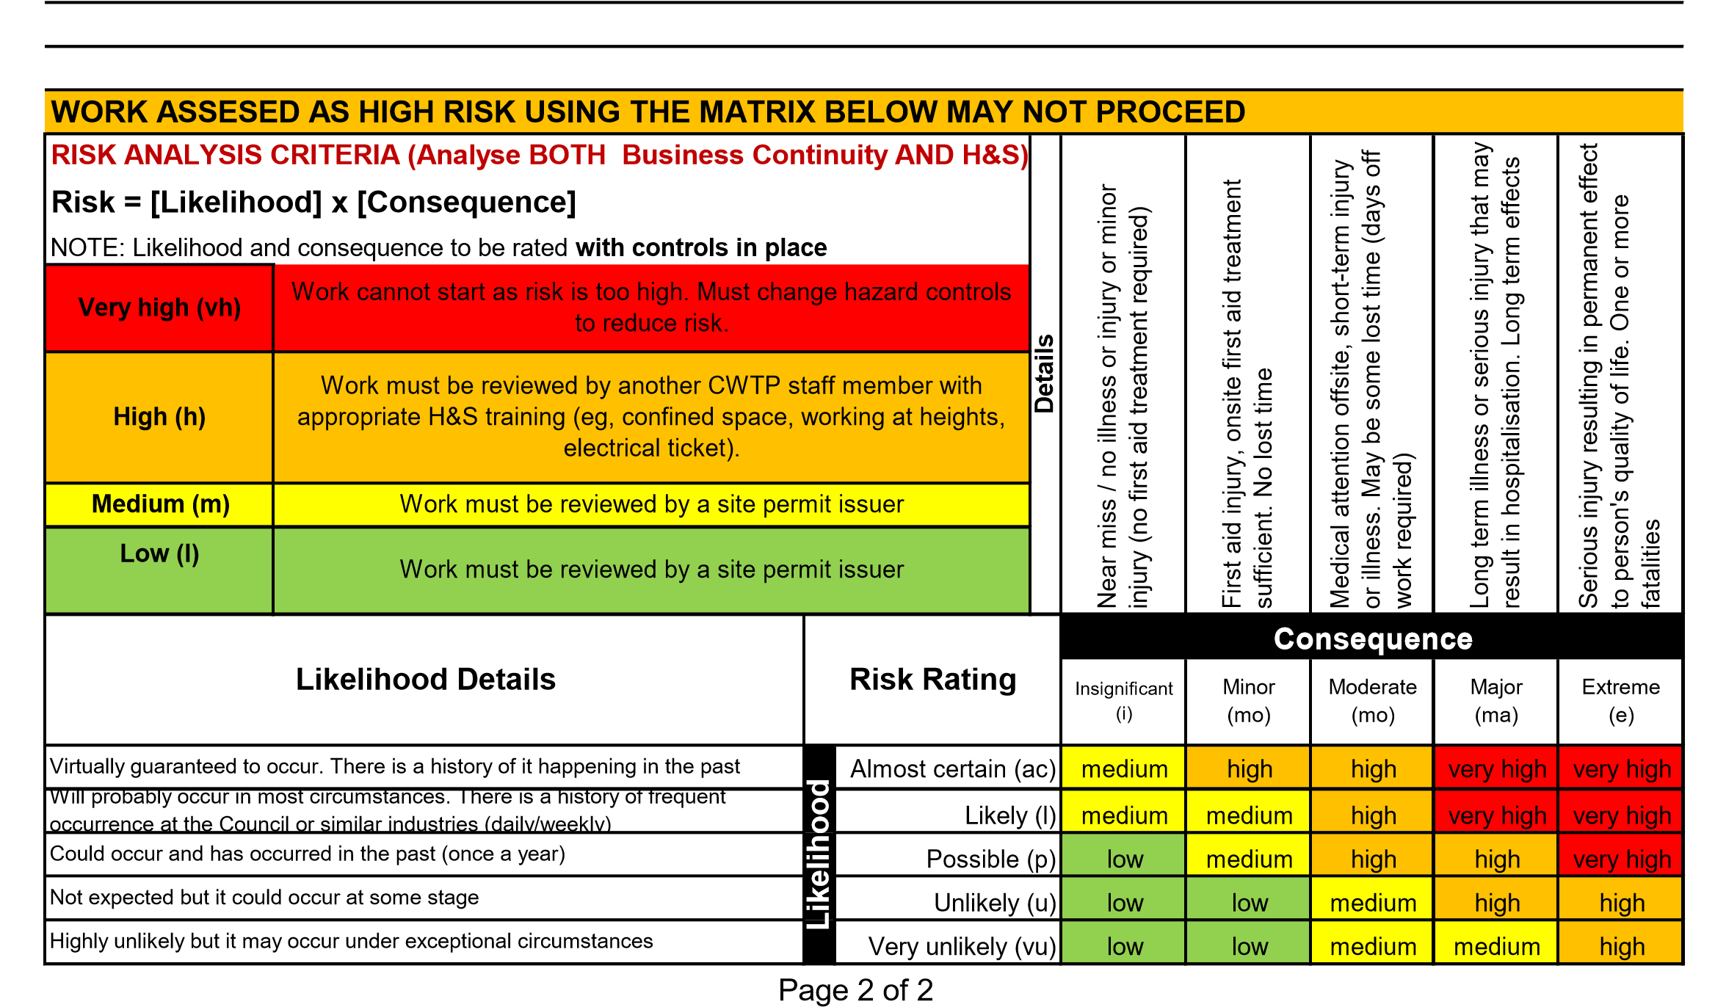

JOB SAFETY ANALYSIS

Attach additional sheets as required, alternatively attach an existing Job Safety Analysis to this form |  |  |  | Risk Analysis (with controls)
Job Step |  | Significant Hazards (e.g. harm to people, damage to equipment, process disruptions, environmental damage, etc.) | Proposed hazard controls
 |  |  | Control Method (where no additional control is proposed, write "risk Accepted") | Likelihood | Consequence | Rating
Start-up – Hand over from operations to work activity
2
3
4
5
6
7
8
Close out – hand back from work activity to operations

CWTP Isolation Schedule & Certificate
Permit Issuer to complete
TRIM: 22/1725461
NOTE: All Permits involving isolations must be reviewed and co-signed by another CWTP team member.
The person performing the isolations must ensure the following is in place before work commences:
- All personnel working under this isolation schedule clearly understand the LOTO procedure (GEN_HSE_0002).
- The Shift Engineer and/or IE&C team member have installed and tested the isolations.
All Permit Users (workers) have installed their individual locks and tags on each isolation point or group lockout (clasp or lockbox).
Scope of Work: ____________________________________________________________________________________________________________________________________________________________________________________________________________________________________________________________________________________________________________________________________________________________________________________________________________________________
Z.E.S / I.E.S Comments: ____________________________________________________________________________________
(Zero Energy State/ Isolated Energy State)
PTW / LOTO ID:__________________
Group Lockout Y/ N LOCKBOX #
Note: If lockbox is used then this Isolation schedule must be posted adjacent to the lockbox
Lock # | Isolation Point Tag & Description | Check By: | State (Open/Close) | Applied By | Personal Lock added? | Removed By

☐ I confirm that the precautions described in the scope of work will be put in place and will remain in place for the duration of the work.
Person isolating:
Name : | Sign:

CWTP Team Member:
Name : | Sign:

Working at Height Certificate
TRIM: 22/1786221
NOTE: All staff involved must have completed training for NZQA 17600: Explain safe work practices for working at heights.
The Safety Observer must ensure the following is in place before work commences:
☐ A safety observer has been assigned to maintain continuous communication with any person wearing a safety harness. (Strike through if not applicable)
☐ Worksafe NZ has been notified if required (If there is a potential for a fall of 5 m or higher, including the erection or dismantling of scaffolding form which a person many fall 5 m or more. Work carried out from a ladder only, or maintenance and repair work of a minor and routine nature is excluded) Strike through if not applicable.
☐ Suitable fall protection has been provided and has been documented in the Job safety Analysis for this Permit to work
☐ Barriers and signs are in place to prevent the passage of other personnel into or underneath the area
☐ Safe access to any essential service within the work area has maintained, including protection from falling items. Strike through if not applicable.
☐ All safety equipment and specialised work tools are fit for purpose, are in good condition and have valid certification/inspection certificates where relevant

A rescue plan has been documented and is understood by all team members.
Name | Signed

Rescue Plan: List all the equipment that will be used and is on hand for self-rescue or team rescue, and how the rescue will be undertaken.
Equipment | Expiry date | rating

Description of job and rescue plan
______________________________________________________________________________________________________________________________________________________________________________________________________________________________________________________________________________________________________________________________________________________________________________________________________________________________________________________________________________________________________________________________________________________________________________________________________________________________________________________________________________________________________________________________________________________________________________________________________________________________________________________________________________________

☐ I confirm that the precautions described above will be put in place and will remain in place for the duration of the work.

Permit will only be open for 12 hours, additional time will need to be documented and signed daily.

Issue date: _________ | Sign__________________
Change in hazards (circle) | Yes | No
If yes JSA will need to be changed and signed off
Closure date:_________ | Sign__________________
Revalidation Date: _________ | Sign__________________
Signed by Safety Observer | Sign__________________

Cranage Certificate
TRIM: 22/1725417
Job description and diagram of work site if appropriate
________________________________________________________________________________________________________________________________________________________________________________________________________________________________________________________________________________________________________________________________________________________________________________________________________________________________________________________________________________________________________________________________________________________________________________________________________________________________________________________________________________________________________________________________________________________________________________________________________________________________________________________________________________________________

The Safety Observer must ensure the following is in place before work commences:
☐ A safety observer has been assigned to maintain continuous communication with every person involved in the lift.
☐ Worksafe NZ has been notified if required. Work is notifiable if a load of 500kg or more has to be lifted a vertical distance of 5 m or more. Use of an excavator, forklift, or self-propelled mobile crane is not notifiable for any loads/heights. Strike through if not applicable.

☐ The CWTP underground services drawing has been reviewed to check that no weight bearing outriggers are positioned over potential subsidence circumstances (Risk can be mitigated by using load spreading pads.)

☐ Signs, barriers or personnel are in place to prevent passage of people or vehicles into the lifting area

☐ The crane and load will be clear of overhead power lines by at least 4m at all stages of the lift. (Unless the electrical supply authority has been advised in writing and power has been shutoff)

☐ If the load can rotate when lifted, tag lines will be used to ensure that the load is under control at all times.

☐ Strong wind, rain, poor visibility and other environmental conditions that could compromise safety are absent. The lift will be postponed if such conditions arise.

Is this a Critical Lift? (Will the crane operate at over 75% of its capacity, use multiple hoists, or lift people/Dangerous Goods?) Yes / No If Yes complete below. If No, draw a line through the section below:
The Safety Observer must ensure the following is in place before work commences:
☐ The CWTP underground services drawing has been reviewed and marked up with the intended position of the crane and its outriggers and attached to this permit.
☐ The crane's load chart showing the crane's capacity at the intended lifting radius and annotated with the intended weight of the load to be lifted is attached.
☐ A plan showing the direction of the lifting slew and the area to be taped off and controlled is attached.
☐ Barriers or danger tape are in place to prevent passage of others into the lifting area.
☐ I confirm that the precautions described above will be put in place and will remain in place for the duration of the work.

Include diagram of work site if appropriate

☐ I confirm that the precautions described above will be put in place and will remain in place for the duration of the work.

Issue date: _________ | Sign__________________
Change in hazards (circle) | Yes | No
If yes JSA will need to be changed and signed off
Closure date:_________ | Sign__________________
Revalidation Date: _________ | Sign__________________
Signed by Safety Observer | Sign__________________

Confined Space certificate

Note: All Permits involving confined space entry must be reviewed and co-signed by another CCC team member with current training in AS 2865 Confined Spaces. All staff involved with confined spaces must be training in AS 2865 Confined spaces.

TRIM: 22/1725404
Reason for entry: _________________________________________________________________

Max Entry Duration: _________ Max number of people allowed in space: ___________

Entry Register:
Date: | Name: | Time In: | Time Out: | Signature:

Atmospheric Monitoring: (every 15 - 30 min) |  | Entry Results | Exit Result | Ceiling (instant) |  | High level | Low level | TWA (for 8 hour shift) | STEL
Measured Gases | Oxygen (%) |  |  |  |  | 23.5 | 19.5
 | H₂S (ppm) |  |  | 35 |  |  |  | 5 | 10
 | CO (ppm) |  |  | 200 |  |  |  | 20 | 100
 | LEL/CH₄ (%) |  |  | 10
 | Other: e.g. Ammonia
Detector serial no.
Safe to Enter (Y/N)

The Safety Observer must ensure the following is in place before work commences:
☐ A qualified and competent Safety Observer has been assigned. While the entry is in progress, the Safety Observer will:
- Never, under any circumstances enter the confined space, never leave their post, and be free of all other duties
- Control the entry and exit points and ensure only qualified people enter the confined space
- Maintain the entry and exit register to keep track of who is inside the confined space at any time.
- Maintain constant communication with all those working inside the confined space.
- Maintain continuous monitoring of the atmosphere inside the confined space
- Withdraw people from the confined space if the atmosphere deteriorates, conditions change or worksite become unsafe.
☐ The pre entry atmospheric testing has returned a safe result
☐ Ventilation (natural or forced) is sufficient to maintain the safe atmosphere
☐ A rescue plan has been documented in the Rescue Plan section of this Permit to Work and is understood by all team members.
☐ Rescue equipment is on standby, located near the entrance of the confined space and safety observer has been briefed on job

Rescue Plan: List all the equipment that will be used and is on hand for self-rescue or team rescue, and how the rescue will be undertaken.
__________________________________________________________________________________________________________
__________________________________________________________________________________________________________
__________________________________________________________________________________________________________________________________________________________________________________________________________________________
☐ I confirm that the precautions described above will be put in place and will remain in place for the duration of the work.
Permit will only be open for 12 hours, additional time will need to be documented and signed daily.

Issue date: | Sign__________________
Change in hazards (circle) | Yes | No
If yes JSA will need to be changed and signed off
Closure date: | Sign__________________
Revalidation date: | Sign__________________
Signed by Safety Observer | Sign__________________

Confined Space certificate

Additional atmospheric testing (every 15 – 30 min)

 |  | Pre-Entry Testing Results | Routine Testing Results | Routine Testing Results | Routine Testing Results | Routine Testing Results | Routine Testing Results | Routine Testing Results | Routine Testing Results
Date
Time
Safe level | O₂ 19.5-23.5%
 | H₂S <5 ppm (TWA)
 | CO <20 ppm (TWA)
 | Other:
 | Other
 | Other
Safe to Enter (Y/N)
Signed by Safety observer

 |  | Pre-Entry Testing Results | Routine Testing Results | Routine Testing Results | Routine Testing Results | Routine Testing Results | Routine Testing Results | Routine Testing Results | Routine Testing Results
Date
Time
Safe level | O₂ 19.5-23.5%
 | H₂S <5 ppm (TWA)
 | CO <20 ppm (TWA)
 | Other:
 | Other
 | Other
Safe to Enter (Y/N)
Signed by Safety observer

 |  | Pre-Entry Testing Results | Routine Testing Results | Routine Testing Results | Routine Testing Results | Routine Testing Results | Routine Testing Results | Routine Testing Results | Routine Testing Results
Date
Time
Safe level | O₂ 19.5-23.5%
 | H₂S <5 ppm (TWA)
 | CO <20 ppm (TWA)
 | Other:
 | Other
 | Other
Safe to Enter (Y/N)
Signed by Safety observer

Excavation Certificate
TRIM: 22/1725450
Do any job steps require excavations 150 mm or deeper or involve demolition YES/NO If Yes complete below:
NOTE: All Permits involving Excavation and/or Demolition must be reviewed by the Maintenance Team Leader
The Safety Observer must ensure the following is in place before work commences:
☐ A safety observer has been assigned to check the excavation face during periods of mechanical digging
☐ The Worksafe NZ has been notified if required (if a person is required to work in any excavation more than 1.5 m deep and having a depth greater than the horizontal width at the top, if a person is required to work with groundcover overhead, or if a person is required to work below a face higher than 5 m with an average slope steeper than a ratio of 1 horizontal to 2 vertical.) Strike through if not applicable.
☐ Safe access and egress to the excavation is in place (steps, ramps or secure ladders where possible, alternatively a mechanical transportation method)
☐ The CWTP underground services drawing has been reviewed in consultation with the CWTP Maintenance Team Leader, CWTP Operations team leader, IE&C Team Leader and a copy attached to this permit that has been marked up with the intended position of the excavation.
- Excavation within 500 mm in any direction of a positively identified (visual) underground service must be carried out by hand.
- Excavation within 2 m in any direction of an indicatively identified (by drawings or locator) underground service must be carried out by hand.
☐ All unattended excavations will be barricaded and lit with warning lights if the area is otherwise unlit, or covered securely.
☐ Updated drawings provided
☐ All underground services have been positively identified

☐ I confirm that the precautions described above will be put in place and will remain in place for the duration of the work.

Description of work
________________________________________________________________________________________________________________________________________________________________________________________________________________________________________________________________________________________________________________________________________________________________________________________________________________________________________________________________________________________________________________________________________________________________________________________________________________________________________________________________________________________________________________________________________________________________________________________________________________________________________________________________________________________________

Include diagram of work site if appropriate

☐ I confirm that the precautions described above will be put in place and will remain in place for the duration of the work.

Issue date: | Sign__________________
Change in hazards (circle) | Yes | No
If yes JSA will need to be changed and signed off
Closure date:_________ | Sign__________________
Signed by Safety Observer | Sign__________________

Hot Work Certificate
TRIM: 22/1725458

Note: All Permits involving Hot Work must be reviewed and co-signed by another CCC team member familiar with the hot work processes
The permit user must ensure the following is in place before work commences:
☐ The building condition has been inspected, and cable runs, cavities, pipework, and poly panel identified and protected.
☐ Combustible panels or liquids are not closer than 10 m to the worksite or have been inspected and covered with a fire blanket
☐ Pipework and vessels for flammables have been purged with inert material and certified ‘gas free’ Strike through if not applicable
☐ Fire safety equipment on-hand or nearby (e.g. extinguishers, hoses, fire blanket, etc.)
☐ Screens and barriers are in place to prevent the passage of others into the workspace and to protect personnel from arc flash
☐ Sensitive electronic equipment such as flow meters have been isolated from welding current and conducted heat
☐ Sufficient ventilation is in place to remove any toxic fumes generated
☐ All escape routes have been walked and are clear
☐ Any hot work in sludge room B requires both doors to be locked OPEN and all extraction fans operating for the duration of work
☐ Before applying any heat to metal built into or projecting through walls, floors or ceilings, an examination will be made to ensure that the other end of the metal is cleared of combustible material or such combustible material is covered with fireproof blankets or similar protective equipment

Description of job
_____________________________________________________________________________________________________________________________________________________________________________________________________________________________________________________________________________________________________________________________________________________________________________________________________________________________________________________________________________________________________________________________________________________________________________________________________________________________________________________________________________________________________________________________________________________________________________________________________________________________________________________________________________________________

☒ I confirm that the precautions described above will be put in place and will remain in place for the duration of the work.

Permit will only be open for 12 hours, additional time will need to be documented and signed daily.

Issue date: _________ | Sign__________________
Change in hazards (circle) | Yes | No
If yes JSA will need to be changed and signed off
Closure date:_________ | Sign__________________
Revalidation Date: _________ | Sign__________________
Signed by Safety Observer | Sign__________________

On Closure: After at least one hour after hot works has cessed a fire water must return to prove the area safe

Signed by Safety Observer | Sign__________________

Transfer of Control (to a third Party)
TRIM: 22/1725465
Transfer of Controls: Are the safety controls for a work zone (or project) being transferred to a third party? Yes/No
If yes complete below. If no draw a line through the checklist below
The permit issuer must ensure the following is in place before control is transferred and work commences:
☐ The transfer of control is to an organisation and responsible person who has the appropriate systems /procedures and competencies to effectively manage the health and safety risks within the scope of work and the controlled work zone
☐ The person receiving control clearly understand their personal responsibilities and organisations responsibilities when accepting control
☐ The physical boundaries of the transferred “control zone” are clearly defined and controlled
☐ The isolation points between the operational plant / services and the control zone are itemised within this PTW’s isolation schedule
☐ Operational plant and service within the control zone have been clearly identified
☐ The demarcations between any operational plant / services and the transfer of control are clearly defined and controlled
Procedures for CWTP entering and/or working within the controlled work area:
Physical boundaries and controls
Defined the physical boundaries and control measures to be implemented (attached site map and PID’s as appropriate)
____________________________________________________________________________________________________________________________________________________________________________________________________________________________________________________________________________________________________________________________________________________________________________________________
Operations demarcation
Define any operational demarcations (equipment/services) and controls within the transferred control zone
_____________________________________________________________________________________________________________________________________________________________________________________________________________________________________________________________________________________________

Other requirements
Stipulate any requirements and/or restrictions associated with the transfer of control
☐ I confirm that the precautions described above will be put in place and will remain in place for the duration of the control transfer.

Transfer of control from CWTP to third party organisation:____________________________
Date/time: ____________________ Responsible person: ____________________
CWTP Permit Issuer:____________________ | CWTP Team Leader/manager: ____________________
Transfer of control from third party organisation to CWTP:____________________________
Date/time: ____________________ Responsible person: ____________________
CWTP Permit Issuer: ____________________

CWTP Team Leader/manager: ____________

