Christchurch Wastewater Treatment Plant

Quarterly Monitoring Report

August - October 2018

Summary

This report summarises the results of parameters monitored by the Christchurch Wastewater Treatment Plant (CWTP) over the period August - October 2018 in accordance with consent CRC051724. Consent CRC051724 allows the discharge of treated wastewater from the CWTP Oxidation Ponds into the Pegasus Bay Coastal Marine Area via an ocean outfall.
Of the comprehensive sampling programme required by the consent, all samples were collected during the monitoring period and all monitored parameters achieved the required standards.

Other News:
A partial plant bypass around CWTP's secondary treatment process occured for 10 hours occured 9 September. Primary treated effluent was sent to the ponds to enable access to channels for minor earthquake repairs and asset renewal. This will be followed by a series of partial and full bypasses over the next 8 months to enable a combination of earthquake repairs to effluent channels.

- A trial is underway to use a dredging device to control midges. This works by disturbing the sediment at the bottom of the ponds. The trials will be concentrating on ponds nearest to nearby residents, so it is anticipated any sediment would have resettled in the downstream ponds.

Christchurch Wastewater Treatment Plant Contents

Quarterly Monitoring Report

August - October 2018
1 Outfall Discharge 4
1.1 Resource Consent Conditions 4
1.2 Comments on Compliance 4
1.3 Resource Consent Standard Conditions 6
1.4 Comments on Compliance 6
1.5 Dissolved BOD₅ Compliance 7
1.6 Total Suspended Solids Compliance 8
1.7 Ammonia Nitrogen Compliance 9
1.8 Enterococci Monitoring 10
1.9 Faecal Coliform Compliance 11
2 Receiving Environment Monitoring in Pegasus Bay 12
2.1 Water Quality Resource Consent Conditions 12
2.2 Comments on Compliance 12
2.3 Beach Water Quality Analysis Results 13
2.4 Other Receiving Environment Analysis 15
2.5 Comments on Compliance 15

Outfall Discharge

Resource Consent Conditions
Consent CRC051724 allows CWTP to discharge up to 518,000 cubic metres per day of treated wastewater from the CWTP Oxidation Ponds at a maximum rate of six cubic metres per second into the Pegasus Bay coastal marine area. Compliance conditions regarding the physical discharge to the estuary are summarised in Table 1.1.1. Daily records of maximum outfall discharge flow rates and volumes are attached as an appendix to this report, and shown in summary in Figures 1.2.1 and 1.2.2.

Table 1.1.1 Pond Discharge Consent Compliance for Monitoring Period CRC051724
Consent Condition | Parameter | Compliance Condition | Compliance
 |  |  | Aug 18 | Sep 18 | Oct 18 | Overall
2 | Discharge Content | Discharge is only wastewater from the CWTP ponds | ☺ | ☺ | ☺ | ☺
3 | Discharge Volume | Recorded | ☺ | ☺ | ☺ | ☺
4 | Discharge Rate | Recorded | ☺ | ☺ | ☺ | ☺
9 | Outfall Maintenance | Routine maintenance completed and recorded | ☺ | ☺ | ☺ | ☺
10 | Outfall Condition | Visual inspection of outfall | n/a | n/a | n/a | n/a
12 | Pumping Pressure for a given flow | Monitored | ☺ | ☺ | ☺ | ☺
Key: ☺ Full Compliance 😐 Minor, Isolated or Risk of Non-Compliance ☹ Major or Consistent Non-Compliance

Comments on Compliance
Flowrate and pressure data were recorded as per consent requirements.

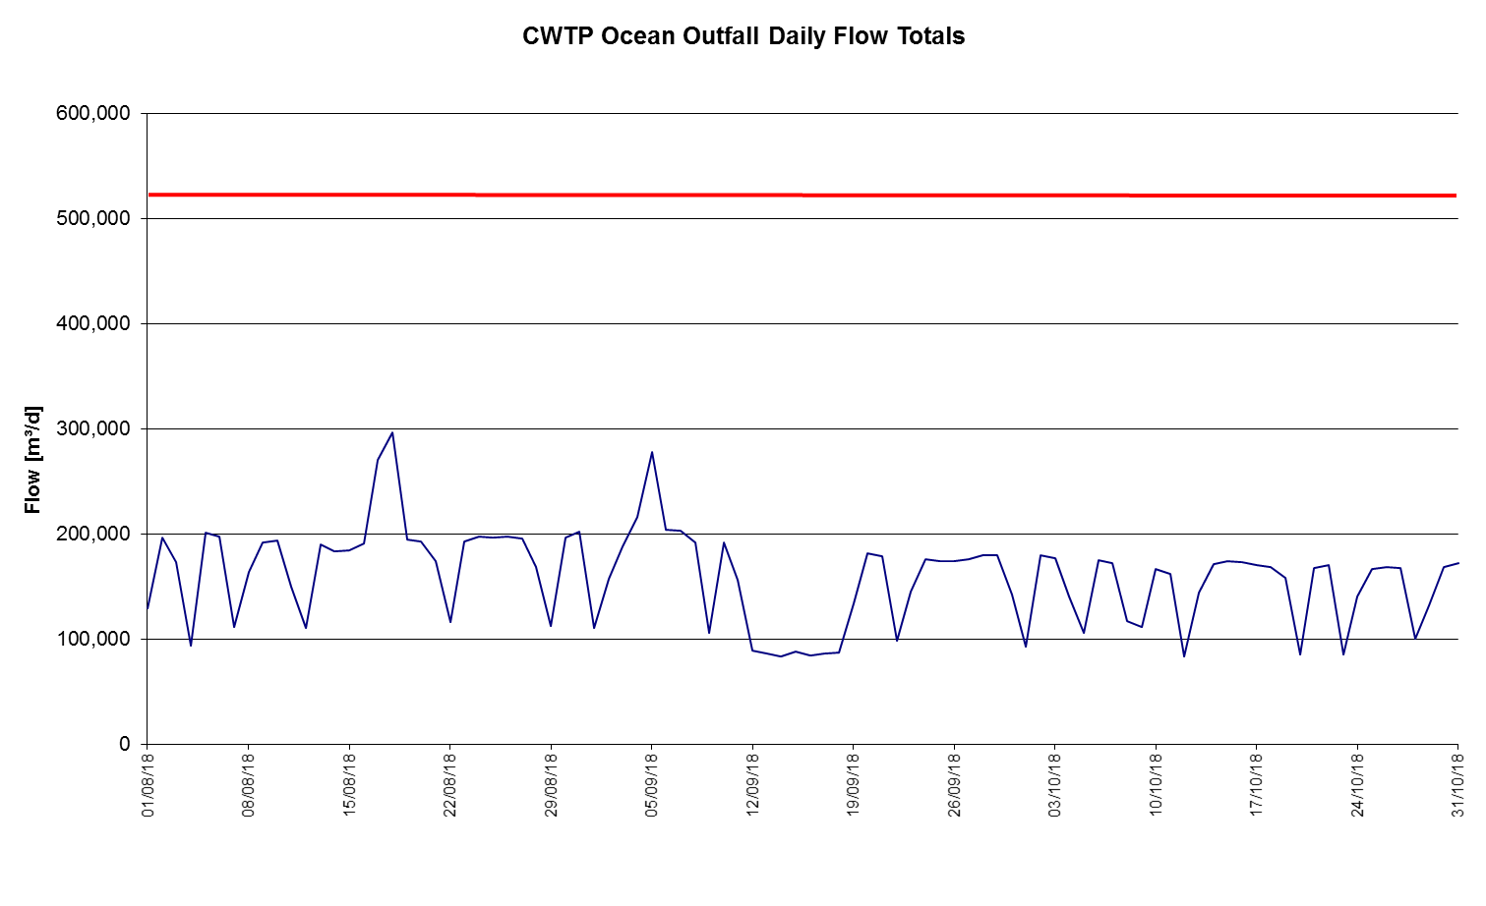

Figure 1.2.1 - Daily Outfall Flow Totals

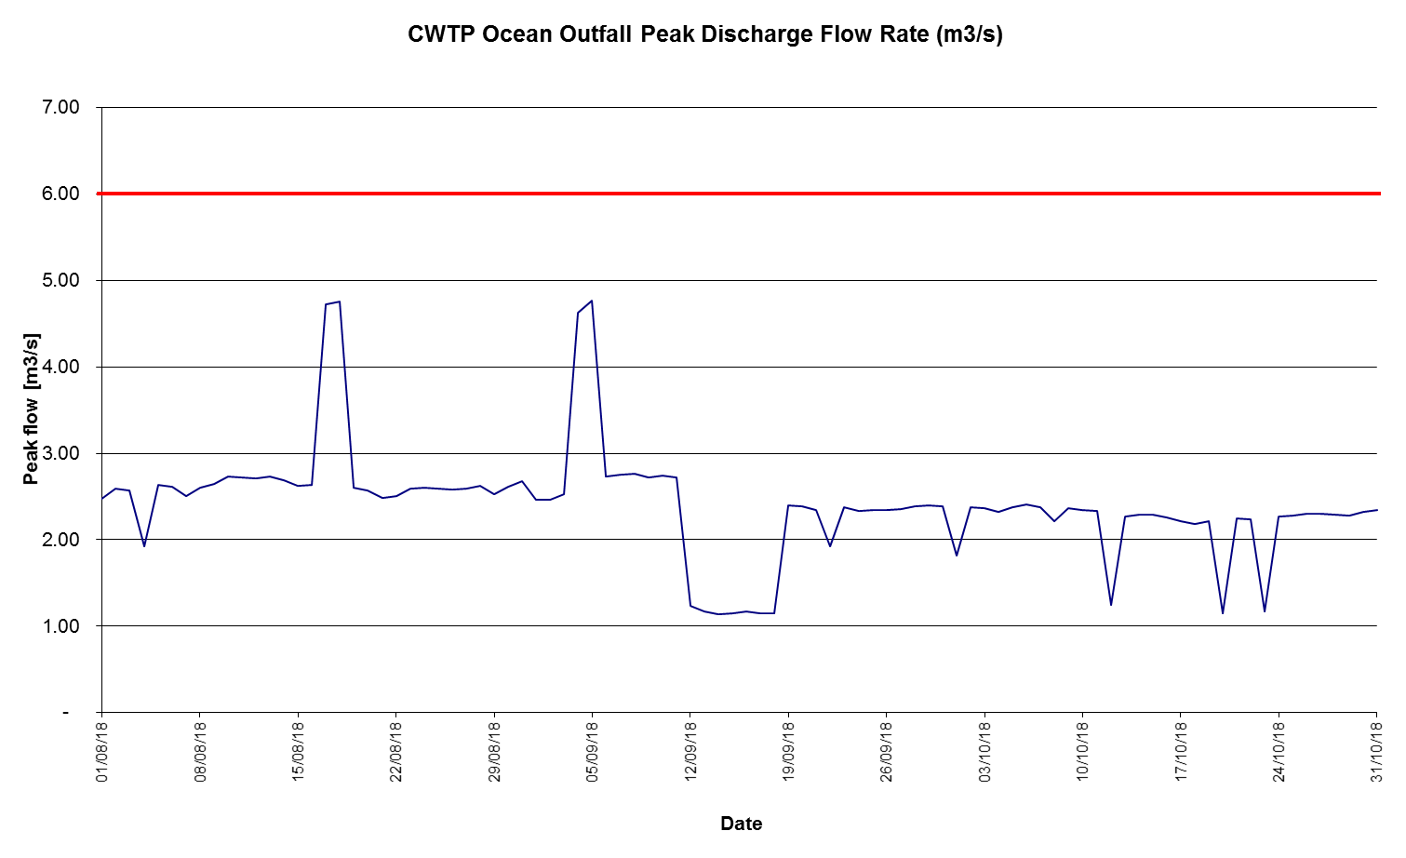
Figure 1.2.2 - Daily Peak Outfall Flows

Resource Consent Standard Conditions
Conditions 15 and 16 of consent CRC051724 set out concentration standards for a selection of parameters monitored in compliance with condition 13. No more than 16 samples in each rolling 26 week period should exceed the standard value for contaminants listed under condition 15a, and if more than seven from eight consecutive samples should exceed the standard value ECan must be notified within 48 hours. No more than six from eight consecutive samples should exceed the standard value for contaminants listed under condition 16a, and no more than two from eight consecutive samples should exceed the higher value. If more than seven from eight exceed the standard value, or three from eight exceed the higher value, ECan must be notified within 48 hours. Compliance conditions regarding adherence to these standard values are summarised in Table 1.3.1. Analysis results are supplied to Environment Canterbury at quarterly intervals. Contaminant monitoring results for consent CRC051724 are discussed further in Sections 1.4 – 1.9.

Table 1.3.1 Contaminant Limits Consent Compliance May – July 2018 CRC051724
Consent Condition | Parameter | Compliance Condition | Compliance
 |  |  | Aug 18 | Sep 18 | Oct 18 | Overall
15a | Dissolved BOD₅ | Concentration does not exceed 20 g/m³ | ☺ | ☺ | ☺ | ☺
 | Total Suspended Solids | Concentration does not exceed 50 g/m³ | ☺ | ☺ | ☺ | ☺
 | Ammoniacal Nitrogen | Concentration does not exceed 40 g/m³ | ☺ | ☺ | ☺ | ☺
16a | Faecal Coliforms | Concentration does not exceed 1,000(standard)/5,000(higher) MPN/100mL | ☺ | ☺ | ☺ | ☺
 | Enterococci | Concentration does not exceed 1,500 MPN/100mL | ☺ | ☺ | ☺ | ☺
Key: ☺ Compliance Achieved with no Exceedance of Standard 😐 Compliance Achieved with Occasional Exceedance of Standard ☹ Exceedance of Standard resulting in Non-Compliance

Comments on Compliance
All samples were collected and analysed. There were no exceedances of any of the standards.

Dissolved BOD₅ Compliance
The median dissolved BOD₅ concentration for the reporting period was 2.4g/m³. This is higher than the median concentrations in the previous quarter and but lower than the same quarter in 2017. There were no exceedances of the standard value (20.0 g/m³) in the current monitoring quarter.
Table 1.5.1 Pond Discharge Dissolved BOD₅

Median Value [g/m³]  Current Monitoring Quarter  (August 2018 – October 2018) | 2.4 | Number of Exceedances  Current Monitoring Quarter  (August 2018 – October 2018) | 0
Median Value [g/m³]  Previous Monitoring Quarter  (May 2018 – July 2018) | 2.3 | Number of Exceedances  Previous Monitoring Quarter  (May 2018 – July 2018) | 0
Median Value [g/m³]  Same Monitoring Quarter of Previous Year  (August 2017 – October 2017) | 2.6 | Number of Exceedances  Same Monitoring Quarter of Previous Year  (August 2017 – October 2017) | 0

1.5.2 Pond Discharge Dissolved BOD₅
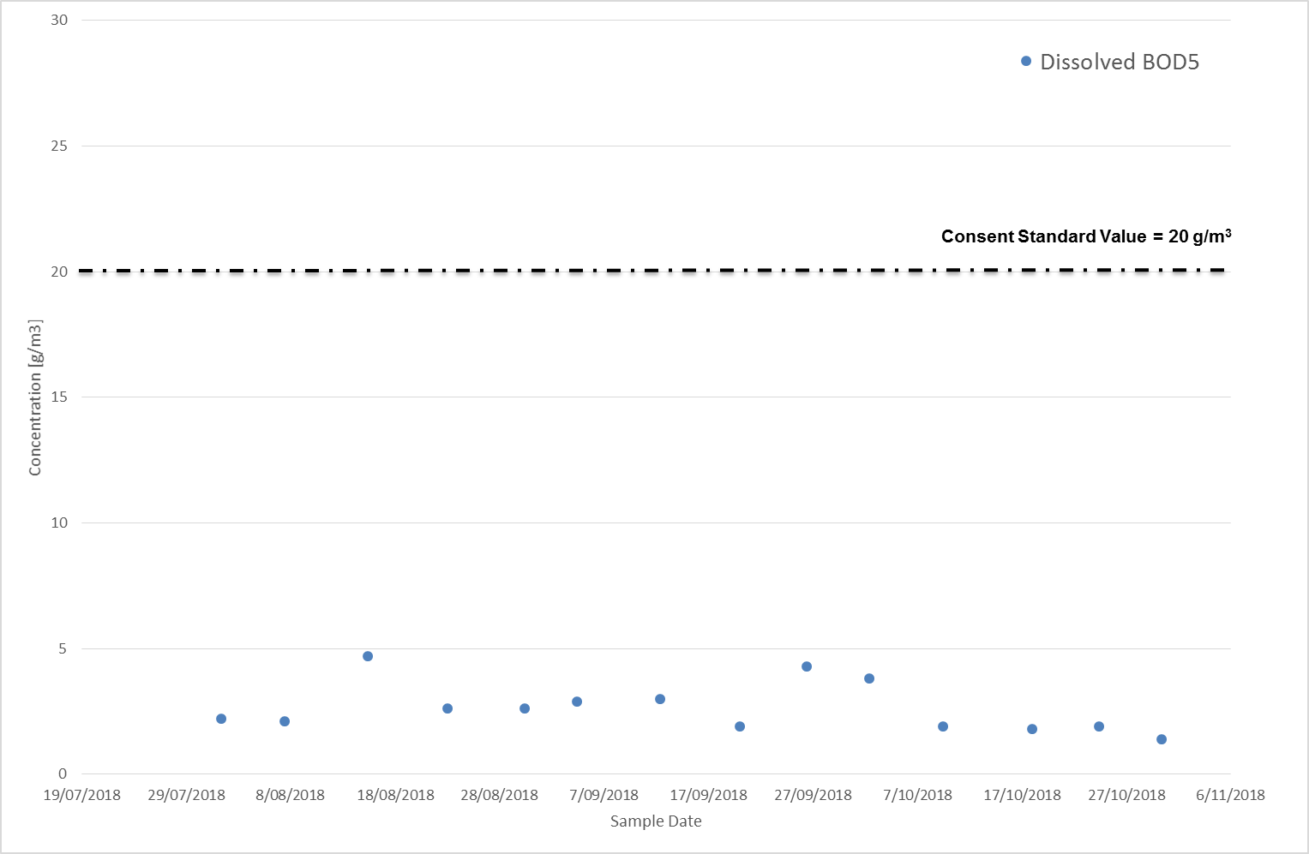

Total Suspended Solids Compliance
The median total suspended solids concentration for the monitoring period was 8.8 g/m³. This is higher than the previous quarter and higher than the same quarter last year. There were no exceedances of the standard value (50 g/m³) this quarter.
Table 1.6.1 Pond Discharge Total Suspended Solids

Median Value [g/m³]  Current Monitoring Quarter  (August 2017 – October 2017) | 8.8 | Number of Exceedances  Current Monitoring Quarter  (August 2017 – October 2017) | 0
Median Value [g/m³]  Previous Monitoring Quarter  (May 2017 – July 2017) | 5 | Number of Exceedances  Previous Monitoring Quarter  (May 2017 – July 2017) | 0
Median Value [g/m³]  Same Monitoring Quarter of Previous Year  (August 2016 – October 2016) | 7 | Number of Exceedances  Same Monitoring Quarter of Previous Year  (August 2016 – October 2016) | 1

1.6.2 Pond Discharge Total Suspended Solids
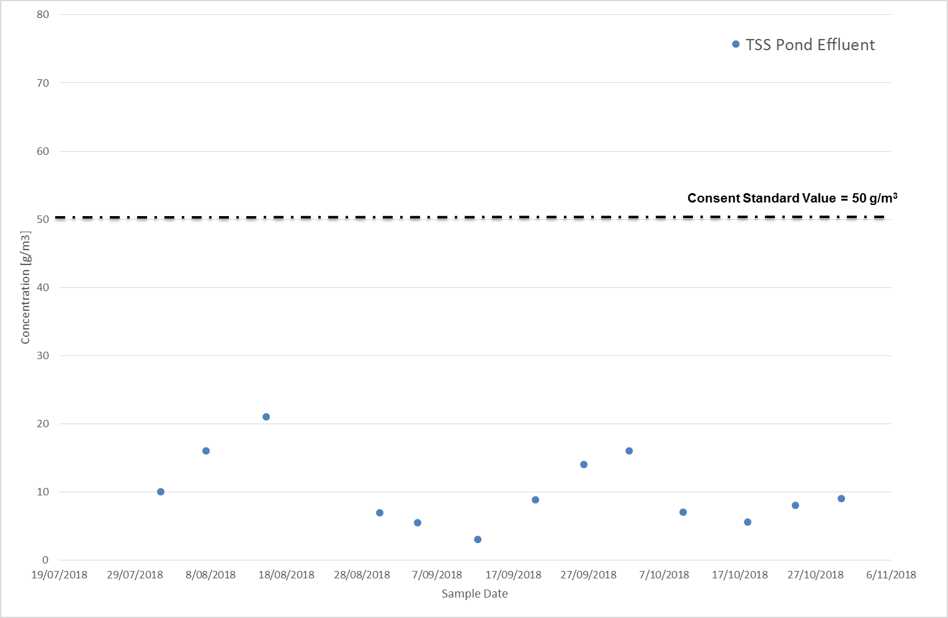

Ammonia Nitrogen Compliance
The median total ammonia nitrogen concentration for the monitoring period was 27 g/m³. This was higher than the previous quarter and higher than the same quarter last year. There were zero exceedances of the 40 g/m³ limit.

Table 1.7.1 Pond Discharge Ammoniacal Nitrogen
Median Value [g/m³]  Current Monitoring Quarter  (August 2018 – October 2018) | 27 | Number of Exceedances  Current Monitoring Quarter  (August 2018 – October 2018) | 0
Median Value [g/m³]  Previous Monitoring Quarter  (May 2018 – July 2018) | 26.5 | Number of Exceedances  Previous Monitoring Quarter  (May 2018 – July 2018) | 2
Median Value [g/m³]  Same Monitoring Quarter of Previous Year  (August 2016 – October 2016) | 20 | Number of Exceedances  Same Monitoring Quarter of Previous Year  (August 2016 – October 2016) | 0

1.7.1 Pond Discharge Ammoniacal Nitrogen
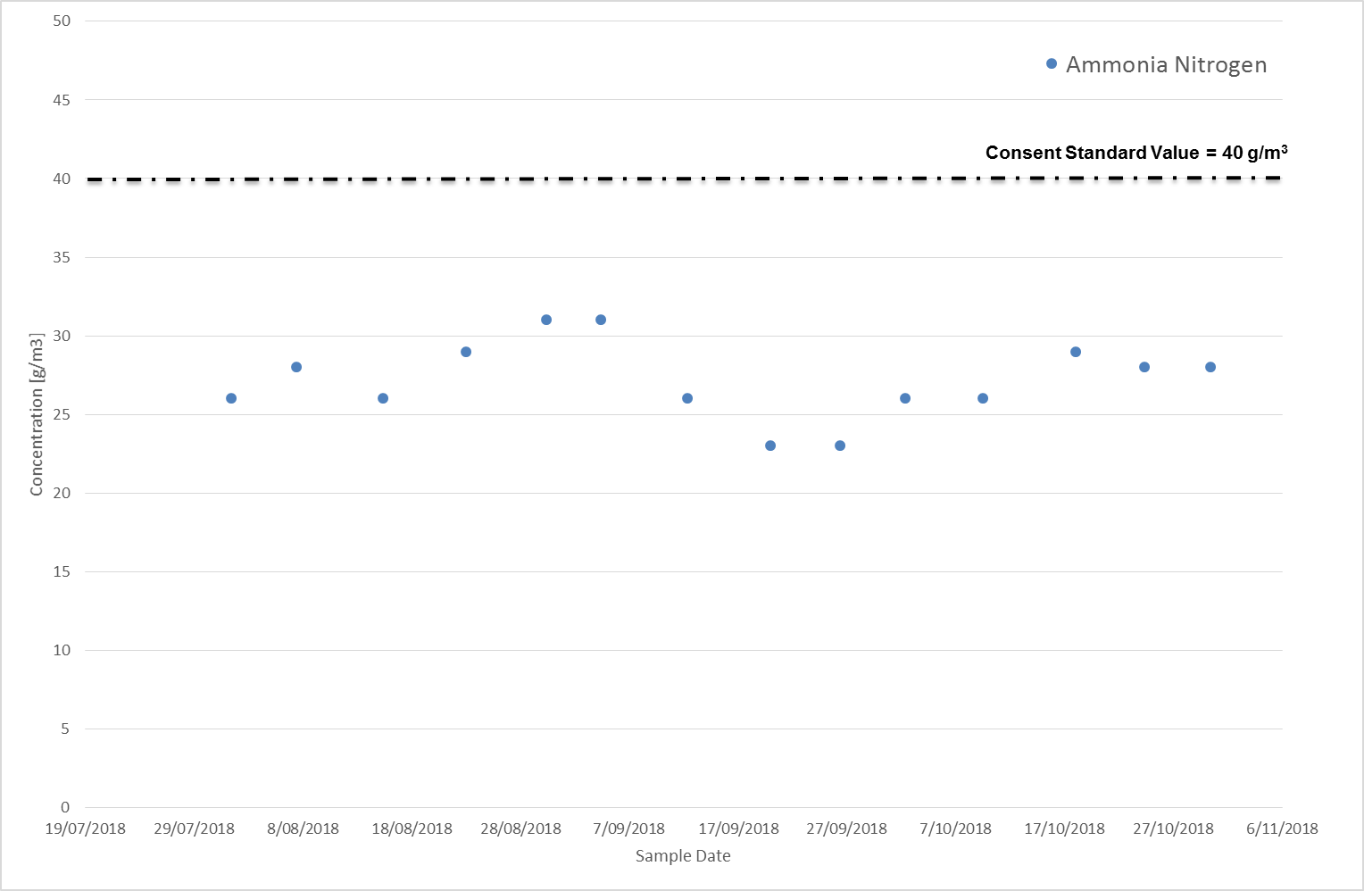

Enterococci Monitoring
The median enterococci concentration during the reporting period was <10 MPN/100mL. This was lower than previous quarter and equal to the same quarter last year. There were no exceedances of the 1,500 MPN/100ml limit during the reporting quarter.

Table 1.8.1 Pond Discharge Enterococci
Median Value [g/m³]  Current Monitoring Quarter  (August 2018 – October 2018) | <10 | Number of Exceedances  Current Monitoring Quarter  (August 2018 – October 2018) | 0
Median Value [g/m³]  Previous Monitoring Quarter  (May 2018 – July 2018) | 85.5 | Number of Exceedances  Previous Monitoring Quarter  (May 2018 – July 2018) | 1
Median Value [g/m³]  Same Monitoring Quarter of Previous Year  (August 2017 – October 2017) | <10 | Number of Exceedances  Same Monitoring Quarter of Previous Year  (August 2017 – October 2017) | 0

1.8.1 Pond Discharge Enterococci
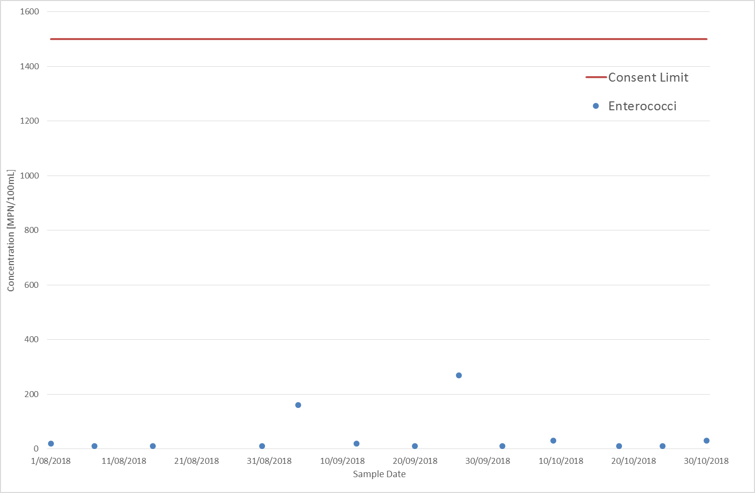

Faecal Coliform Compliance
The median concentration for the reporting period was 30 MPN/100 mL, which is less than the median for the previous quarter, and lower than the same quarter last year. There were no exceedances of the standard faecal coliform limit.

Table 1.9.1 Pond Discharge Faecal Coliforms
Median Value [g/m³]  Current Monitoring Quarter  (August 2018 – October 2018) | 30 | Number of Exceedances  Current Monitoring Quarter  (May 2018 – July 2018 | 0
Median Value [g/m³]  Previous Monitoring Quarter  (May 2018 – July 2018) | 60 | Number of Exceedances  Previous Monitoring Quarter  (May 2018 – July 2018) | 0
Median Value [g/m³]  Same Monitoring Quarter of Previous Year  (August 2017 – October 2017) | 60 | Number of Exceedances  Same Monitoring Quarter of Previous Year  (August 2017 – October 2017) | 1

1.9.1 Pond Discharge Faecal Coliforms
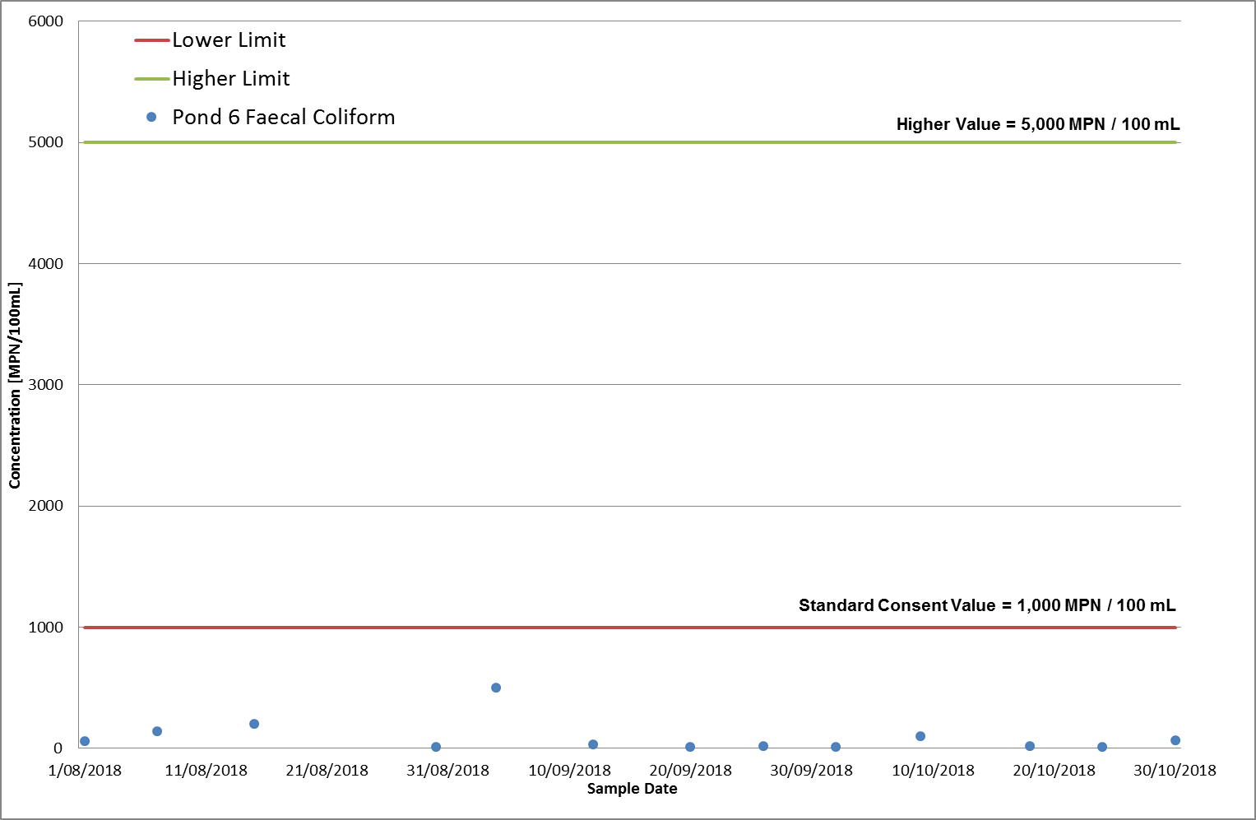

Receiving Environment Monitoring in Pegasus Bay

Water Quality Resource Consent Conditions
All samples were collected and analysed as required by consent condition 18. Samples for condition 18 are collected from South New Brighton Beach at Jellicoe Street, Sumner Beach at the surf club, and New Brighton at the Surf Club. Sampling for condition 22a is due February 2019.
Table 2.1.1 Receiving Environment Water Quality Consent Compliance
Consent Condition | Parameter | Compliance Condition | Compliance
 |  |  | Aug – Oct 18
18 | Faecal Coliforms | Sampled and Analysed
 | Enterococci | Sampled and Analysed
22a | Temperature | 2 yearly | na
 | DO | 2 yearly | na
 | Salinity | 2 yearly | na
 | Total Suspended Solids | 2 yearly | na
 | Nitrogen Oxides | 2 yearly | na
 | Ammoniacal Nitrogen | 2 yearly | na
 | Dissolved Reactive Phosphorus | 2 yearly | na
 | Chlorophyll-a | 2 yearly | na
 | Trace Metals | 2 yearly | na
 | Faecal Coliforms | 2 yearly | na
 | Enterococci | 2 yearly | na
 | Phytoplankton Species | 2 yearly | na
Key: ☺ Full Compliance 😐 Minor, Isolated or Risk of Non-Compliance ☹ Major or Consistent Non-Compliance

Comments on Compliance
All results for the Pegasus Bay area were within consent for the recording period.
Beach Water Quality Analysis Results
Samples for condition 18 were taken at weekly intervals from the prescribed onshore locations. Results are presented in Figures 2.3.1 and 2.3.2. Any retest results are contained in the appendices.
2.2.1 Enterococci Levels at beaches adjacent to the Outfall
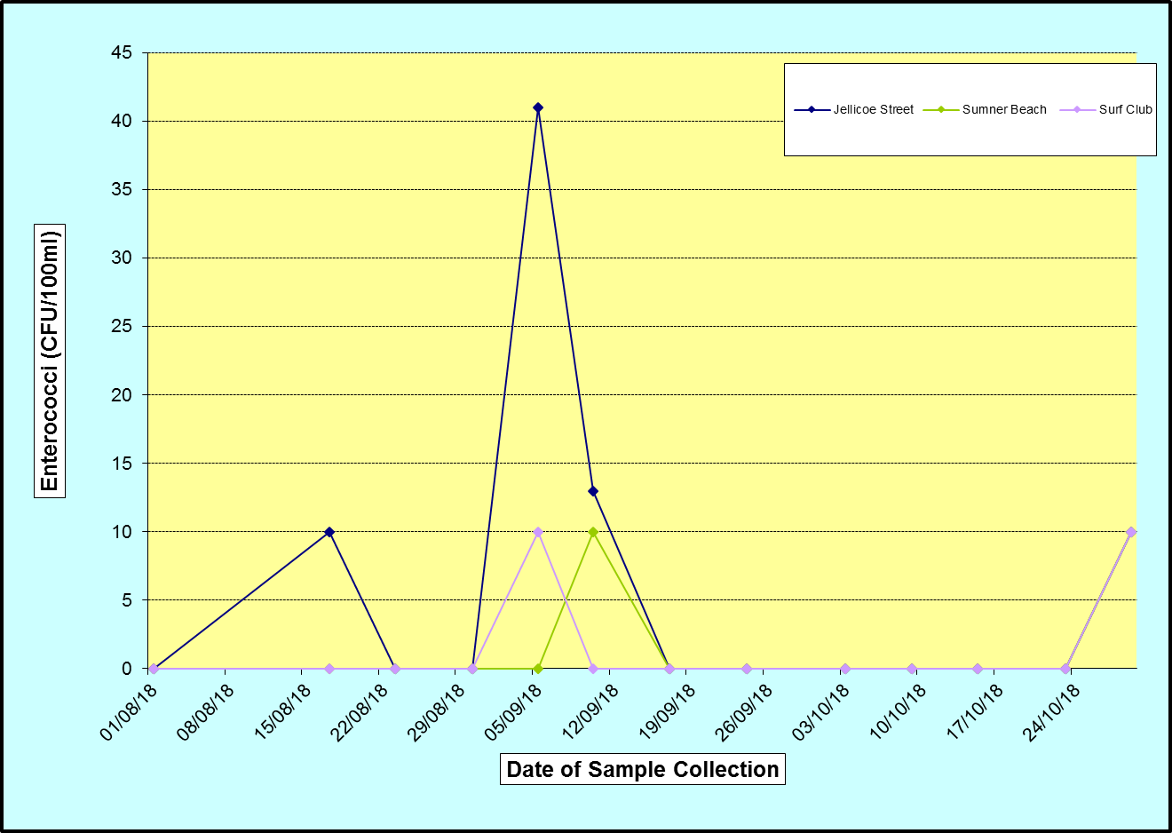
2.2.2 Faecal Coliform Levels at beaches adjacent to the Outfall
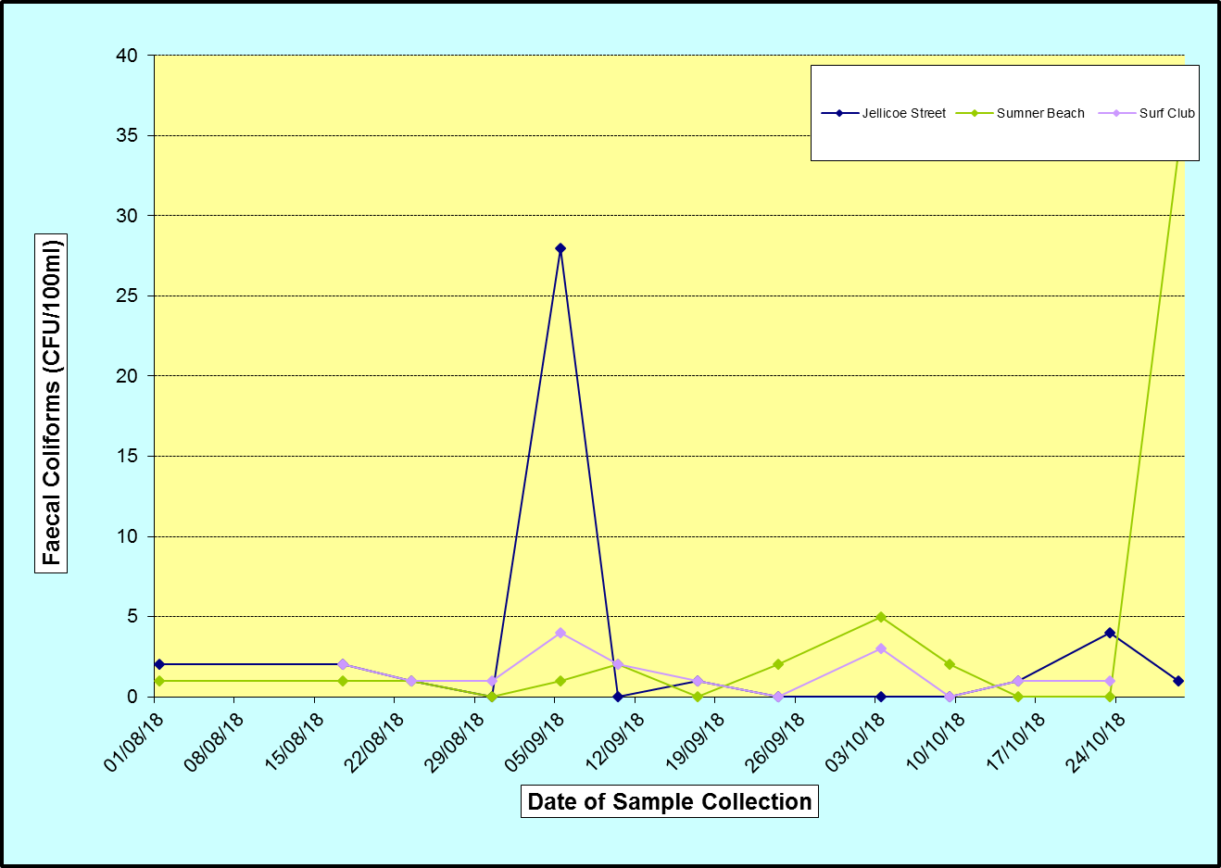

Other Receiving Environment Analysis
Consent conditions 23, 25, 26 and 27 call for monitoring of the marine environment around the outfall at various frequencies, some of which fall in the monitoring period. These requirements are summarised in Table 2.4.1, and the results are attached as an appendix to this report. Sampling for Conditions 23 – 26 are due 2017 but was delayed and completed in early 2018, while condition 36 is now only undertaken if requested by members of the community.
Table 2.3.1 Receiving Environment Monitoring Consent Compliance
Consent Condition | Parameter | Frequency | Compliance Condition | Compliance
 |  |  |  | Aug – Oct 18
23 | Marine Sediments | 5-yearly | Not monitored this quarter | —
25 | Benthic Invertebrates | 5-yearly | Not monitored this quarter | —
26 | Epibenthic Fauna | 5-yearly | Not monitored this quarter | —
27 | Shellfish | Quarterly | Sampled and analysed | ☺
29 | Complaints | As required | Recorded and reported | ☺
31 | Report | Quarterly and Annually | Report and information lodged with ecan | ☺
36 | Community Liaison Group | Annually | Not done this quarter | —
Key: ☺ Full Compliance 😐 Minor, Isolated or Risk of Non-Compliance ☹ Major or Consistent Non-Compliance

Comments on Compliance
No complaints regarding the ocean outfall have been received this quarter. This report and supporting documentation will be submitted to Environment Canterbury.

